ToR STF 669 (Ref. Body ISG ARF)
Version: 0.2
Author: Jérôme Royan – Date: 2023-03-06
Last updated by: ETSI Secretariat – Date: 2023-06-19
page 1 of 21

Terms of Reference – Specialist Task Force
STF 669 (Ref. Body ISG ARF)
Development and Validation of ARF World Analysis APIs

Summary information
Approval status | Approved by Ref. Body ISG ARF (doc ref: ARF(23)000015) |  | YES
 | Approved by Board#143 (06-07 June 2023) |  | YES
Reference Body | Ref. Body ISG ARF
ETSI Funding | Maximum budget : 100 000 EUR
Minimum of 4 ETSI Members Support | YES
Time scale | From | 2023-09-25
 | To | 2024-07-31
Work Items | RGS/ARF-005_v2.1.1  DGS/ARF-008  DMI/ARF-009
Board priority | ETSI STF funding criteria  Priority Criteria X  Maintenance of standards in mature domains  Innovation in mature domains  Emerging domains for ETSI X  Horizontal activities (quality, security, etc.)  Societal good / environmental

Part I – STF Technical Proposal

Rationale & Objectives

Rationale
Augmented Reality (AR) mixes in real-time spatially registered digital content with the experience of the real world. To achieve this, an AR system with individual components is required.
The Industry Specification Group on Augmented Reality Framework (ISG ARF) is defining a framework for the interoperability of AR components, systems, and services. Transparent and reliable interworking between different AR components is key to the successful rollout and wide adoption of AR technologies and services. Allowing components from different providers to interoperate through defined interfaces, this framework will avoid vertical silos and reduce market fragmentation, enabling players in the eco-system to offer parts of an overall AR solution.

The ETSI Group Specification ARF 003 – AR Framework Architecture, published in March 2020, introduces the characteristics of an AR system and defines a modular reference architecture forming the basis of the interoperability framework. The generic nature of the architecture was validated by mapping the workflow of several use cases to the components of this framework architecture.

The functional architecture consists of eleven logical functions, covering, e.g., the capture of the real world, its analysis, or the management of a virtual scene embedded in the real world (seeFigure 1). The logical functions are connected by Reference Points (RPs), representing the interactions between those functions. The next step after the publication of the reference architecture has been the development of interoperability requirements for the most relevant RPs, which will lay the basis for their standardization. Standardized interfaces between components of the AR framework will allow the usage of different components in an AR system without affecting its functionality. This typically prevents vendor lock-in situation.

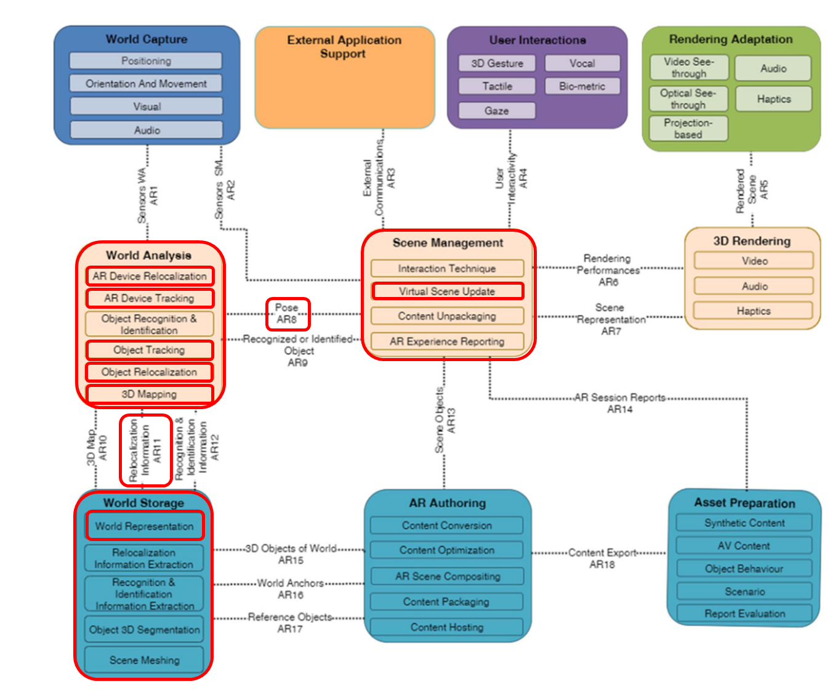Figure 1: Diagram of the functional reference architecture. Highlighted in red, the function, subfunctions and reference points addressed by this STF.
A survey amongst ISG ARF members identified a set of RPs where interoperability is needed the most. These are grouped under the following four clusters of RPs:

- World Storage and Pose cluster with an initial focus on the RPs AR16 “World Anchors” and AR17 “Reference Objects”
- World Analysis and Pose cluster with an initial focus on the RPs AR8 “Pose”, AR10 “3D Map”, and AR11 “Relocalization Information”
- Sensors for World Capture
- External Communications

The ISG is specifying in detail the requirements to be fulfilled by these RPs. The activity proposed for the STF at hand focuses on the functionalities to be provided by the component “World Analysis” to communicate with the “World Storage” and “Scene Management” functions (seeFigure 1). In addition to others, this component is responsible for analysing the real world based on data captured in real-time by the function “World Capture” and a representation of the real world stored by the function “World Storage”. Among the various World Analysis subfunctions, five are crucial for AR systems, namely the “AR Device Relocalization” (respectively the “Object Relocalization”), which estimates the pose of the AR device (respectively an object) when starting a session or when the tracking is lost, the “AR Device Tracking” (respectively the “Object Tracking”) subfunction, which estimates the movement of the AR device (respectively an Object) in real time, and the “3D mapping” subfunction, which creates a 3D representation of the real world. “AR Device Relocalization”, “Object Relocalization”, “AR Device Tracking” and “Object Tracking” subfunctions provide the “Scene Management” with the pose of the AR device or an object to register AR assets in 3D attached to “World Anchors” or “Trackables” with elements of the real world.

During its work on interoperability requirements, the ISG has defined the requirements for these interfaces. In a next step, the group will verify whether the requirements specifications for AR8, and AR 11 cover all necessary aspects and whether existing solutions could be used for the world analysis.

The ISG proposes to set up an STF to accelerate the specification of the APIs following an implementation-driven standardization approach. This will also ensure that the APIs are complete and validated with several implementations at the time of their publication. To make their evaluation and adoption even easier for the industry, the code developed by the STF will be Open Source and publicly available under the Open Source license Apache 2.0.

ISG ARF has already indicated in its Terms of Reference that it plans to initiate Open Source development of parts of its AR Framework to promote and support its adoption. These Terms of Reference were submitted for Board consultation at Board #134 prior to being approved by the Director General in September 2021.

Objectives of the work to be executed
The main objective is to develop API specifications and a validation application based on existing implementations focussing on reference points (AR8 & AR11) between the World Storage, The World Analysis, and the Scene Management functions (see Figure 2).

The STF will draft an initial specification of the APIs resp. It will extend the existing one (in OpenAPI notation).

They will then implement the APIs as Open Source, testing it on existing implementations of the World Analysis components through the development of dedicated wrappers (wrappers of World Storage function implementations have already been carried out within the scope of the STF 620). In this way, the STF will evaluate by multiple AR-example experiences, whether AR8, and AR11 are sufficient in their current state or whether they need extensions. For this purpose, a validation application will be developed, also as Open Source.

Once the APIs are completed and validated based on several existing World Analysis implementations, the OpenAPI specification, a formal, implementation independent notation, will be updated for inclusion in an extension of GS ARF 005 and a new ARF Group Specification GS ARF 008.

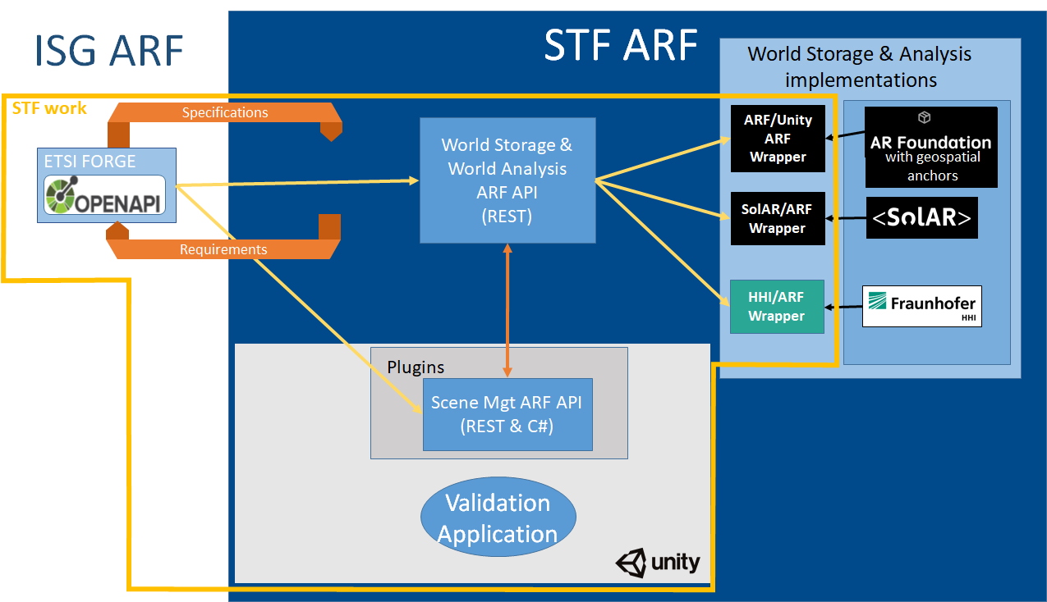Figure 2: Overview about STF 669 activities.

Previous funded activities in the same domain
Similar activities, but with another technical focus with respect to the reference points of the ARF functional architecture, had been funded by ETSI in 2021-2022 as STF 620. The scope of this STF was the development of APIs for reference points AR16 and AR17. Details about STF 620 can be found at https://portal.etsi.org/XTFs/#/xTF/620.

Market impact
The necessity of offering a better interoperability between the “World Storage”, the “World Analysis” and the “Scene Management” functions as part of an application is currently recognized by many stakeholders in the eco-system. To prevent the provision of proprietary solutions by large players which become de-facto standards and to facilitate future collaboration amongst stakeholders, the ISG ARF plans to develop the corresponding specifications as a publicly available baseline accompanied by Open Source code showing ETSI’s leading in this area.

The implementation-driven specification approach followed by the STF will allow ISG ARF to refine and validate its interface specifications for the corresponding reference points before publication. The validation application will increase the value of these specifications to the industry by showing how they enable the interchanging of components without impacting the overall functionality of the AR experience. Moreover, making the code (to define and validate the API specifications) developed by the STF publicly available as Open Source will facilitate the evaluation and broader adoption of the ARF APIs.

Consequences if not agreed
As indicated above, there is a risk of emergence of proprietary or de-facto standards, dominated by some large players. Therefore, there is some urgency with this STF request.

If the STF is not agreed, there will be significant delays to developing the focused APIs in the ISG ARF. If the APIs were developed without the implementation-driven standardisation approach, they would not be validated and would not have a validation application to help to promote its take-up and use in the community. In such a scenario, it would be likely that de-facto standard APIs would emerge, controlled by a single large player, together with a number of competing APIs and interfaces from other players, leading to market fragmentation and ultimately limiting the adoption of Augmented Reality systems.

Relation with ETSI strategy and priorities

Priority Criteria | Rationale
Maintenance of standards in mature domains
Innovation in mature domains
Emerging domains for ETSI | Augmented Reality is one of the ten technical trends highlighted in ETSI’s Long Term Technology Roadmap under section 3.2.7 ‘eXtended Reality’ in BOARD(19)123_014. eXtended Reality (XR) is the umbrella term used for Virtual Reality (VR), Augmented Reality (AR), and Mixed Reality (MR), as well as future immersive technologies.
Horizontal activities (quality, security, etc.)
Societal good / environmental

This STF proposal addresses several areas of the key strategic dimensions identified in the new ETSI Strategy (ETSI/GA(20)76_012):

5.1 Being at the Heart of Digital
“ETSI is at the forefront of the standardization of new and existing digital technologies, providing the right environment and tools for an open discussion of ideas and an efficient development of standards for the benefit of all.”
[…]
“ETSI develops and makes appropriate use of software, including open source, and establishes effective liaisons with open source foundations and communities to further the global adoption of ETSI standards.”

This STF will develop an Open Source implementation of the APIs in scope, wrappers, plugins and a validation application to accelerate the specification of the targeted APIs.

5.2 Being an Enabler of Standards
“ETSI is where its members come to debate and exchange ideas around the development and use of technology of central importance to their success. […]
ETSI provides support and a range of tools to enable the identification of the needs and requirements for standards and their production and adoption.” [..]

5.3 Being Global
“ETSI carries out the promotion, education and other strategies required to ensure that its work programme and activities are widely known, in order to make ETSI attractive to new and existing members.”

Releasing the validation application produced by this STF as Open Source will contribute to the promotion, evaluation and adoption of the ARF APIs by the broad market.

5.4 Being Versatile
“ETSI is versatile in the methods it uses to create ICT standards.
ETSI innovates in its working methods, creating room for wide participation, innovation, time to deployment, and the global acceptance of ETSI standards.”

The STF will follow an “implementation-driven standardization approach” allowing acceleration of the API specification process, reducing time to market and improving the quality of the resulting API specifications, as they will have been validated and demonstrated by the time they are published.

ETSI Members Support
# | ETSI Member | Supporting delegate
1 | DT | Jens Johann
2 | Orange | Jérémy Lacoche
3 | b<>com | Jérôme Royan
4 | Fraunhofer HHI | Sylvain Renault
5 | SnT - University of Luxembourg | Aurel Machalek
6 | Nokia Bell Labs | Gabor Soros

# | ISG ARF Participant | Supporting delegate
1 | Technische Hochschule Nürnberg | Patrick Harms
2 | University College Dublin | Eleni Mangina
3 | Perey Research & Consulting | Christine Perey

Deliverables

Base documents
Document | Title | Status
ETSI GS ARF 003 v1.1.1 | Augmented Reality Framework (ARF) AR framework architecture | Published
ETSI GS ARF 004-4 v1.1.1 | Augmented Reality Framework (ARF); Interoperability Requirements for AR components, systems and services; Part 4: World Analysis, World Storage and Scene Management functions | Published
ETSI GS ARF 005 v1.1.1 | Augmented Reality Framework (ARF); Open APIs for the Creation and Management of the World Representation | Published

New deliverables
Deliv. | Work Item code  Standard number | Working title  Scope | Expected date for publication
D1 | RGS/ARF-005_v2.1.1 (GS ARF 005 v2.1.1) | Working title: Open APIs for the Creation, Management, and Querying of the World Representation  Scope:  The deliverable provides an overview and an introduction to the interface specification for the reference points "AR 16 - World Anchors", "AR 17 - Reference Objects", and “AR 11 - Relocalization Information” of the AR framework architecture developed by the ETSI Industry Specification Group (ISG) for an Augmented Reality Framework (ARF).  Note: This deliverable is an extension of the specification GS ARF 005 v1.1.1 adding the API for the reference point “AR 11 - Relocalization Information” to allow the World Analysis function to query the World Storage function. | 2024-07-31
D2 | DGS/ARF-008  (GS ARF 008 v1.1.1) | Working title: Open APIs for Managing and Querying the World Analysis function.  Scope:  The deliverable provides an overview and an introduction to the interface specification for the reference points "AR 8 – Pose” of the AR framework architecture developed by the ETSI Industry Specification Group (ISG) for an Augmented Reality Framework (ARF). | 2024-07-31
D3 | DMI/ARF-009 | Working title: Wrappers for World Analysis and World Storage solutions and Validation Application  Scope:  Extension of the wrappers for the World Storage function previously implemented as part of STF 620 and implementation of wrappers for targeted World Analysis solutions (SolAR framework, AR runtimes supported by AR Foundation, HHI XR Framework).  Development of a plugin interfacing the Unity framework with any of the developed wrappers.  Development of an exemplary application validating the use of the various API calls and demonstrating the interoperability with the targeted world analysis solutions. | 2024-07-31

Maximum budget

Task summary/Manpower Budget

Task short description | Budget (EUR)
T0 - Project Management | 5,000
T1 - Definition and generation of the World Storage and World Analysis API | 25,000
T2 - Implementation of wrappers | 25,000
T3 - Development of a generic plugin to access the World Analysis function | 35,000
T4 - Development of a validation application | 10,000
TOTAL | 100,000

Travel budget
None

Other budget line
None

Part II – Details on STF Technical Proposal

Tasks, Technical Bodies and other stakeholders

Organization of the work
The STF will develop the APIs, wrappers and a validation application, together with the OpenAPI specification of the APIs as a draft ETSI Group Specification. The STF members will ensure a clear and careful separation of the software demonstrator from the standardisation work.

The OpenAPI specification will be made available via the ETSI Forge repository and integrated into a new draft ETSI Group Specification. The wrappers and the validation application development will be managed and made available via the ETSI Labs GitLab Repository and published under the Open Source license Apache 2.0. When establishing the STF, a corresponding contributor license agreement will be set up.

The work itself will be organized in an agile fashion. For this, the STF with its members will hold regular online meetings to clarify challenges and to decide for the next steps. In these meetings, members of the ISG ARF will participate to represent the role of a product owner and to steer the work of the STF. Due to the rather small size of the ISG ARF, we refrain from setting up a complex steering group or a dedicated working group. This structure will allow simple decision making and an efficient work of the STF.

Following completion of the STF, the Open Source validation application and the OpenAPI specification will be maintained by the ISG.

Tasks for which the STF support is necessary
The STF will support the ISG ARF with the following tasks as shown in Figure 3, for which the members of the ISG ARF do not have sufficient resources within the targeted schedule:

- Development of OpenAPI specification and generation of APIs.
  - The STF will develop an initial draft of the API specification in the OpenAPI notation based on the interoperability requirements specified by ISG ARF in ETSI GS ARF 004-4. This OpenAPI specification will be hosted and versioned on the ETSI Forge, and will consist firstly of an extension to the existing GS ARF 005 v1.1.1 with a new API allowing the World Analysis function to query the World Storage function (reference point AR-11), and secondly of a new API specification GS ARF 008 allowing the Scene Management function to query the World Analysis function (reference point AR-8).
  - Specific tools (e.g., OpenAPI generator) will be used to automatically generate source code from the OpenAPI specification for at least the C++ and C# languages. Steps 1 and 2 here are iterative: the work of the STF in implementing the OpenAPI specification will result in feedback of new requirements and corrections to this specification.
- Wrappers will be developed to interface World Storage and World Analysis function implementations with the ARF APIs for two or more of the following existing implementations:
  - AR Foundation (Unity framework for interfacing various AR runtimes) with geospatial and cloud anchor modes (ARKit and ARCore)
  - SolAR Framework
  - HHI XR Framework
- A plugin for Unity will allow to call subfunctions of the World Analysis using a C# API from within the game engine Unity.
- Finally, a validation application will be developed with the game engine Unity to demonstrate the full pipeline, using different World Storage implementations with the Unity engine, and thereby demonstrate the benefits of a common ARF API in terms of interoperability. An interim version of the validation application will involve a single trackable, the final version will demonstrate how an AR application can benefit from a world graph including several trackables (e.g.; a geotrackable, map trackables, or fiducial marker trackables).

Note: AR Foundation refers to a framework developed by Unity providing a unique API interfacing various AR runtimes (ARCore, ARKit, Magic Leap, and HoloLens) accessible at https://unity.com/unity/features/arfoundation.
Note: SolAR framework refers to an Open Source framework dedicated to Augmented Reality accessible at http://www.solarframework.org.
Note: HHI XR Framework refers to sample libraries which provide the functionality required to test certain aspects of the developed API wrappers. These libraries may simulate complex algorithmic implementations rather than provide full functionality. The HHI XR Framework propagates AR datasets and functional commands between the different services and visualization clients.

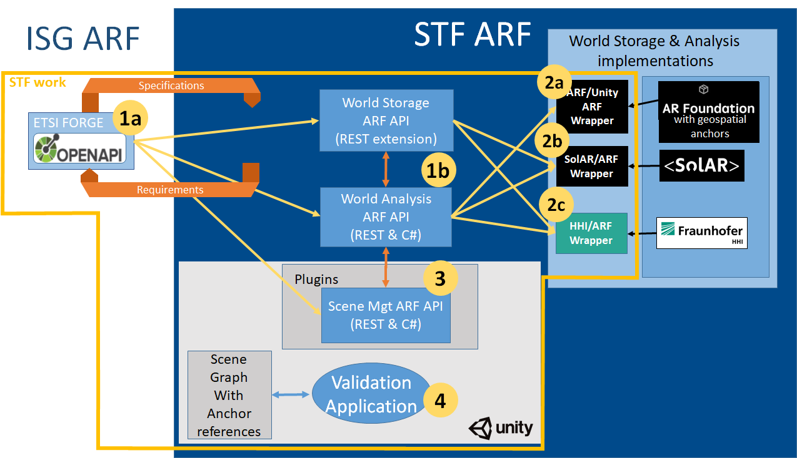
Figure 3: Detailed description of the STF 669 activities.

Other interested ETSI Technical Bodies
The following group may have an interest in the work of this STF but is not expected to be actively involved.

ISG ARF will handle any required liaison or communication with this group:

- ETSI ISG MEC

Other stakeholders
The following groups may have an interest in the work of this STF but are not expected to be actively involved.

ISG ARF will handle any required liaison or communication with these groups:

- 3GPP/SA4-Codec
- ISO MPEG
- W3C AR Community Group
- Khronos
- The AREA
- IEEE AR Mobile Device
- OGC
- Open AR Cloud
Part III: Execution of Work

Work plan, time scale and resources

Task description
Task 00 | Project Management
Objectives | Planning, organisation, and preparation of STF meetings  On-going reporting  Participation at ISG meetings  Delivery of the STF final report
Input | This ToR  Information from the preparatory meeting  Expertise availability information and other project management data
Output | Session planning  Materials for ISG meetings  Progress reports  Final report
Interactions | The STF leader (along with the whole STF) will interact with the ISG ARF  Communicating with other stakeholders  Code and repository management  Additional support will be provided by the ETSI secretariat
Resources required | Skills in agile project management, resource planning, reporting, and coordination

Task 01 | Definition and generation of the World Storage and World Analysis API
Objectives | Define the APIs in OpenAPI format between the World Storage, the World Analysis and the Scene Management functions at the reference points AR8 and AR11 satisfying the requirements expressed in the document “ARF Interoperability Requirements for AR components, systems and services Part 4: World Analysis, World Storage and Scene Management functions”. Generate the C++ and C# codes from the OpenAPI.  Provide the definition, description, documentation and validation environment for the API.
Input | ETSI GS ARF 004-4
Output | Draft ETSI Group Specifications DGS/ARF-005v2.1.1 and DGS/ARF-008, with the OpenAPI definitions referenced from the ETSI Forge.  C++ and C# codes  Code generation workflow to regenerate classes on API changes.  Location: ETSI Labs
Interactions | Regular exchanges with the ISG ARF, in one way to check the conformance of the specification with the requirements and conversely to possibly enrich the original requirements if necessary.  Collaboration with the teams implementing the Wrappers over the different World Storage implementations.
Resources required | Resource knowledgeable in OpenAPI, JSON, Swagger, C++ respectively C#.  Understanding of ISG ARF reference architecture defined in GS ARF 003  Contribution from the ISG

Task 02 | Implementation of wrappers
Objectives | Implement wrappers to targeted solutions (Unity AR Foundation, SolAR, HHI XR Framework)
Input | Result from Task 01
Output | Wrappers transforming calls and data structures of the World Storage API in calls and data structures of the target AR solution (two or more of the following solutions; Unity AR Foundation, SolAR framework, HHI XR Framework).  Location: ETSI Labs  The libraries of the different solutions are not part of the STF deliverables and must be requested from their suppliers.
Interactions | Collaboration with the team defining the API  Collaboration with the team generating the C++ and C# API
Resources required | Resource knowledgeable in C++, one or more of the 3 identified AR frameworks (AR Foundation, SolAR framework, HHI XR Framework)

Task 03 | Development of a generic plugin to access the World Analysis function
Objectives | Creation of a plugin embedding the access to any implementation of the World Analysis, and creation of a validation application backbone using the AR Analysis function API to localize an AR device in relation to World Anchors registered in a World Storage function.
Input | Results from Task 01 & Task 02
Output | A unity plugin instantiating the API of the World Analysis function.  Location: ETSI Labs  The libraries of the different solutions are not part of the STF deliverables and must be requested from their suppliers.
Interactions | Collaboration with the team defining the API  Collaboration with the team generating the C++ and C# API
Resources required | Resource knowledgeable in C++, C# Unity plugins mechanism, AR runtimes

Task 04 | Development of a validation application
Objectives | Creation of a validation application backbone using the AR Analysis function API to localize an AR device in relation to World Anchors registered in a World Storage function including on or several trackables.
Input | Results from Task 03
Output | The validation application backbone.  A specific instantiation for each World Analysis  Location: ETSI Labs  The libraries of the different solutions are not part of the STF deliverables and must be requested from their suppliers.
Interactions | Collaboration with the team defining the API  Collaboration with the team generating the C++ and C# API
Resources required | Resource knowledgeable in C++, C# Unity plugins mechanism, AR runtimes and frameworks

Milestones
Milestone 0 – Start of work

Milestone | Description | Cut-Off Date
M0 | Kick-off meeting | 25/09/2023
Reference Body Deliverable
ETSI Deliverable | Approved detailed planning and deliverables list

Milestone A – First draft of the OpenAPI specification available

Milestone | Description | Cut-Off Date
MA | First draft of the OpenAPI specification available | 30/11/2023
Reference Body Deliverable | First draft of the OpenAPI specification GS ARF 005 v2.1.1 and GS ARF 008 available on the ETSI Forge and accepted by ISG ARF
ETSI Deliverable | Progress Report#1 approved by ISG ARF referring to acceptance of 1st draft of the OpenAPI specification.

Milestone B – Interim version of the validation application.

Milestone | Description | Cut-Off Date
MB | Interim version of the validation application demonstrating the interim versions of:  - The OpenAPI specification  - The generation workflow and the C++/C# classes defining the API  - The wrappers for the world storage and World Analysis implementations  - The implementation of the Unity plugin  - An application implementing a real-time AR scenario involving a single trackable | 29/02/2024
Reference Body Deliverable | Interim draft of the OpenAPI specification available on the ETSI Forge and accepted by ISG ARF  Interim version of the generation workflow and the C++/C# classes defining the API, available on the ETSI Labs repository  Interim version of the wrappers for the world storage solutions, available on the ETSI Labs repository  Interim version of the implementation of the plugin, available on the ETSI Labs repository  Interim version of the validation application, available on the ETSI Labs repository
ETSI Deliverable | Progress Report#2 approved by ISG ARF referring to:  - acceptance of interim draft of OpenAPI specification  - interim version of the generation workflow and the C++/C# classes defining the API available on the ETSI Labs repository  - interim version of the wrappers for the world storage and world analysis implementations, available on the ETSI Labs repository  - interim version of the validation application  - and draft version of GS ARF 005 v2.1.1 and GS ARF 008

Milestone C – Final version of the validation application

Milestone | Description | Cut-Off Date
MC | Final version of the validation application demonstrating the final versions of:  - The OpenAPI specification  - The generation workflow and the C++/C# classes defining the API  - The wrappers for the world storage and World Analysis implementations  - The implementation of the Unity plugin  - An application implementing a real-time AR scenario involving several trackables (including geotrackables and vision based trackables) | 31/05/2024
Reference Body Deliverable | Final draft of the OpenAPI specification available on the ETSI Forge and accepted by ISG ARF  Stable draft of GS ARF 005 v2.1.1 and GS ARF 008  Final version of the generation workflow and the C++ and C# classes defining the API, available on the ETSI Labs repository  Final version of the wrappers for the world storage solutions, available on the ETSI Labs repository  Final version of the implementation of the plugin, available on the ETSI Labs repository  Final version of the validation application, available on the ETSI Labs repository
ETSI Deliverable | Progress Report#3 approved by ISG ARF referring to:  - acceptance of final draft of OpenAPI specification,  - final version of the generation workflow and the C++/C# classes defining the API available on the ETSI Labs repository  - final version of the wrappers for the world storage and world analysis implementations, available on the ETSI Labs repository  - final version of the validation application  - and stable draft of GS ARF 005 v2.1.1 and GS ARF 008  Progress Report#3 approved by ISG ARF referring to acceptance of final version of the validation application

Milestone D – Final draft for approval of Group Specification Final report on the STF work

Milestone | Description | Cut-Off Date
MD | Final report on the STF work | 30/06/2024
Reference Body Deliverable | Final Draft of GS ARF 005 v2.1.1 and GS ARF 008, approved by ISG ARF
ETSI Deliverable | Final Report approved by ISG ARF referring to validation of the API and ISG approval of GS ARF 005 v2.1.1 and GS ARF 008

Milestone E – Deliverables published, STF closed

Milestone | Description | Cut-Off Date
ME | Deliverables published, STF closed | 31/07/2024
Reference Body Deliverable
ETSI Deliverable | GS ARF 005 v2.1.1 and GS ARF 008 v1.1.1

Task summary

Code | Task | Target Date |  | Estimated Cost (EUR)
 |  | From | To
T0 | Project management | 25/09/2023 | 31/07/2024 | 5,000
T1 | Definition and generation of the World Storage and World Analysis API | 25/09/2023 | 31/05/2024 | 25,000
T2 | Implementation of wrappers | 01/11/2023 | 31/05/2024 | 25,000
T3 | Development of a generic plugin to access the World Analysis function | 01/11/2023 | 31/05/2024 | 35,000
T4 | Development of a validation application | 01/12/2023 | 31/05/2024 | 10,000
 |  |  |  | 100,000

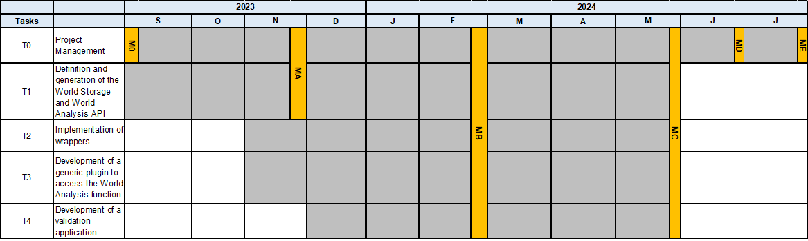

Expertise required

Team structure
(Up to) 3 participants to ensure the following mix of competences:

Priority | Qualifications and competences
High | A good understanding of ISG ARF reference architecture specified in GS ARF 003
High | A good knowledge of the existing World Analysis frameworks to be wrapped through the API, i.e., AR Foundation, SolAR, HHI XR Framework
High | Skilled at code development in C++, C#, Unity
High | Skilled in agile project management, resource planning, reporting, and coordination
Medium | Knowledge of OpenAPI, JSON, Swagger.

Part IV: STF performance evaluation criteria

Performance Indicators

Select relevant Performance indicators applicable for these ToR (X)
Contribution from ETSI Members to STF work
Support to the STF work (e.g., provision of test–beds, organization of workshops, events) | X
Number of delegates directly involved in the review of the deliverables | X
Contribution from the STF to ETSI work
Contributions to Reference Body meetings (number of documents / meetings / participants) | X
Liaison with other stakeholders
Potential interest of new members to join ETSI
Liaison to identify requirements and raise awareness on ETSI deliverables
Comments received on drafts (e.g. on WEB site, mailing lists, etc.)
Quality of deliverables
Approval of deliverables according to schedule | X
Respect of time scale, with reference to start/end dates in the approved ToR | X
Comments from Quality review by Reference Body | X
Comments from Quality review by ETSI Secretariat | X

Time recording
For reporting purposes, the STF experts shall fill in the time sheet provided by ETSI with the days spent for the performance of the services.

During the activity, the STF Leader shall collect the relevant information, as necessary to measure the performance indicators. The result will be presented in the Final Report.

Document history
 | Date | Author | Status | Comments
0.1 | 2023-05-04 | Jérôme Royan | Final draft | Presented for ISG ARF review via mailing list, and after approval via remote consensus.
0.2 | 2023-06-19 | ETSI Secretariat | Final version | Update before CL.

Annex I Response to the Request for Proposals
CfE – STF 669 (REFERENCE BODY ISG ARF) Deadline: 18 July 2023
If you are an ETSI Member *

ETSI membership status (Indicate your status):
□ Full
□ Associate
□ Observer

If you are not an ETSI Member *
Please indicate:

Full name of the ETSI member supporting the application (list of ETSI members on etsi.org):
-________________________

Official contact name of the ETSI member supporting the application:
-________________________

Note: A formal confirmation of the support from the Official contact is required (e.g. by e-mail sent to STFLINK@etsi.org) and an “ETSI Member Support Letter” will be required if you are selected.

Contractor information *
Contractor name *:
Indicate the Company/Organization Name
Contact person for the technical aspects |  | Contact person for Decision on ETSI financial offer to this project (if any)
Title |  | Title
First name |  | First name
Last name |  | Last name
Role |  | Role
e-mail |  | e-mail
Phone |  | Phone
 |  | Yes |  | No
Do you or any employee of your Company/Organization hold an elected or appointed position in the Reference Body requesting the STF 669 creation? |  | o  Indicate in which position:  ----------------------------------- |  | o
If you are self-employed candidate:  Do you currently have other contracts in progress with ETSI? |  | o |  | o

All fields marked with an asterix (*) are mandatory

1.1 Introduction

A short presentation of the technical structure responsible for this activity, e.g.:
- Business area, number of employees, link to WEB site,
- Department(s)/team(s)/experts in charge of the technical activities related to this Project,
- Reference to products/services of your Company/Organization or supporting Member to which the standards developed by this Project will apply,
- Motivation for your Company/Organization or supporting Member to participate in this Project.

1.2 Proposed approach

Proposed contribution to tasks & related cost
Identify the tasks to which your Company/Organization is proposing to contribute by filling-in the table below:
Tasks_No | Tasks_Description | Max_Budget_Allocated_in_Euro | Amount_in_Euro_(mandatory) | %_of_whole_Task_(mandatory)
00 | Project Management | 5000 | . | .
01 | Definition and generation of the World Storage and World Analysis API | 25000 | . | .
02 | Implementation of wrappers | 25000 | . | .
03 | Development of a generic plugin to access the World Analysis function | 35000 | . | .
04 | Development of a validation application | 10000 | . | .
 |  | 100000

Amount in Euro (mandatory): Indicate the price offered for your contribution to the task(s)

% of whole task (mandatory): Indicate to which percentage of the execution of the whole task your offer corresponds
Provide a description of the proposed approach, competences, reference to related activities:
- Explain which part of the task is corresponding to the requested percentage that your Company/Organization will handle,
- Explain the scope that your Company/Organization will cover,
- Explain your approach to the management of the quality and,
- Explain your approach to the management of the risks and their mitigation,
- Describe and justify the proposed costs to achieve this project objectives.

Annex II Terms and Conditions
CfE – STF 669 (REFERENCE BODY ISG ARF) Deadline: 18 July 2023
2.1 Submission of Proposals

All proposals in response to this CfE shall be submitted before the deadline indicated in this Collective Letter, using exclusively the WEB application on the ETSI Portal at the following address: https://portal.etsi.org/cfe.

Proposals shall be composed of Curriculum Vitae of the proposed service providers’ personnel and the Annex I of this CfE duly filled-out.
Proposals that will be partial or incomplete at the deadline will not be accepted.

The Terms and Conditions in this Annex will apply.

2.2 Modification and Withdrawal of Proposals

Applicants may, without prejudice to themselves, modify or withdraw their proposal by written request, provided that the request is received by ETSI prior to the due date and time, at the address to which their proposal was submitted. The applicant may submit a new proposal provided that such new proposal is received prior to the deadline for responding which is specified in this Collective Letter.

2.3 Assessment of Proposals

The ETSI Director-General, in consultation with the Reference Body Chairman, is responsible for the selection of the service providers that will be contracted to perform this Project work. The ETSI Director-General and the Reference Body Chairman may be assisted by a Selection Panel to assess the applications received and make the final decision.

As per article 1.10.4 of the ETSI Directives, the Director-General may discard proposals that could be identified as creating potential conflict of interest.

The ETSI Secretariat will only communicate to the applicants the result of the selection (accepted or not accepted). Should applicants need more information on the rationale for the selection, they must address a formal request to the ETSI Director-General.

The following evaluation criteria will be applied to all proposals, in order of priority:
- Evidence that the applicant has the necessary structure and expertise to ensure delivery
- Reference to current or previous activities in the specific technical domain of this project
- Critical review of the most efficient way to achieve the objectives in this Project ToR
- Effective proposed approach/methodology for the execution of the tasks
- Implementation schedule
- Clear pricing policy

Compliance with the first two (2) criteria is mandatory.
Proposals that are not considered compliant with these criteria will be discarded.

Priority will be given to technical quality of the proposals. Pricing considerations will be taken into account to ensure that the best value for money is achieved. Compatibility with the maximum budget allocated to this Project will be verified before placing a Service Contract.

Following the assessment process, ETSI reserves the right to grant contracts to other than the cheapest proposals, to accept or reject any offer completely or in part, or to reject all proposals, without providing the reasons. If no offer is accepted, ETSI may decide to abandon the work or proceed in any other manner ETSI may select.

2.4 IPR and confidentiality Agreements

The information provided in this CfE, as well as the fact that the applicant has received the CfE, is considered confidential and protected under copyright laws. The applicant may not discuss, share, or use the information in this CfE for any purpose other than the response to this CfE.

ETSI will not disclose the content of any proposals to other applicants or any other party, with the exception of the persons involved in the assessment process described in §2.3 above.

However, ETSI reserves the right to make use of the information provided in this proposal to improve this project definition for the purpose of this CfE or any other manner in which ETSI may decide to proceed to select the service providers.

If successful, the applicant will be required to sign a Service Contract, which includes IPR and Confidentiality clauses aligned with the relevant policies in the ETSI Directives.

2.5 Preparation cost

ETSI will not be responsible for any costs or expenses that the applicant may incur in preparing and/or submitting the proposal.

2.6 Service Contract

A Service Contract will be proposed to the applicants that will be selected to perform the work.
Details on the Terms and Conditions of this contract can be found on the ETSI Portal, at the following address: https://portal.etsi.org/STF/STFs/Contracts.aspx

