ToR STF 620 (Ref. Body ISG ARF)
Version: 1.2
Author: Patrick Harms – Date: 2021-04-27
Last updated by: ETSI Secretariat – Date: 2021-06-23
page 1 of 18

Terms of Reference – Specialist Task Force Proposal
STF 620 (Ref. Body ISG ARF)
Development and Validation of ARF World Storage APIs

Summary information
Approval status | Approved by Ref. Body ISG ARF (doc ref: ARF(21)000048) |  | YES
 | Approved by Board#133 (08-11 June 2021) |  | YES
Reference Body | Ref. Body ISG ARF
ETSI Funding | Maximum budget : 100 000 EUR
Minimum of 4 ETSI Members Support | YES
Time scale | From | 2021-09-20
 | To | 2022-07-31
Work Items | DGS/ARF-005  DMI/ARF-006
Board priority | ETSI STF funding criteria  Priority Criteria X  Maintenance of standards in mature domains  Innovation in mature domains  Emerging domains for ETSI X  Horizontal activities (quality, security, etc.)  Societal good / environmental

Part I – STF Technical Proposal

Rationale & Objectives

Rationale
Augmented Reality (AR) mixes in real-time spatially registered digital content with the experience of the real world. For this, an AR system with its individual components is required.
The Industry Specification Group on Augmented Reality Framework (ISG ARF) is defining a framework for the interoperability of AR components, systems, and services. Transparent and reliable interworking between different AR components is key to the successful rollout and wide adoption of AR technologies and services. Allowing components from different providers to interoperate through defined interfaces, this framework will avoid vertical silos and reduce market fragmentation, enabling players in the eco-system to offer parts of an overall AR solution.

The ETSI Group Specification ARF 003 – AR Framework Architecture published in March 2020 introduces the characteristics of an AR system and defines a modular reference architecture forming the basis of the interoperability framework. The generic nature of the architecture was validated by mapping the workflow of several use cases to the components of this framework architecture.

In the functional architecture, there are eleven logical functions covering, e.g., the capture of the real world, its analysis, or the management of a virtual scene embedded in the real world. The logical functions are connected by Reference Points (RPs), representing the interactions between those functions. The next step after the publication of the reference architecture has been to develop interoperability requirements for the most relevant RPs, which will lay the basis for their standardization. Standardized interfaces between components of the AR framework will allow interchanging components in an AR system without affecting its functionality. This typically prevents vendor lock-in situation.

A survey amongst ISG ARF members identified a set of RPs where interoperability is needed the most. These are grouped under the following four clusters of RPs:

- World Storage and Pose cluster with an initial focus on the RPs AR16 ‘World Anchors’ and AR17 ‘Reference Objects’
- User Interactivity
- Sensors for World Capture
- 3D Objects of World

The ISG is specifying in detail the requirements to be fulfilled by a subset of these RPs. The activity proposed for the STF at hand focuses on the functionalities to be provided by the component “World Storage”. In addition to others, this component is responsible for storing information that is required to track elements in the real world and to determine the actual position of an AR system in the real world. When authoring an AR experience, this component must be fed with tracking and location information via the dedicated interfaces “AR16” and “AR17”. During its work on interoperability requirements so far, the ISG has defined the requirements for these interfaces. In a next step, it needs to verify whether the requirements specifications for AR16 and AR17 cover all necessary aspects and whether existing solutions could be used as world storage because they match these requirements.

The ISG proposes to set up an STF to accelerate the specification of the APIs following an implementation-driven standardization approach. This will also ensure that the APIs are complete and validated with several implementations at the time of their publication. To make their evaluation and adoption even easier for the industry, the code developed by the STF will be in Open Source and publicly available under the Open Source license Apache 2.0.

ISG ARF has already indicated in its Terms of Reference that it planned to initiate Open Source development of parts of its AR Framework to promote and support its adoption. These Terms of Reference were submitted for Board consultation at Board #124 prior to being approved by the Director General in September 2019.

Objectives of the work to be executed
The main objective is to develop API specifications and a validation application based on existing implementation focussing on reference points (AR16 & AR17) between the world World Storage and the AR authoring functions.

The STF will draft an initial specification of the APIs (in OpenAPI notation).

They will then implement the APIs as Open Source, testing it on existing implementations of the World Storage component through the development of dedicated wrappers. In this way, the STF will evaluate by multiple AR-example experiences, whether AR16 and AR17 are sufficient in their current state or whether they need extensions. For this purpose, a validation application will be developed, also as Open Source.

Once the APIs are completed and validated based on several existing World Storage implementations, the OpenAPI specification, a formal, implementation independent notation, will be updated for inclusion in ARF Group Specification 005.

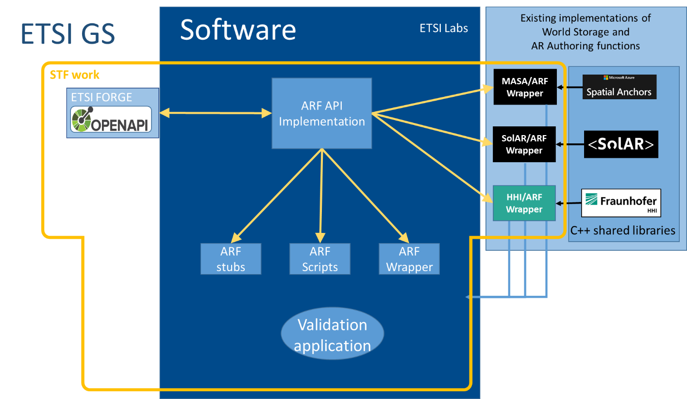

Previous funded activities in the same domain
There have not been any other funded activities in this direction.

Market impact
The necessity of defining and using an interoperable World Storage component as part of an application is currently recognized by many stakeholders in the eco-system. To prevent the provision by large players of proprietary solutions which become de-facto standards and to facilitate future collaboration amongst stakeholders, the ISG ARF plans to develop the corresponding specifications as a publicly available baseline accompanied by Open Source code. Through this, ETSI will take the lead in this area.

The implementation-driven-specification approach followed by the STF will allow ISG ARF to refine and validate its interface specifications for the corresponding reference points before publication. The validation application will increase the value of these specifications to the industry by showing how they enable the interchanging of components without impacting the overall functionality of the AR experience. Moreover, making the code (to define and validate the API specifications) developed by the STF publicly available as Open Source will facilitate the evaluation and broader adoption of the ARF APIs.

Consequences if not agreed
As indicated above, there is a risk of emergence of proprietary or de-facto standards, dominated by some large players. There is therefore some urgency with this STF request.

If the STF is not agreed, there will be significant delays to developing the focused APIs in the ISG ARF. If the APIs were developed without the implementation-driven standardisation approach, they would not be validated and would not have a validation application to help to promote its take-up and use. In such a scenario, it would be likely that de-facto standard APIs would emerge, controlled by a single large player, together with a number of competing APIs and interfaces from other players, leading to market fragmentation and ultimately limiting the adoption of Augmented Reality systems.

Relation with ETSI strategy and priorities

Priority Criteria | Rationale
Maintenance of standards in mature domains
Innovation in mature domains
Emerging domains for ETSI | Augmented Reality is one of the ten technical trends highlighted in ETSI’s Long Term Technology Roadmap under section 3.2.7 ‘eXtended Reality’ in BOARD(19)123_014. eXtended Reality (XR) is the umbrella term used for Virtual Reality (VR), Augmented Reality (AR), and Mixed Reality (MR), as well as future immersive technologies.
Horizontal activities (quality, security, etc.)
Societal good / environmental

This STF proposal addresses several areas of the key strategic dimensions identified in the new ETSI Strategy (ETSI/GA(20)76_012):

5.1 Being at the Heart of Digital
“ETSI is at the forefront of the standardization of new and existing digital technologies, providing the right environment and tools for an open discussion of ideas and an efficient development of standards for the benefit of all.”
[…]
“ETSI develops and makes appropriate use of software, including open source, and establishes effective liaisons with open source foundations and communities to further the global adoption of ETSI standards.”

This STF will develop an Open Source implementation of the APIs in scope, wrappers, plugins and a validation application to accelerate the specification of the targeted APIs.

5.2 Being an Enabler of Standards
“ETSI is where its members come to debate and exchange ideas around the development and use of technology of central importance to their success. […]
ETSI provides support and a range of tools to enable the identification of the needs and requirements for standards and their production and adoption.” [..]

5.3 Being Global
“ETSI carries out the promotion, education and other strategies required to ensure that its work programme and activities are widely known, in order to make ETSI attractive to new and existing members.”

Releasing the validation application produced by this STF as Open Source will contribute to the promotion, evaluation and adoption of the ARF APIs by the broad market.

5.4 Being Versatile
“ETSI is versatile in the methods it uses to create ICT standards.
ETSI innovates in its working methods, creating room for wide participation, innovation, time to deployment, and the global acceptance of ETSI standards.”

The STF will follow an “implementation-driven standardization approach” allowing acceleration of the API specification process, reducing time to market and improving the quality of the resulting API specifications, as they will have been validated and demonstrated by the time they are published.

ETSI Members Support
# | ETSI Member | Supporting delegate
1 | DT | Jens Johann
2 | Orange | Eric Villain
3 | b<>com | Jérôme Royan
4 | Fraunhofer HHI | Ingo Feldmann
5 | SnT - University of Luxembourg | Aurel Machalek
6 | Perey Research & Consulting (Applicant) | Christine Perey

# | ISG ARF Participant | Supporting delegate
1 | Technische Hochschule Nürnberg | Patrick Harms
2 | University College Dublin | Eleni Mangina

Deliverables

Base documents
Document | Title | Status
ETSI GS ARF 003 v1.1.1 | Augmented Reality Framework (ARF) AR framework architecture | Published
ETSI GS ARF 004-2 v1.1.1 | Augmented Reality Framework (ARF)  Interoperability Requirements for AR components, systems and services  Part 2: World Storage and pose cluster | Final Draft  (TB approval 21/06/2021)

New deliverables
Deliv. | Work Item code  Standard number | Working title  Scope | Expected date for publication
D1 | DGS/ARF-005  GS ARF 005 | Working title: Open APIs for the Creation and Management of the World Representation  Scope:  Definition, specification, documentation and validation of the API that meets the requirements relative to the World Storage and pose cluster. The result will be the publication of a GS defining in OpenAPI format the data structures, API calls and exchange protocols required to create and manage the World Graph stored in the World Storage function. | 2022-07-29
D2 | DMI/ARF-006 | Working title: Wrappers for World Storage solutions and Validation Application  Scope:  Implementation of wrappers for existing World Storage solutions satisfying the APIs for the Creation and Management of the World Representation  Development of a plugin interfacing the Unity framework with any of the developed wrappers.  Development of a trivial application validating the use of the various API calls and demonstrating the interoperability with the targeted world storage solutions. | 2022-07-29

Maximum budget

Task summary/Manpower Budget

Task short description | Budget (EUR)
T0 - Project Management | 5,000
T1 - Definition of the World Storage API | 30,000
T2 - Generation of the C++ API version | 10,000
T3 - Implementation of Wrappers, one for each underlying AR solution | 25,000
T4 - Development of a generic plugin to access the World Storage | 20,000
T5 - Development of a validation application | 10,000
TOTAL | 100,000

Travel budget
None

Other budget line
None

Part II – Details on STF Technical Proposal

Tasks, Technical Bodies and other stakeholders

Organization of the work
The STF will develop the APIs, wrappers and a validation application, together with the OpenAPI specification of the APIs as a draft ETSI Group Specification. The STF members will ensure a clear and careful separation of the software demonstrator from the standardisation work.

The OpenAPI specification will be made available via the ETSI Forge repository and integrated into the draft ETSI Group Specification. The wrappers and the validation application development will be managed and made available via the ETSI Labs GitLab Repository and published under the Open Source license Apache 2.0. When establishing the STF, a corresponding contributor license agreement will be set up.

The work itself will be organized in an agile fashion. For this, the STF with its members will hold regular online meetings to clarify challenges and to decide for the next steps. In these meetings, members of the ISG ARF will participate to represent the role of a product owner and to steer the work of the STF. Due to the rather small size of the ISG ARF, we refrain from setting up a complex steering group or a dedicated working group. This structure will allow simple decision making and an efficient work of the STF.

Following completion of the STF, the Open Source validation application and the OpenAPI specification will be maintained by the ISG.

Tasks for which the STF support is necessary
The STF will support the ISG ARF with the following tasks, for which the members of the ISG ARF do not have sufficient resources within the targeted schedule:

- Development of OpenAPI specification. The STF will develop an initial draft of the API specification in the OpenAPI notation based on the interoperability requirements specified by ISG ARF in ETSI GS ARF 004-2. This OpenAPI specification will be hosted and versioned on the ETSI Forge.
- With specific tools (e.g. OpenAPI generator), the API will be automatically generated from the OpenAPI specification for at least the C++ language. Steps 1 and 2 here are iterative: the work of the STF in implementing the OpenAPI specification will result in feedback of new requirements and corrections to this specification.
- Wrappers will be developed to interface World Storage function implementations with the ARF APIs for two or more of the following existing implementations:
  - Microsoft Azure Spatial Anchor
  - SolAR Framework
  - Fraunhofer HHI framework.
- C++ to C# wrappers with associated C# interfaces will be automatically generated with SWIG. SWIG is a software development tool that connects programs written in C and C++ with a variety of high-level programming languages. This will allow to call C++ shared libraries compliant with the ARF API from C# scripts from within the game engine Unity.
- Finally, a validation application will be developed with the game engine Unity to demonstrate the full pipeline, using different World Storage implementations with the Unity engine, and thereby demonstrate the benefits of a common ARF API in terms of interoperability.

Note: SolAR framework refers to an open source framework dedicated to Augmented Reality accessible at http://www.solarframework.org .
Fraunhofer HHI framework refers to one or more sample libraries which provide the functionality required to test certain aspects of the developed API wrappers. These libraries may simulate complex algorithmic implementations rather than provide full functionality.

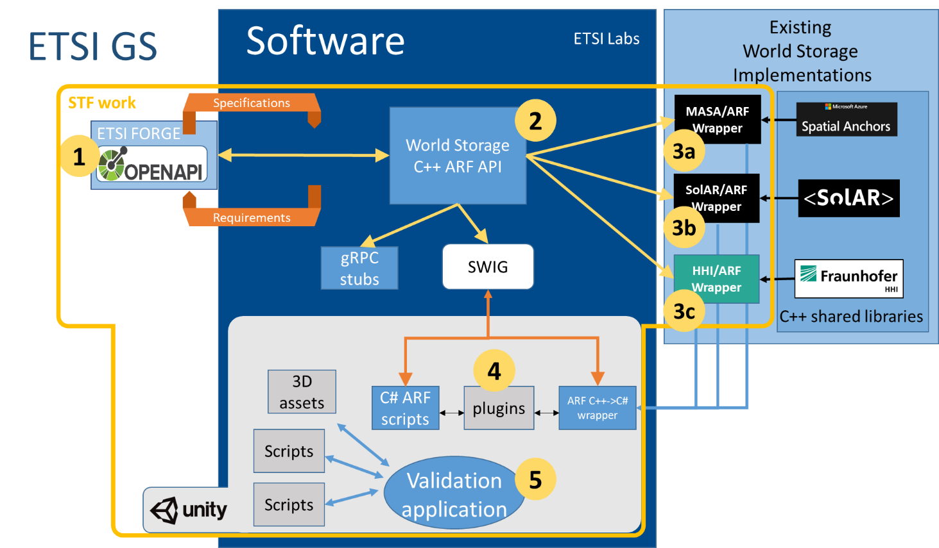

Other interested ETSI Technical Bodies
The following group may have an interest in the work of this STF but is not expected to be actively involved.

ISG ARF will handle any required liaison or communication with this group:

- ETSI ISG MEC

Other stakeholders
The following groups may have an interest in the work of this STF but are not expected to be actively involved.

ISG ARF will handle any required liaison or communication with these groups:

- 3GPP/SA4-Codec
- ISO MPEG
- W3C AR Community Group
- Khronos
- The AREA
- IEEE AR Mobile Device
- OGC
- Open AR Cloud

Part III: Execution of Work

Work plan, time scale and resources

Task description
Task 00 | Project Management
Objectives | Planning, organisation, and preparation of STF meetings  On-going reporting  Participation at ISG meetings  Delivery of the STF final report
Input | This ToR  Information from the preparatory meeting  Expertise availability information and other project management data
Output | Session planning  Materials for ISG meetings  Progress reports  Final report
Interactions | The STF leader (along with the whole STF) will interact with the ISG ARF  Communicating with other stakeholders  Code and repository management  Additional support will be provided by the ETSI secretariat
Resources required | Skills in agile project management, resource planning, reporting, and coordination

Task 01 | Definition of the World Storage API
Objectives | Define the APIs in OpenAPI format between the World Storage and AR Authoring functions at the reference points AR16 and AR17 satisfying the requirements expressed in the document “ARF Interoperability Requirements for AR components, systems and services  Part 2: World Storage and pose cluster”  Provide the definition, description, documentation and validation environment for the API.
Input | ETSI GS ARF 004-2
Output | Draft ETSI Group Specification DGS/ARF-005, with the OpenAPI definitions referenced from the ETSI Forge
Interactions | Regular exchanges with the ISG ARF, in one way to check the conformance of the specification with the requirements and conversely to possibly enrich the original requirements if necessary.
Resources required | Resource knowledgeable in OpenAPI, JSON, Swagger.  Understanding of ISG ARF reference architecture defined in GS ARF 003  Contribution from the ISG

Task 02 | Generation of the C++ API version
Objectives | Generate the C++ classes from the OpenAPI defined in Task 01
Input | OpenAPI definition resulting from Task 01
Output | C++ classes  Code generation workflow to regenerate classes on API changes.  Location: ETSI Labs
Interactions | Collaboration with the team defining the API  Collaboration with the teams implementing the Wrappers over the different World Storage implementations.
Resources required | Resource knowledgeable in OpenAPI, JSON, Swagger, C++

Task 03 | Implementation of Wrappers, one for each underlying AR solution
Objectives | Develop wrappers implementing the C++ World Storage API generated in Task 02
Input | Results from Task 02
Output | Wrappers transforming calls and data structures of the World Storage API in calls and data structures of the target AR solution (two or more of the following solutions; Azure Anchors, SolAR framework, Fraunhofer HHI framework).  Location: ETSI Labs  The libraries of the different solutions are not part of the STF deliverables and must be requested from their suppliers.
Interactions | Collaboration with the team defining the API  Collaboration with the team generating the C++ API
Resources required | Resource knowledgeable in C++, one or more of the 3 identified AR frameworks (Azure Anchors, SolAR framework, Fraunhofer HHI framework)

Task 04 | Development of a generic plugin to access the World Storage
Objectives | Creation of a plugin embedding the access to any implementation of the World Storage.  More than one plugin instance should work in the same application to be able to take benefit of various World Storage implementations at the same time.
Input | Results from Task 02 and Task 03
Output | A plugin instantiating;  on one end the API of the AR Authoring function,  and on the other end the API bridging the libraries giving access to the representation of the world in the World Storage function.  Location: ETSI Labs  The libraries of the different solutions are not part of the STF deliverables and must be requested from their suppliers.
Interactions | Collaboration with the team defining the API  Collaboration with the team generating the C++ API
Resources required | Resource knowledgeable in C++, C# Unity plugins mechanism

Task 05 | Development of a validation application
Objectives | Creation of a validation application backbone using the AR Authoring function API to author an AR scene that references world anchors and trackables created in a representation of the world implemented in one or another World Representation accessible through the plugin created in Task 04.  Instantiation of this backbone application for each World Storage implementation.
Input | Specifications of the validation application  Results from Task 04
Output | The validation application backbone.  A specific instantiation for each World Storage implementation (Indeed, the access to the World Storage at run time is still not specified, so each framework will use its own proprietary API)  Location: ETSI Labs  The libraries of the different solutions are not part of the STF deliverables and must be requested from their suppliers.
Interactions | Collaboration with the team defining the API  Collaboration with the teams implementing the Wrappers over the different World Storage implementations.  Collaboration with the team creating the generic plugin to access the World Storage
Resources required | Resource knowledgeable in C#, one or more of the 3 identified AR frameworks (Azure Anchors, SolAR framework, Fraunhofer HHI framework)

Milestones
Milestone 0 – Start of work

Milestone | Description | Cut-Off Date
M0 | Kick-off meeting | 20/09/2021
Reference Body Deliverable
ETSI Deliverable | Approved detailed planning and deliverables list

Milestone A – First draft of the OpenAPI specification available

Milestone | Description | Cut-Off Date
MA | First draft of the OpenAPI specification available | 15/12/2021
Reference Body Deliverable | First draft of the OpenAPI specification available on the ETSI Forge and accepted by ISG ARF
ETSI Deliverable | Progress Report#1 approved by ISG ARF referring to acceptance of 1st draft of the OpenAPI specification.

Milestone B – Interim versions of the generating workflow and the C++ classes defining the API

Milestone | Description | Cut-Off Date
MB | Interim versions of the generation workflow and the C++ classes defining the API | 15/02/2022
Reference Body Deliverable | Interim versions of the generation workflow and the C++ classes defining the API, available on the ETSI Labs repository
ETSI Deliverable | Progress Report#2 approved by ISG ARF referring to acceptance of the interim version of the generation workflow and the C++ classes defining the API

Milestone C – Interim versions of the wrappers and the implementation of the plugin. Validation of the specification of validation application

Milestone | Description | Cut-Off Date
MC | Interim versions of :  - the wrappers for the world storage solutions and  - the implementation of the plugin  Validation of the specification of validation application | 25/03/2022
Reference Body Deliverable | Interim versions of the wrappers for the world storage solutions and the implementation of the plugin, available on the ETSI Labs repository.  Validation of the specification of validation application
ETSI Deliverable | Progress Report#3 approved by ISG ARF referring to acceptance of the interim versions of the wrappers for the world storage solutions; the implementation of the plugin and the validation of the specification of validation application

Milestone D – Final versions of the Open API specification, the generating workflow and the C++ classes defining the API, the wrappers, the implementation of the plugin and interim version of the validation application

Milestone | Description | Cut-Off Date
MD | Final versions of:  - OpenAPI specification  - generation workflow and the C++ classes defining the API  - the wrappers for the world storage solutions  - the implementation of the plugin  Interim version of the validation application | 02/05/2022
Reference Body Deliverable | Final draft of the OpenAPI specification available on the ETSI Forge and accepted by ISG ARF  Stable draft of GS ARF 005  Final version of the generation workflow and the C++ classes defining the API, available on the ETSI Labs repository  Final version of the wrappers for the world storage solutions, available on the ETSI Labs repository  Final version of the implementation of the plugin, available on the ETSI Labs repository
ETSI Deliverable | Progress Report#4 approved by ISG ARF referring to:  - acceptance of final draft of OpenAPI specification,  - final version of the generation workflow and the C++ classes defining the API  - final version of the wrappers for the world storage solutions  - final version of the wrappers for the world storage solutions, available on the ETSI Labs repository  - interim version of the validation application  - and stable draft of GS ARF 005

Milestone E – Final version of the validation application

Milestone | Description | Cut-Off Date
ME | Final version of the validation application | 15/06/2022
Reference Body Deliverable | Final version of the validation application, available on the ETSI Labs repository
ETSI Deliverable | Progress Report#5 approved by ISG ARF referring to acceptance of final version of the validation application

Milestone F – Final draft for approval of Group Specification Final report on the STF work

Milestone | Description | Cut-Off Date
MF | Final report on the STF work | 30/06/2022
Reference Body Deliverable | Final Draft of GS ARF 005, approved by ISG ARF
ETSI Deliverable | Final Report approved by ISG ARF referring to validation of the API and ISG approval of GS ARF 005

Milestone G – Deliverables published, STF closed

Milestone | Description | Cut-Off Date
MG | Deliverables published, STF closed | 29/07/2022
Reference Body Deliverable
ETSI Deliverable

Task summary

Code | Task / Milestone | Target Date |  | Estimated Cost (EUR)
 |  | From | To
T0 | Project management | 20/09/2021 | 29/07/2022 | 5,000
M0 | Start of work | 20/09/2021
T1 | Definition of the World Storage API | 20/09/2021 | 30/06/2022 | 30,000
MA | Progress Report#1 approved by ISG ARF referring to acceptance of 1st draft of the OpenAPI specification. |  | 15/12/2021
MB | Progress Report#2 approved by ISG ARF referring to acceptance of the interim versions of the generation workflow and the C++ classes defining the API |  | 15/02/2022
T2 | Generation of the C++ API version | 15/12/2021 | 02/05/2022 | 10,000
MC | Progress Report#3 approved by ISG ARF referring to acceptance of the interim versions of the wrappers for the world storage solutions; the implementation of the plugin and the validation of the specification of validation application |  | 25/03/2022
T3 | Implementation of Wrappers, one for each underlying AR solution | 15/02/2022 | 02/05/2022 | 25,000
MD | Progress Report#4 approved by ISG ARF referring to:  - acceptance of final draft of OpenAPI specification,  - final version of the generation workflow and the C++ classes defining the API  - final version of the wrappers for the world storage solutions  - final version of the wrappers for the world storage solutions, available on the ETSI Labs repository  - interim version of the validation application  - and stable draft of GS ARF 005 |  | 02/05/2022
T4 | Development of a generic plugin to access the World Storage | 15/02/2022 | 02/05/2022 | 20,000
ME | Progress Report#5 approved by ISG ARF referring to acceptance of final version of the validation application |  | 15/06/2022
T5 | Development of a validation application | 15/02/2022 | 15/06/2022 | 10,000
MF | Final Report approved by ISG ARF referring to validation of the API and ISG approval of GS ARF 005 |  | 30/06/2022
MG | Deliverables published, STF closed |  | 29/07/2022
 |  |  |  | 100,000

 |  | 2021 |  |  |  |  | 2022
Task/ Mil. |  | S | O | N | D |  | J | F | M | A | M | J | J
T1 | Definition of the World Storage API
MA | First draft of the OpenAPI specification available
MB | Interim versions of the generating workflow and the C++ classes defining the API
T2 | Generation of the C++ API version
MC | Interim versions of the wrappers and the implementation of the plugin. Validation of the specification of validation application
T3 | Implementation of Wrappers, one for each underlying AR solution
MD | Final versions of the Open API specification, the generating workflow and the C++ classes defining the API, the wrappers, the implementation of the plugin and interim version of the validation application
T4 | Development of a generic plugin to access the World Storage
ME | Final version of the validation application
T5 | Development of a validation application
MF | Final draft for approval of Group Specification Final report on the STF work
MG | Deliverables published, STF closed

Expertise required

Team structure
(Up to) 3 participants to ensure the following mix of competences:

Priority | Qualifications and competences
High | A good understanding of ISG ARF reference architecture specified in GS ARF 003
High | A good knowledge of the existing World Storage frameworks to be wrapped through the API, i.e., Azure Anchors, SolAR, solution from Fraunhofer HHI
High | Skilled at code development in C++, C#, Unity
High | Skilled in agile project management, resource planning, reporting, and coordination
Medium | Knowledge of SWIG
Medium | Knowledge of OpenAPI, JSON, Swagger.

Part IV: STF performance evaluation criteria

Performance Indicators

Select relevant Performance indicators applicable for these ToR (X)
Contribution from ETSI Members to STF work
Support to the STF work (e.g., provision of test–beds, organization of workshops, events) | X
Number of delegates directly involved in the review of the deliverables | X
Contribution from the STF to ETSI work
Contributions to Reference Body meetings (number of documents / meetings / participants) | X
Liaison with other stakeholders
Potential interest of new members to join ETSI | X
Liaison to identify requirements and raise awareness on ETSI deliverables | X
Comments received on drafts (e.g. on WEB site, mailing lists, etc.) | X
Quality of deliverables
Approval of deliverables according to schedule | X
Respect of time scale, with reference to start/end dates in the approved ToR | X
Comments from Quality review by Reference Body | X
Comments from Quality review by ETSI Secretariat | X

Time recording
For reporting purposes, the STF experts shall fill in the time sheet provided by ETSI with the days spent for the performance of the services

During the activity, the STF Leader shall collect the relevant information, as necessary to measure the performance indicators. The result will be presented in the Final Report.

Document history
 | Date | Author | Status | Comments
1.2 | 2021-06-23 | ETSI Secretariat | Board#133 approval | Inclusion of open source licensing reference and update of project planning
1.1 | 2021-05-21 | ETSI Secretariat | Final Draft | Update before Board#133 submission
1.0 | 2021-05-11 | Patrick Harms | 1.0 | For RC approval
0.9 | 2021-05-10 | Patrick Harms | Final draft

