1 References
TWP clause 3 Operation of Industry Specification Groups
TWP clause 3.2 Creation and Termination of an Industry Specification Group
TWP Annex D 3 Requirements for an Industry Specification Group

2 Rationale
The public IPv4 address space managed by IANA (http://www.iana.org) has been completely depleted by February 1st, 2011. This creates by itself an interesting challenge when adding new things and enabling new services on the Internet. Without public IP addresses, the Internet sustainability and growth potential would be greatly reduced. For instance, most discussions about Internet of Things (IoT) have been based on the assumption that the IP address space is an unlimited resource.

The introduction of IPv6 provides enhanced features that were not tightly designed or scalable in IPv4 like IP mobility, ad hoc services, catering for the extreme scenario where IP becomes a commodity service enabling lowest cost networking deployment of large scale mobile or sensor networks, RFID, IP in the car, or any imaginable scenario where networking adds value to commodity.

IPv6 has not resonated very well with industry primarily due to the lack of the business case needed to commit investment and resources to do the upgrade, despite the fact that the address space has melted away and temporary solutions have been preferred to a clean solution with an end to end concept model.

However, the Internet has become a worldwide critical infrastructure and its upgrade is of paramount importance to keep the Internet growing; more specifically to cater for the new technologies that will adopt it such as IoT, Cloud Computing or 5G.

According to Geoff Huston, Chief Scientist of APNIC, there is not only depletion of IPv4 addresses but there is a shortfall of 800 Million globally routable IPv4 addresses just for the year 2014 to cater for the demand of address space from industry. In this case, the Internet growth is on breaks denying new entrants to join the Internet creating the digital divide or even market distortion affecting the openness of the Internet.
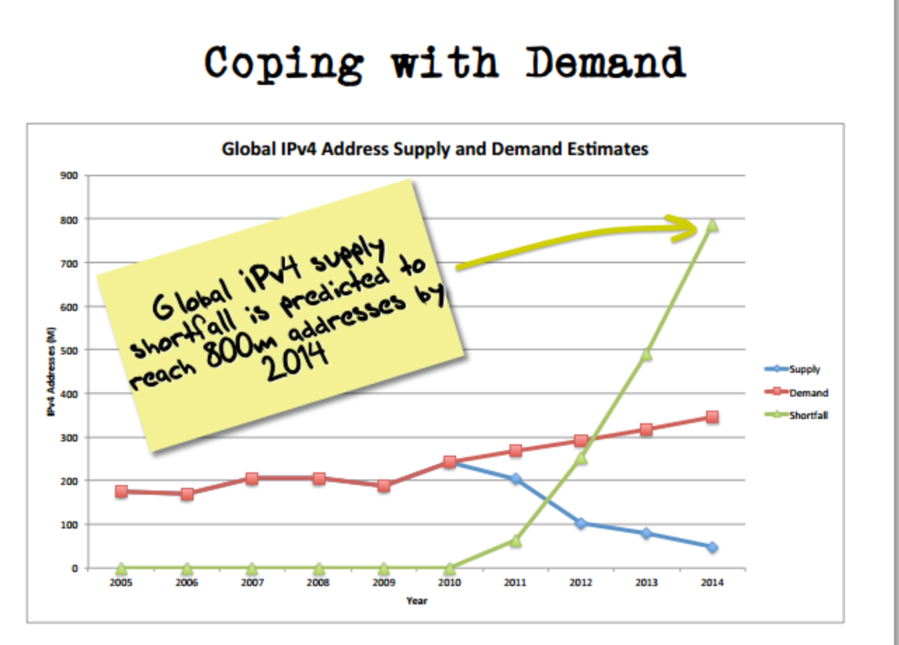
Figure 1: Geoff Huston : Coping with IP address demand for 2014

The IPv6 Deployment worldwide is becoming a reality now with some countries achieving more than 10 % user penetration with Belgium (26.68%) and Switzerland (13.74%) ranking at the top (http://labs.apnic.net/dists/v6dcc.html ) and reaching double digits v6 coverage on Google IPv6 stats. Many Autonomous Networks (ASN) reach more than 50% with v6 preferred or v6 capable penetration: (http://labs.apnic.net/ipv6-measurement/Economies/US/). Over 50 Million users are accessing Internet over IPv6 and probably without even knowing it. The US remains by far the biggest adopter of IPv6 with some 22 Million users followed by Germany, Japan and China with some 5 Million users. Worldwide IPv6 deployment has passed the 4 % Google usage bar doubling every 6 months (http://www.google.com/intl/en/ipv6/statistics.html). If this trend continues, we should achieve 50% by 2017 which would be the inflection point when the full roll-out of IPv6 becomes a strategic plumbing decision, and to decide whether it makes sense to keep running two Internet Protocols as demonstrated recently by Facebook that IPv6 should be run in the core and IPv4 can be moved to the edge.

However, this decision has been avoided so far due to strategic and resource issues (lack of top management decision-making, lack of IPv6 skilled engineers and IPv6 deployment best practices,...). The deployment of Carrier-grade NAT (Network Address Translation) is in full swing especially in the mobile world making networking and user experience more brittle. Security and cybersecurity issues are brushed over at this stage due mainly to lack of IPv6 security skills and production-grade IPv6 firewalls. New topics are more on the lime light such as Cloud Computing, Internet of Things, SDN, NFV, 5G. However, these fields are taking IP networking for granted, designing them on IPv4/NAT, thus building non-scalable and non-end to end solutions.

3 Terms of Reference for ETSI ISG IP6 [TWP D.3, Part Aa)]
In the following clauses, deviations from the applicable ETSI TWP as agreed by the members of ISG IP6 including deviations to the ETSI TWP made in the ISG Membership Agreement are stipulated.

3.1 Scope

The IP6 ISG will be used as an embryonic working group to attract and garner support from all stakeholders worldwide to join and work on pre-standardization in a neutral membership environment with infrastructure and logistics caring also for IPR issues and working procedures.

The next generation wireless efforts and new technologies are sprouting around the world in different directions with diverging views on the networking level. The outcome is not yet predictable. Therefore, interoperability harmonization and coalition efforts are needed to converge and focus the work for greater impact and exploitations for the common good.

The IP6 ISG has the ambition to define some best practices, garner support and create awareness of the impact of IPv6 on critical infrastructure in the first round and then on hot topics such as Cloud Computing, IoT, SDN/NFV and 5G, which are making abstraction of IPv6.

The IP6 ISG is a best practice working group focusing on study and definition of requirements and use cases, .

In the case of future wireless networks, the IP6 ISG will decouple its work from radio and focus on IPv4-IPv6 impact in early technical discussions, integrating new technologies with a holistic approach such as IPv6-based Software Defined Networks (SDN), Machine-to-Machine, Mobile Internet of Things, Mobile Cloud Computing and Fringe Internet, focusing on commonly agreed requirements toward the emergence of potential “IPv6 integration”.

The tasks of the IP6 ISG will be implemented in three phases:

- Phase 1:

- The IP6 ISG will select and define 3 focused scenarios where IPv6 could have real critical impact, such as:

  - Mobile networks and services
  - Critical infrastructure in the safety and emergency networks,
  - Security and privacy

- Phase 2:

- Describe and evaluate the impact of IPv6 on

- Mobile Cloud Computing and the impact of Mobile IPv6.
- Internet of Things and the impact of addressing billion devices.
- SDN and NFV and the role Ipv6 will play in the Internet Data Centers (IDCs) and the Operator networks
- Fringe Internet and the impact of scalability of the edge network.

- Phase 3:

- Coordinate with 5G researchers and attract IPv6 experts with focused and practical knowledge in 5G networking to:

- Understand the impact of IPv6 on5G radio research (5G PPP) especially in areas of spectrum efficiency and latency when using IPv6 packets.

3.2 Membership

According to TWP 3.4., membership is restricted to ETSI members and applicants for membership, who have signed the ISG agreement.

Non-members of ETSI may not become members of the ISG IP6 but may participate in the ISG IP6 according to the rules as described in clause 3.4 of the ETSI Technical Working Procedures (TWP).

The Participant shall pay to ETSI a per-meeting attendance fee amounting to €100 (excluding taxes) per delegate per meeting day.
3.3 Dues

Dues for membership and operation are fixed on an annual basis by the members, based on the costs the members anticipate to incur.

3.4 Duties and Rights of Members

Members and participants have the duty to constructively cooperate on the development of ISG Group Specifications within the scope of the ISG as described in 3.1.

Members have the right to cast their vote on the approval of a Group Specification when necessary, and in other instances when decisions by the members are required. Members have the right to appeal directly to the ETSI Board to challenge a Chairman's decision and shall inform the ISG Chairman and the ETSI Director-General beforehand.

3.5 Preparation of Group Specifications

Group specifications are prepared within the ISG or within specific working groups. Working groups are chaired by working group chairs, who are appointed according to the rules of operation of the ISG. All draft specifications must be approved by the ISG members using the decision making process detailed in the rules of operation of the ISG. If a specification is prepared in a working group and fails to be approved by the members, it is referred back to the working group.

3.6 Detailed deviations from the ETSI Technical Working Procedures (TWP)
In the following, deviations from the applicable ETSI TWP as agreed by the members of ISG IP6, including deviations to the ETSI TWP made in the ISG Membership Agreement, are stipulated.

Section 3.6 is included in these Terms of Reference only for information as the prevailing document in respect of changes to the TWP is the ISG IP6 Membership Agreement.

3.6.1 Participation in the work of the Industry Specification Group (extension of TWP 3.4)
Observers or non-members of ETSI must agree to the ISG Participant Agreement in order to be authorized to participate. The Participant Agreement will be terminated if the participant has not participated in at least 2 meeting of the ISG in a 12 months period. A revocation notice under article 9.1 (c) of the ISG Participant Agreement is sent to the participant in this case. The ISG Chairman will periodically review the participation record of authorized Participants.
In addition, access to meeting documents, mailing lists etc. will be removed from authorized Participants if they fail to participate in, or register and pay participation fees for two successive meetings. Such access will be restored upon registration for a subsequent meeting of the ISG IP6.

3.6.2 Convening an ISG meeting (TWP 3.5)

3.6.2.1 Invitation to an Industry Specification Group meeting (TWP 1.5.1)
The invitation to an Industry Specification Group meeting and the necessary logistical information shall be disseminated by the hosting organization at least 30 days before the meeting to all on the Industry Specification Group membership list (see clause 1.5.5).

The first meeting of a new Industry Specification Group will be announced in a Collective Letter, with at least 30 days notice, by the ETSI Secretariat.

3.6.2.2 Agenda for an Industry Specification Group meeting (TWP 1.5.2)
The draft agenda shall be disseminated by the responsible Chairman to all on the Industry Specification Group membership list at least 30 days before a meeting. The draft agenda shall include details of draft ETSI deliverables for approval and officials for appointment. Any other subject matters where voting may be required shall also be included and indicated in the draft agenda.

The draft agenda for the first meeting of a new Industry Specification Group will be announced in a Collective Letter, with at least 30 days notice, by the ETSI Secretariat.

3.6.2.3 Documentation for an Industry Specification Group meeting (TWP 1.5.3)
Documents shall be numbered as shown in the following example:

ETSI/IP6(nn)x_filename

This numbering system has three logical elements:
- ETSI: to indicate that it is an ETSI document;
- IP6: the name of the ISG;
- (nn): to indicate the year, e.g. (98);
- x: a unique number of the document, appended with a revision number if applicable;
filename of the document

3.6.2.4 Registration for an Industry Specification Group meeting (TWP 1.5.4)
Every Attendee shall register on arrival at each meeting. Each Attendee who represents an ETSI full or associate member shall declare the precise name of that member. An Attendee may only represent one ETSI full member or one ETSI associate member.

Each Attendee who represents a ETSI participant shall declare the precise name of that participant. An Attendee may only represent one participant.

3.6.2.5 Maintaining an Industry Specification Group membership list (TWP 1.5.5)
The IP6 Industry Specification Group shall maintain a membership list within an email exploder list established specifically for that purpose. Any individual may join this email exploder list if he/she is a representative of an ETSI member that has signed the "IP6 Industry Specification Group agreement" and has an ETSI server user account, and those who join this email exploder list will be considered as being on the Industry Specification Group membership list. Failure to reconfirm the intention to remain on the email exploder list at regular intervals (lists are normally reviewed every six months) will result in removal from this email exploder list and thus from the Industry Specification Group membership list.

The Industry Specification Group membership list shall be used for the dissemination of information and for decision making within the Industry Specification Group.

3.6.3 Decision making (TWP 1.7 and TWP 3.7)

3.6.3.1 Principles of decision making (TWP 1.7.1)
An Industry Specification Group shall endeavour to reach Consensus on all issues, including the approval of draft ETSI deliverables and the adoption of Group Specifications. If Consensus cannot be achieved, the Chairman can decide to take a vote which may be performed by a secret ballot. A vote may be conducted during an Industry Specification Group meeting or by correspondence.

Where voting is used, vote results shall be evaluated by the Chairman.

A proposal shall be deemed to be approved if 71 % of the votes cast are in favour. Abstentions or failure to submit a vote shall not be included in determining the number of votes cast.

If a proposal fails to achieve 71 %, the result shall be re-calculated using the votes of ETSI full members only. If the re-calculated result achieves 71 %, the proposal shall be deemed to be approved

For interpreting the result of an election for an official of the Industry Specification Group, a simple majority of the votes cast shall be used (see 3.6.3.1.3 below).

3.6.3.1.1 Voting during a Technical Body meeting (TWP 1.7.1.1)
The following procedures apply for voting during an ISG IP6 meeting:
- before voting, a clear definition of the issues shall be provided by the chairman;
- voting members shall only be entitled to one vote per member;
- if a voting member has more than one representative present, only one representative may vote;
- if manual voting procedures are used, each voting member may only cast the vote once;
- if electronic voting procedures are used, votes may be changed prior to the closure of the vote;
- ISG IP6 members are only eligible for voting (voting members), if they have been present during at least two out of the previous 3 meetings;
- Founding members of the ISG as identified in the ISG Agreement shall be eligible to vote during and up to the end of the first three meetings following the creation of the ISG. Thereafter they are subject to the above participation requirements as for all other members;
- voting by proxy is not permitted;
- there are no quorum requirements;
- the voting weight shall be 1 per voting member;
- the result of the vote shall be recorded in the meeting report.

3.6.3.1.2 Voting by correspondence (TWP 1.7.1.2)
The following procedures apply for voting by correspondence:
- before voting, a clear definition of the issues shall be provided by the Chairman and disseminated to all on the ISG IP6 membership list;
- the voting period shall be defined by the ISG IP6 Chairman and communicated to all on the ISG IP6 membership list;
- ISG IP6 members are only eligible for voting (voting members), if they have been present during at least two out of the previous 3 meetings;
- Founding members of the ISG as identified in the ISG Agreement shall be eligible to vote during and up to the end of the first three meetings following the creation of the ISG. Thereafter they are subject to the above participation requirements as for all other members;
- voting members shall only be entitled to one vote per member;
- electronic voting only shall be used for voting by correspondence;
- votes may be changed prior to the closure of the vote;
- the voting weight shall be 1 per voting member;
- there are no quorum requirements;
- at the end of the voting period the Chairman shall count the votes as described in clause TWP 1.7.1.2;
- the result of the vote should be disseminated to everybody on the ISG membership list within 15 days.

3.6.3.1.3 Voting for the election of a Technical Body official (TWP 1.7.1.3)
For the purpose of electing any Industry Specification Group official the procedures given in clauses 3.6.3.1, 3.6.3.1.1 and 3.6.3.1.2 shall apply.

In the case where there is more than one candidate, a secret ballot shall be used. For interpreting the result of an election for an Industry Specification Group official the following procedure shall apply:
the candidate obtaining the highest number of votes in the ballot is elected.

The Industry Specification Group Chairman shall be responsible for the voting process and shall ensure that confidentiality is maintained.

If the vote is conducted during an Industry Specification Group meeting only the final result shall be recorded in the meeting report.

If the vote is conducted by correspondence only the final result of the vote shall be disseminated.

3.6.3.2 Appealing against a Chairman's decision (TWP 1.7.2)
Any member of ETSI who is against the Chairman's ruling on a vote may submit its case to the Board for decision. In such cases the member shall also inform the Industry Specification Group Chairman.

When the Industry Specification Group Chairman has made a ruling, his decision shall be taken as the basis for future operations, unless overturned by the Board.

4 ETSI field of interest [TWP D.3, Part Ab)]
The IP6 ISG will complement and go beyond the work of 3GPP addressing the IPv6-based networking for SDN, NFV, Cloud Computing, Internet of Things, Fringe Internet.

5 Why any overlapping or complementary elements (with reference to existing work or Terms of Reference of any existing Technical Committee or Project) is regarded as desirable [TWP D.3, Part Ac)]
There is no known overlapping with any ongoing work in ETSI.

6 Time plan [TWP D.3, Part Ad)]
The first 2 years ISG IP6 meetings and conf-calls will be planned to produce ISG IP6 Group Specifications. After 2 years, ISG IP6 will make proposals on how to evolve the ISG IP6’s future activities:
- close the ISG,
- or transfer and continue the work in an existing Technical Body meaning that all ISG participants would be required to become ETSI Members and that the ISG IP6 voting rule would be changed to the ETSI Directive TC weighted vote rule,
- or create a new Technical Body (new WG in a TC, new TC, new EP or new EPP)
- or continue in ISG IP6 for an extended period with revised Terms of Reference.

7 Chairmanship [TWP D.3, Part Ae)]
Latif Ladid has accepted to stand as convenor for the first meeting. The Collective Letter announcing the first meeting will include a call for candidates for the Chairmanship. If it is not possible to appoint a permanent Chairman at the first meeting then the meeting shall appoint a convenor for the second meeting.

8 Resource requirements [TWP D.3, Part Af)]
No resource requirements, beyond the "basic administrative support" provided by the ETSI Secretariat to ISGs, have been identified. Further resource requirements may be identified from time to time by the ISG members, who will decide on the funding arrangements as required.

9 ETSI Secretariat resources [TWP D.3, Part Ag)]
“Basic administrative support” will be provided by the ETSI Secretariat, e.g. :

- info/meeting/document handling area on the ETSI Portal.
- document storage area on the ETSI DOCBOX server.
- e-mail lists provision
- entry of the Work Items into the WPM database (provided by ESP).
- processing/publication of ETSI Deliverables (providing they have respected the ETSI Drafting Rules).
- a support officer will be allocated to provide guidance and assistance to the ISG.

Support for meetings will be provided when the meeting is held at the ETSI Headquarters, e.g.:
- meeting rooms in ETSI premises.
- meeting support for invitations, badges, etc in ETSI premises.
- tea/coffee in ETSI premises.

Meetings held outside of the ETSI Headquarters shall be supported by the hosting member organization.

10 ISG membership agreement [TWP D.3, Part Ah)]
See the ISG IP6 Agreements (Member Agreement, Participant Agreement).

11 ETSI full and/or associate members having declared their willingness to provide resources [TWP D.3, Part Ba)]
The following members have indicated that they are willing to support the ISG IP6:
- SnT University of Luxembourg
- Cisco Systems Belgium
- University of Athens
- Cosmote S.A.

12 Planned deliverables and their delivery dates shall be identified [TWP D.3, Part Bb)]
At the point of writing this proposal no specific deliverables have been planned.

13 Internal organization [TWP D.3, Part Bc)]
No internal organization or Working Groups have yet been identified. This will depend on the results of the initial work of the ISG.

14 Any committee/project-external ETSI resources required (i.e. outside those provided by the Industry Specification Group participants) shall be specified [TWP D.3, Part Bd)]
No additional resources such as experts or Special Task Forces have yet been identified. This will depend on the results of the initial work of the ISG IP6.

15 Maintenance arrangements for deliverables shall be specified [TWP D.3, Part Be)]
The maintenance of any deliverables will be assured by the ISG IP6. At the end of the work the ISG IP6 shall define the follow-on responsibility for any required maintenance.

16 The relationship with ETSI Technical Organisation shall be specified (i.e. list the interfaces between the ISG and ETSI TBs) [TWP D.3, Part Bf)]
- 3GPP
- ETSI NTECH/AFI
- ETSI NFV
- ETSI TC Cable
- IEEE COMSOC 5G MWI
- IEEE COMSOC IOT
- IEEE COMSOC SDN-NFV
- IETF
- IPv6 Forum
- Other relationships might be established according to needs.

