ETSI System Reference documents (SRdocs) overview
2025/10/02

Contents
Contents 1
1. ETSI System Reference documents (SRdocs) 1
1.1. Introduction 1
1.2. SRdocs recently published (from January 2024 onwards) 1
1.3. System reference documents in drafting stage before ERM#87 (October 2025) 3
2. ETSI SRdocs in ECO EFIS 3

ETSI System Reference documents (SRdocs)

Introduction
A System Reference document (SRdoc) is drafted by an ETSI member or by an ETSI Technical Committee using the guidance for drafting a SRdoc in EG 201 788.
An SRdoc is usually produced in support of any new system, service or application, in particular when a change of the present frequency designation / utilization within the EU or the CEPT or a change in the present regulatory framework for the proposed band(s) regarding either wanted or unwanted emissions is needed.
SRdocs can also be prepared in order to help users understanding the concepts relating to a particular standard, even in cases where an SRdoc would not be required for frequency coordination purposes.

SRdocs recently published (from January 2024 onwards)
IDENTIFICATION | TITLE (Formal & Working) | STATUS
Doc. Nb. TR 104 078 Ver. 1.1.1  Ref. DTR/ERM-630  Technical Body: ERM  Details and Download | System Reference document (SRdoc); Short Range Devices;  Radar equipment operating in 57 GHz to 64 GHz and 76 GHz to 77 GHz for applications on drones  SRdoc - ERM TGUWB - 57-64 GHz & 76-77GHz radar at drones | Published  Current Status:  Publication (2025-06-20)
Doc. Nb. TR 104 052 Ver. 1.1.1  Ref. DTR/ERM-629  Technical Body: ERM  Details and Download | System Reference document (SRdoc);  Short Range Devices; Radar equipment operating in the 76 GHz to 77 GHz range; additional applications  SRdoc - ERM TGUWB - 76-77 GHz additional applications | Published  Current Status:  Deliverable published  (2025-06-20)
Doc. Nb. TR 104 096 Ver. 1.1.1  Ref. DTR/ERM-632  Technical Body: ERM  Details and Download | System Reference document (SRdoc);  Short Range Devices;  Vehicular applications operating in 300 GHz to 400 GHz and 600 GHz to 700 GHz ranges  SRdoc - ERM TGUWB - Terahertz sensing for imaging, detection and ranging 300-400 GHz & 600-700 GHz | Published  Current Status:  Publication (2025-06-12)
Doc. Nb. TR 103 862 Ver. 1.1.1  Ref. DTR/ERM-612  Technical Body: ERM  Details and Download | System Reference document (SRdoc);  Short Range Devices (SRD) using Ultra Wide Band (UWB);  Technical characteristics for UWB operation of fixed infrastructure based indoor localization systems in the frequency band between 4,2 GHz to 4,8 GHz  SRdoc - ERM TGUWB- UWB infrastructure-based localization within 4,2 GHz - 4,8 GHz | Published  Current Status:  Publication (2024-02-15)
Doc. Nb. TR 103 943 Ver. 1.1.1  Ref. DTR/ERM-603  Technical Body: ERM  Details and Download | System Reference document (SRdoc);  DECT-2020 NR technology operating in frequency bands below 6 GHz  SRdoc - TC DECT - DECT-2020 NR < 6 GHz | Published  Current Status:  Publication (2024-01-26)
Doc. Nb. TR 103 728 Ver. 1.1.1  Ref. DTR/ERM-591  Technical Body: ERM  Details and Download | System Reference document (SRdoc); Transmission characteristics;  Technical characteristics for SRD radiodetermination systems for industry automation in shielded environments (RDI-S) within the frequency range 260 GHz to 1 000 GHz  SRdoc - ERM TGUWB - RDI-S applications | Published  Current Status:  Publication (2024-01-22)

System reference documents in drafting stage before ERM#87 (October 2025)
IDENTIFICATION | TITLE (Formal & Working) | STATUS
Deliverable Type: TR  Ref. DTR/ERM-637  Technical Body: ERM | ERM System Reference document (SRdoc); Short Range Devices (SRD) using Ultra Wide Band (UWB);  Technical characteristics and spectrum requirements for  Ground Based Synthetic Aperture Radars within 32 GHz – 35 GHz tuning range  GBSAT in 32 - 35GHz | Drafting Stage  Current Status:  Work item adopted (2025-09-29)  Next Status:  Start of work (2025-10-06)

ETSI SRdocs in ECO EFIS
Detailed information on the allocations and applications already in the European Common Allocation (ECA) table in the frequency bands targeted through the SRdocs can be found by using the 'Spectrum Inventory' application at ECO Frequency Information System (cept.org).
Choose 'document type' as 'ETSI Draft SRdoc' or 'ETSI SRdoc' and 'Frequency Table' as 'ECA'. Press 'Search'. A list of the (draft) SRdocs will appear.
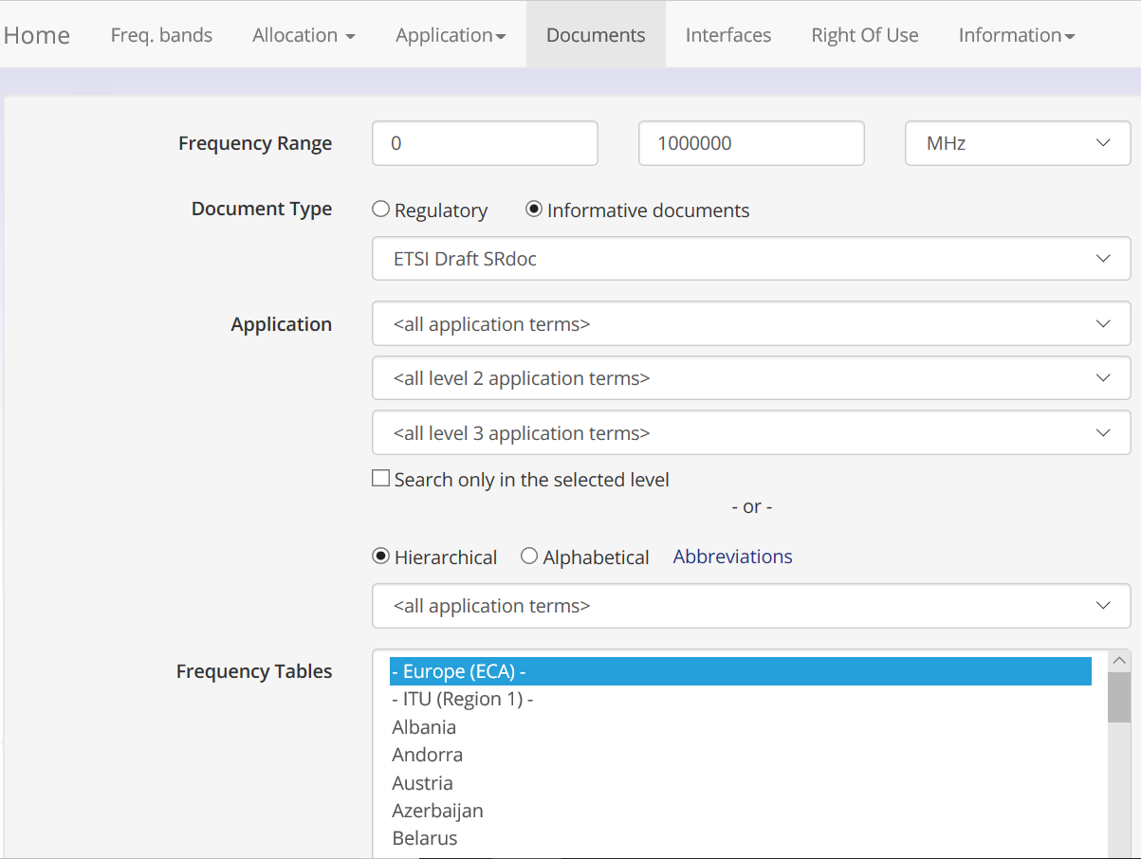
Click on the icons for more information on allocations and applications.
