ToR TTF T041 (TC INT)
Version: 0.5
Author: TC INT – Date: 2022-06-06
Last updated by: ETSI Secretariat – Date: 2024-04-24
page 1 of 15

Terms of Reference –Testing Task Force Proposal
TTF T041 (Ref. Body TC INT)
“Conformance Test Specifications for the 5G NAS protocol over the N1 reference point”

Summary information
Approval status | Approved by TC INT#55 |  | YES
Reference Body | Ref. Body TC INT
ETSI Funding | Maximum budget :ETSI FWP :  Phase I running under TTF T033  Phase II 56 500€ manpower cost 2 000€ travel cost
Minimum of 4 ETSI Members Support | YES
Time scale | From | Phase I: 2023-06-01 Phase II: 2024-06-17
 | To | Phase I: 2024-03-15 Phase II: 2025-04-30
Work Items | Phase II  - DTS/INT-00200 (TS 103 921-1)  5G NAS Conformance Testing for the N1 interface  Part 1: Protocol Implementation Conformance Statement (PICS)  - DTS/INT-00201 (TS 103 921-2)  5G NAS Conformance Testing for the N1 interface  Part 2: Test Suite Structure (TSS) and Test Purposes (TP)  - DTS/INT-00202 (TS 103 921-3)  5G NAS Conformance Testing for the N1 interface  Part 3: Abstract Test Suite (ATS) and partial Protocol Implementation eXtra Information for Testing (PIXIT) proforma specification
TTF Roadmap reference | 2024 for Phase II

Part I –TTF Technical Proposal

Rationale & Objectives

Rationale
Access and Mobility Management Functionality (AMF) is the key control-node for the 5G access-network. AMF main responsibilities are:
- Registration Management which allows registration and de-registration of UEs within 5G systems.
- Connection Management which establishes and releases the control plane signalling connections between UE and AMF over the N1 interface.
- Reachability Management which ensures that UE is always reachable. In case the UE is in idle state Paging is used to bring UE into the connected mode.
- Mobility Management maintains knowledge of UE’s location within the network. The UE is required to trigger periodic registration updates after it has completed initial registration. These periodic updates act as keep-alive to verify that the UE remains on the system and has not moved out of coverage or became unavailable. The UE is also required to complete updates due to mobility. These updates are triggered if UE moves outside the current registration area.

AMF connects via the N2 interface with an gNodeB using the NGAP protocol as defined in ETSI TS 138 413.
The 5G Non Access Stratum (NAS) signalling from the UE also terminates at the AMF. The 5G NAS protocol is defined in ETSI TS 124 501 and forms the highest stratum of the control plane between a UE and the AMF. 5G NAS protocols support the mobility of the UE and the session management procedures to establish and maintain IP connectivity. 5G NAS messages are transported between the gNodeB and the AMF encapsulated in NGAP messages and are transparent for the gNodeB.

The network architecture is described in figure 1 below.

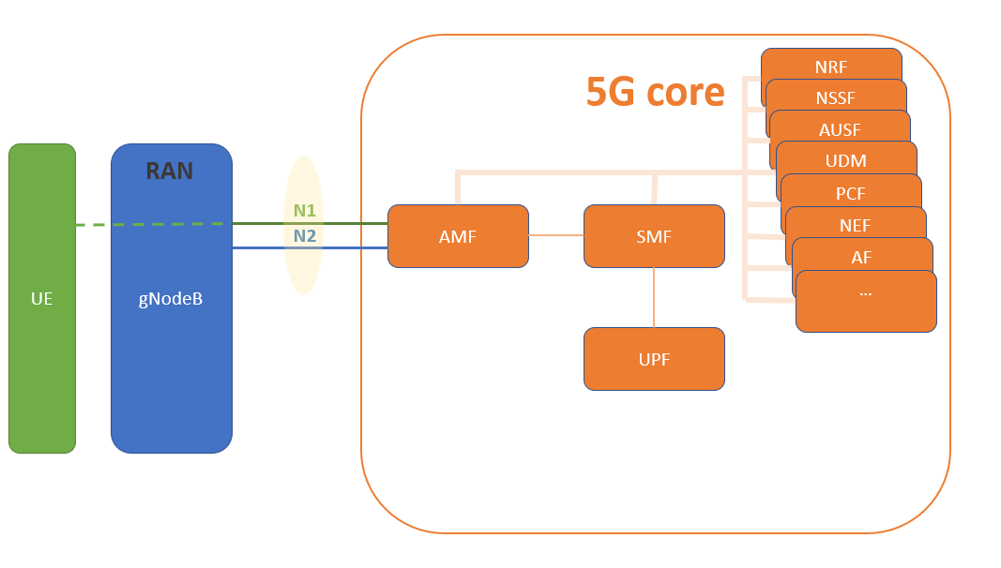
Figure 1: 5G network architecture.

Objectives of the work to be executed
Recently major efforts have been made by 5G core network component providers to inter-connect complete networks, i.e. connecting the single components that comprise a 5G core network of different operators to allow seamless roaming for end customers and complete and reliable functionality for network providers. The N2 interface is a very important point for testing as it typically connects the radio components of one vendor to the AMF of another vendor making flawless interworking of those components essential to the functioning of the network. Beside 5G the N2 interface is also of high importance for local small cell networks and new technologies such as M2M, IoT, ITS, MCX communications, etc. which will be parts of different 5G slice networks.

Following the methodologies developed and used by ETSI this implies the production of multi-part conformance test specification documents covering both the static conformance review (PICS proforma) and the dynamic conformance review (Test Purposes, Abstract Test Suite). The result would be a complete set of test suites for both the NGAP and the 5G NAS protocols.

Note: For the NGAP protocol tests will be written for testing both the AMF and the gNodeB. For the 5G NAS protocol only the AMF will act as Implementation Under Test (IUT) as the 5G NAS messages are transparent to the gNodeB. Testing the UE is out of the scope of TC INT.
ETSI members have expressed their interest in test specifications related to the NGAP and 5G NAS protocols as defined in ETSI TS 138 413 and ETSI TS 124 501 and also declared their willingness to review the outputs of this TTF and in a later stage in a potential follow-up project provide ETSI with the possibility to validate the outputs of this TTF against their network components (i.e. gNodeB and AMF). See also list of supporting organisations.

Experience with the development of other testing standards has shown that involvement of experts on conformance testing of protocols requires highly specialised knowledge in testing methodology, TTCN-3 language and dedicated tools. There is an advantage if testing experts are disjoint from experts developing the protocol specifications. In addition, the development of this kind of specifications requires significant effort and it cannot be expected that this effort can be provided on a voluntary basis. Hence the involvement of testing experts is needed in order to assure timely completion and high quality of the Test Specifications. These testing experts are not available on TC INT level and need to be recruited on a funded basis. The experts will use dedicated software tools available at ETSI.

NOTE: Security aspects on the N1 and N2 interfaces are out of scope of the above described conformance test specifications. However, an implementor of the test specification needs to consider those aspects to create an executable test software allowing for monitorable message exchanges. A validation phase covering such an implementation may follow the specification project.

Current funded activities in the same domain
TTF T033 – Conformance Test Specifications for the 5G NGAP protocol over the N2 reference point, 101 250€

Consequences if not agreed
5G core networks are currently being deployed in telecoms networks during the progression towards fully 5G compliant network architectures. Thorough conformance testing will increase the level of confidence that equipment from various suppliers will interwork. This in turn will reduce implementation and rollout times. Not providing timely test specifications, would ultimately delay the deployment of 5G core networks.

ETSI Members Support

# | ETSI Member | Supporting delegate
1 | Telecom Italia | Giulio Maggiore
2 | Orange France | Radier Benoit
3 | Fraunhofer Fokus | Axel Rennoch/Marius Corici
4 | University of Gottingen | Dieter Hogrefe
5 | Huawei | Fabio Faoro
6 | S&T Iskratel | Urban Zaletel

Deliverables

Base documents
Document | Title | Current Status
ETSI TS 138 413 (V16.2.0) | NG Application Protocol (NGAP) | Published
ETSI TS 124 501  (V16.6.0) | Non-Access-Stratum (NAS) protocol for 5G System (5GS) | Published
ETSI TS 123 501  (V16.5.0) | System architecture for the 5G System (5GS) | Published
ETSI TS 123 502  (V16.7.0) | Procedures for the 5G System (5GS) | Published
Table 1: Base documents

New deliverables
Working titles sufficient for both phases. Complete with full WI reference when final ToR are submitted
Deliv. | Work Item code  Standard number | Working title | Expected date for publication
Phase II:
D4 | DTS/INT-00200  ETSI TS 103 921-1 | 5G NAS Conformance Testing for the N1 interface  Part 1: Protocol Implementation Conformance Statement (PICS) | 30.04.2025
D5 | DTS/INT-00201  ETSI TS 103 921-2 | 5G NAS Conformance Testing for the N1 interface  Part 2: Test Suite Structure (TSS) and Test Purposes (TP) | 30.04.2025
D6 | DTS/INT-00202-3  ETSI TS 103 921-3 | 5G NAS Conformance Testing for the N1 interface  Part 3: Abstract Test Suite (ATS) and partial Protocol Implementation eXtra Information for Testing (PIXIT) proforma specification | 30.04.2025

Maximum budget

Task summary/Manpower Budget

Task short description | Budget (EUR)
Phase II:
Project Management | 4 000
5G NAS PICS | 7 500
5G NAS TSS&TP | 15 000
5G NAS ATS&PIXITS | 30 000
TOTAL | 56 500

Travel budget
Expected travels | Cost estimate
Phase II:
Travel to two INT meetings | 2 000€
Total cost | 2 000€

Other budget line
None

Part II – Details on TTF Technical Proposal

Tasks, Technical Bodies and other stakeholders

Organization of the work

Phase II: 5G NAS Conformance Testing for the N1 interface
The work of the TTF starts with the analysis of the NAS protocol requirements defined in ETSI TS 124 501 on the gNodeB and the AMF. After this analysis will follow the three-step methodology defined in the ISO/IEC 9646 series on conformance test specifications.
- Static aspects of the requirements will be converted into PICS items, i.e. into questions demanding whether a requirement is supported or not. One set of PICS items will be created for the AMF.
- Requirements on the dynamic behaviour will lead to test purposes, i.e. textual descriptions of the expected behaviour of the IUT (AMF). One set of test purposes for AMF will be the resulting output of the TTF.
- The majority of the work will lie in the coding of the dynamic behaviour into test cases using the formal notation TTCN-3 and the production of the PIXIT proforma which contains questions related to the practical aspects of testing.

A feedback loop will be installed to process findings of the later steps into the outputs of the earlier steps. Once the TTCN-3 code and the related PIXIT proforma have been completed phase II of the TTF can be launched.

TC INT will act as the steering committee for all TTF activities and will also inform all identified interested bodies via liaison statements at regular intervals.

An administration task will be maintained handling the progress reports of the TTF and the representation at the TC INT meetings during the lifetime of phase II.

Other interested ETSI Technical Bodies
- 3GPP CT1
- 3GPP CT3
- 3GPP SA3
- ETSI TC MTS

Other stakeholders
- GSMA NG

Part III: Execution of Work

Work plan, time scale and resources

Task description
Task #II.0 | Phase II: Project Management – 5G NAS
Objectives | Provision of progress reports for the TC INT meetings #59 through to #60. Presentation of reports and TTF outputs during said meetings. Scheduling of common sessions, administration of TTF resources.  Processing of feedback comments received from the stakeholders.  The TTF leader will perform all actions required by this task.
Input | None
Output | One TTF progress reports and one final report.
Interactions | Presence at all TC INT meetings during the TTF’s lifetime.
Resources required | Costs: 4 000 EUR

Task #II.1 | PICS – 5G NAS
Objectives | Creation of a PICS document for ETSI TS 124 501 containing one PICS proforma for AMF static conformance review.
Input | ETSI TS 124 501
Output | DTS/INT-00200  ETSI TS 103 921-1
Interactions | Presentation of a stable draft at INT#59 (Nov 2024) and a final draft for approval at INT#60 (Mar 2025).
Resources required | Costs: 7 500 EUR

Task #II.2 | TSS&TP – 5G NAS
Objectives | Creation of an NAS TSS&TP document for ETSI TS 124 501 containing set of test purposes covering all dynamic requirements for AMF for the dynamic conformance review.
Input | ETSI TS 124 501
Output | DTS/INT-00201  ETSI TS 103 921-2
Interactions | Presentation of a stable draft at INT#59 (Nov 2024) and a final draft for approval at INT#60 (Mar 2025).
Resources required | Costs: 15 000 EUR

Task #II.3 | ATS&PIXIT – 5G NAS
Objectives | Implementation of all test purposes defined in DTS/INT-00201 into TTCN-3 code and production of PIXIT proforma for AMF.  :  4.1. Definition of specific test configurations  a) Schematic  b) In TTCN-3  4.2. Types, Templates  4.3. Development of end-to-end test functions  4.4. Implementation of test cases based on Task II.1  4.5. Production of PIXIT tables
Input | DTS/INT-00201  ETSI TS 103 921-2
Output | DTS/INT-00202  ETSI TS 103 921-3
Interactions | Presentation of an early draft at INT#59 (Nov 2024) and a final draft for approval at INT#60 (Mar 2025).
Resources required | Costs: 30 000 EUR

Milestones
Milestone A – Phase II: Approval of progress report A
Milestone | Description | Cut-Off Date
A | Approval of progress report A. | 2024-09
Reference Body Deliverable | Presentation of an early draft of D4 and D5 and skeleton draft of D6.
ETSI Deliverable | Approval of progress report E by INT RC and upload of existing drafts to INT Drafts portal.

Milestone B– Phase II: Approval of progress report B
Milestone | Description | Cut-Off Date
B | Approval of progress report B. | 2024-11
Reference Body Deliverable | Presentation of a stable draft of D4 and D5 and early draft of D6.
ETSI Deliverable | Presentation of progress report for approval at INT#59 (Nov 2024).

Milestone C – Phase II: Approval of Deliverables D4, D5 and D6, and final report C
Milestone | Description | Cut-Off Date
C | Approval of final report C. | 2025-03
Reference Body Deliverable | Presentation of a final drafts D4, D5 and D6 for approval.
ETSI Deliverable | Presentation of final report for approval at INT#60 (Mar 2025).

Milestone D – Deliverables published, TTF closed
Milestone | Description | Cut-Off Date
D | Deliverables D4, D5 and D6 published, TTF closed. | 2025-04
Reference Body Deliverable | Final Draft for approval of D4, D5 and D6. Final Drafts have to be made available at least two weeks before the start of INT#59.
ETSI Deliverable | None

Task summary
Code | Task / Milestone | Target Date |  | Estimated Cost (EUR)
 |  | From | To
 | Start of work | Jul 2024
T II.0 | Project Management – 5G NAS | Jul 2024 | Mar 2025 | 4 000
T II.1 | 5G NAS Conformance Testing for the N1 interface  Part 1: PICS | Jul 2024 | Mar 2025 | 7 500
T II.2 | 5G NAS Conformance Testing for the N1 interface  Part 2: TSS&TP | Jul 2024 | Mar 2025 | 15 000
M A | D4 and D5 early drafts and D6 skeleton draft available at INT portal  Progress Report A to be approved by RC |  | Sep 2024
M B | D4 and D5 stable drafts and D6 early draft available  Progress Report B to be approved at TC INT#58 |  | Nov 2024
T II.3 | 5G NAS Conformance Testing for the N1 interface  Part 3: ATS&PIXITS | Nov 2024 | Mar 2025 | 30 000
M C | D4, D5 and D6 final drafts available  Final Report C to be approved at TC INT#59 |  | Mar 2025
M D | D4, D5 and D6 publication |  | Apr 2025
 |  |  |  | 56 500

Task/ Mil. | 2024 |  |  |  |  |  |  |  |  |  |  |  |  | 2025
Task/ Mil. | J | F | M | A | M | J | J | A | S | O | N | D |  | J | F | M | A | M | J | J | A | S | O | N | D
II.T0
II.T1
II.T2
MA |  |  |  |  |  |  |  |  | X
II.T3
MB |  |  |  |  |  |  |  |  |  |  | X
MC |  |  |  |  |  |  |  |  |  |  |  |  |  |  |  | X
MD |  |  |  |  |  |  |  |  |  |  |  |  |  |  |  |  | X

Expertise required

Team structure
The following experts are required to perform the work. The actual number of experts and mix of skills may depend on the actual applications received and will be decided when setting up the TTF.

Number of experts required: 2 – 3

Priority | Qualifications and competences
High | Expert knowledge of 5G NAS protocols and 5G core architecture
High | Experience in analyzing of protocols and writing of PICS proforma
High | Experience in analyzing of protocols and writing of test purposes in TDL-TO
High | Expert knowledge in implementing Abstract Test Suites in TTCN-3
High | Expertise in conformance testing

Part IV: TTF performance evaluation criteria

Performance Indicators

Select relevant Performance indicators applicable for these ToR (X)
Contribution from ETSI Members to TTF work
Steering Group meetings (number of meetings / participants / duration) | X
Number of delegates directly involved in the review of the deliverables | X
Contributions/comments received from the Reference Bodies | X
Contribution from the TTF to ETSI work
Contributions to Reference Body meetings (number of documents / meetings / participants) | X
Quality of deliverables
Approval of deliverables according to schedule | X
Respect of time scale, with reference to start/end dates in the approved ToR | X
Comments from Quality review by Reference Body | X
Comments from Quality review by ETSI Secretariat | X

Document history
 | Date | Author | Status | Comments
0.3 | 2024-04-09 | TC INT | Approved by TC INT
0.4 | 2024-04-15 | ETSI Secretariat | Final | Update before ETSI internal kick off meeting
0.5 | 2024-04-24 | ETSI Secretariat | Final | Update before CL publication

