CISE data model - 101099627

Technical Description (Part B)

(SMP STAND Standard)

Version 1.2
17 August 2022

PROJECT FACT SHEET
STF 637
Reference Body | ISG CDM
EC/EFTA Funding | Manpower | 358 685,60€
 | Travels | 14 000,00€
 | Equipment | 27 000,00€
 | Total budget | 399 685,60€
Project Duration | 18 months
WP1 STF Project Management and coordination | T0 | Project Management and coordination | 38 430,60€
WP2 Development of the conformance test specifications for CDM | T1 | Selection of most notable features from base standards and ETSI CDM 006 recommendations, Extraction of requirements | 38 430,60€
 | T2 | Development of the Test Purposes and the TTCN-3 code of Test Cases. | 102 481,60€
WP3: Design, development and commissioning of the Testing Platform | T3 | Platform development | 25 620,40€
 | T4 | Tenant configuration | 25 620,40€
WP4: Validation of test suite | T5 | Testing alignment | 12 810,20€
 | T6 | Test suite validation, | 25 620,40€
 | T7 | Testing Platform Assessment | 12 810,20€
WP5: Inputs to normative documents | T8 | Specification alignment | 38 430,60€
 | T9 | Specification extension and updates | 38 430,60€

TECHNICAL DESCRIPTION (PART B)

HISTORY OF CHANGES
VERSION | PUBLICATION DATE | CHANGE
1.0 | 17.08.2022 | Part B for EISMEA Portal and Grant Agreement preparation  The duration of WPs has been changed in the Timetable to be consistent with the due month of the deliverables  Change of WP2 duration from M04 to M18 (instead of M04 to M16)  Change of WP4 duration from M03 to M18 (instead of M03 to M16)  Change of WP5 duration from M02 to M18 (instead of M02 to M16)
1.2 | 26.09.2022 | Deliverables linked to WPM / Split of the budget per tasks and per WPs  Update before CL publication

TABLE OF CONTENTS
PROJECT FACT SHEET 2
TECHNICAL DESCRIPTION (PART B) 3
1. RELEVANCE 4
1.1 Background and general objectives 4
1.2 Needs analysis and specific objectives 6
1.3 Complementarity with other actions and innovation 8
2. QUALITY 9
2.1 Concept and methodology 9
2.2 Consortium set-up 10
2.3 Project teams, staff and experts 10
2.4 Consortium management and decision-making 11
2.5 Project management, quality assurance and monitoring and evaluation strategy 11
2.6 Cost effectiveness and financial management 13
3. IMPACT 14
3.1 Impact and ambition 14
3.2 Communication, dissemination and visibility 15
3.3 Sustainability and continuation 16
4. WORKPLAN, WORK PACKAGES, ACTIVITIES, RESOURCES AND TIMING 17
4.1 Work plan 17
4.2 Work packages, activities, resources and timing 18
Work Package 1 18
Work Package 2 21
Work Package 3 23
Work Package 4 25
Work Package 5 27
Overview of Work Packages 31
Total Project costs 32
Subcontracting 33
Timetable 34
5. OTHER 35
5.1 Ethics 35
5.2 Security 35
6. DECLARATIONS 35

1. RELEVANCE

1.1 Background and general objectives
The Common Information Sharing Environment CISE was initiated by the Commission as a vision to enable cross-sectoral and cross-border information exchange amongst all European authorities with competences at sea in order to improve overall maritime situational awareness across European waters to ensure safer, more secure and cleaner seas, and thus to promote the European Blue Economy. The CISE Roadmap, published in 2010, started a series of EU- funded projects (e.g. BlueMassMed, CoopP, EUCISE2020) to develop a technical solution for such an information exchange. During EUCISE2020, involving 39 partners from 15 European countries, this solution, centred around the CISE Data and Service Model, was tested in a prototype environment involving 11 CISE nodes in 8 MS, connecting and exchanging information from 20 sectoral legacy systems.

Following the successful test bed trials of EUCISE2020, the CISE Transitional Phase started in May 2019 to prepare the ground to further develop CISE into an operational system by 2023.
In this phase, coordinated by EMSA, the CISE Stakeholder Group will build on the results and achievements from the EUCISE2020 project to release the first operational CISE network.
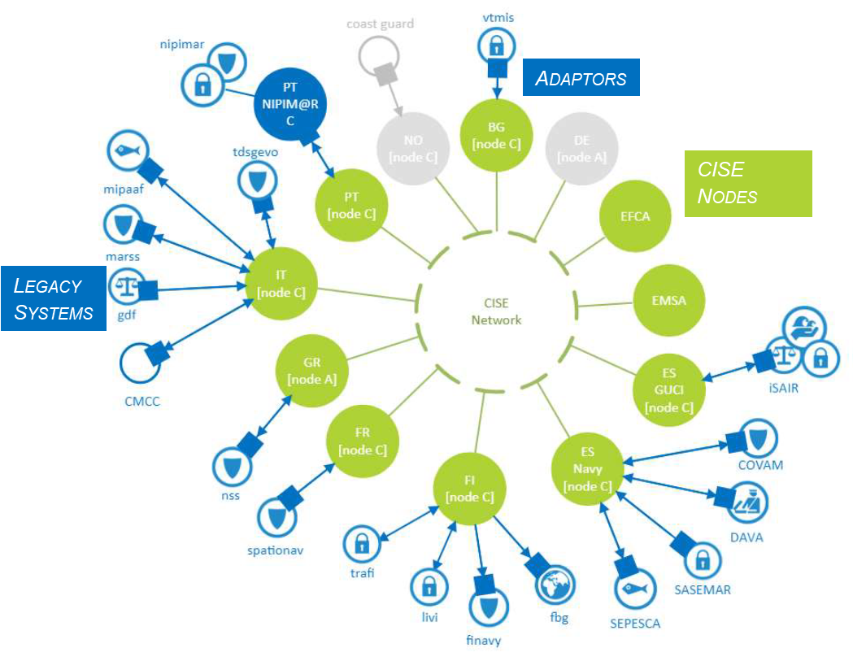
Figure 1: The CISE pre-operational network (as of October 2021).

At the time being 25 legacy systems from 12 Member States and EU agencies have been connected in a pre-operational CISE network implementation.
The technical standardisation was originally addressed both in Section II.10 of the EUCISE2020 Grant Agreement and as a requirement in the Description of Work of EUCISE2020: «Define new technical standards for the components of CISE, including the protocol stack, the semantic and data model specifications, the core and common services»
With the unanimous support of the EUCISE2020 Consortium and the Commission, the Industry Specifications Group “CISE Service and Data Model” (ISG CDM) was founded at ETSI identified as the most appropriate European standardisation institution.
The work of the ISG CDM, through the standardisation of the CISE Service Data Model, enables User Communities, Member States, Public Authorities, and EU Agencies to facilitate information exchange between all parties, and also to promote the European Maritime Security Strategy.
The goal of ISG CDM is therefore to provide a data and service model that may serve as reference for cross-sectoral and cross-border information exchange between European public authorities.
The activities of ISG CDM address the following:
- Network and Secure Communication (communication between Adaptors, Gateway and Nodes);
- Application Security (identification, authentication and authorisation of the users across the network, managing access to secured resources maintained at a service provider);
- Auditing (to perform analysis on events through logging, monitoring and accounting services);
- Collaborative tools (multimedia and auxiliary tools provided to facilitate the communications and work among the users);
- Data Model versioning;
- Service Provider component;
- Consumer component;
- Testing and validation.

ETSI ISG CDM has developed a set of specifications to be used for the implementation of a CISE instance (i.e., a node or an adaptor). Moreover, the ISG CDM has addressed for the first time the topic of validating the implementation of a CISE instance (i.e., a node or an adaptor) complying with CDM standards and capable of interoperating with other CISE instances implemented independently.
The CISE-TP project aims at the realisation of the needs identified and published so far at the regulatory and technical levels.
A very strong consideration is indeed devoted to CISE from the EU institutions. The Rolling Plan for ICT Standardization 2022 details that the technical specifications developed within Standard Setting Organizations, like those carried on within the ‘European Common information sharing environment service and Data Model’ (CDM) Industrial Standardization Group at ETSI, encourages Member States to invest more resources in the exchange of Maritime Surveillance information across Europe (allowing data exchange among different legacy systems in a cooperative network).
The activity hereby proposed is in response to ACTION 1 and ACTION 2 of the draft Rolling Plan for ICT standardisation 2022 part “COMMON INFORMATION SHARING ENVIRONMENT (CISE) FOR THE EU MARITIME DOMAIN” (Section 3.4.9):

Action 1: “Based on the existing CISE data and service model, complete semantic and technical interoperability specifications to exchange surveillance information between competent authorities could be standardised.”
Action 2: “The complementary actions could be developed in addition to the standardisation action:
- Development of a reference implementation of the CISE software components to facilitate the adoption of CISE by interested authorities.
- Development of a testing platform to assess whether the CISE interface developed by the national authorities complies with the standardised specifications. These activities will have to take into account future developments to extend the CISE components to other domains such as Land Border Control.
- Development of template service level agreement or memorandum of understanding for the future agreements on sharing information between Member States”

The proposed action is also aligned with the following:
- Council of the European Union: Conclusions on maritime security, adopted on 22 June 2021.
- Council of the European Union: Conclusions on sustainable blue economy: health, knowledge, prosperity, social equity adopted on 26 May 2021
- The Commission Communication on a new approach for a sustainable blue economy of 17 May2021
- Council of the European Union: Conclusion on the revision of the European Union Maritime Security Strategy (EUMSS) – Action Plan adopted on 26 June 2018 - 10494/14
- Council of the European Union: Council conclusions on Global Maritime Security (19 June 2017 - 10238/17)
- Council of the European Union: European Union Maritime Security Strategy (EUMSS) – Action Plan adopted on 16 December 2014 - 17002/14 (COM/2014/0451 final) Communication from the Commission to the European Parliament and the Council Better situational awareness by enhanced cooperation across maritime surveillance authorities: next steps within the Common Information Sharing Environment for the EU maritime domain
- Commission Staff Working Document: ‘Impact Assessment accompanying the communication from the Commission to the European Parliament and the Council Better situational awareness by enhanced cooperation across maritime surveillance authorities: next steps within the Common Information Sharing Environment for the EU maritime domain’ (SWD/2014/0225 final)
- Council conclusions Towards the integration of maritime surveillance: A common information sharing environment for the EU maritime domain, 3092nd General Affairs Council meeting, Brussels, 23 May 2011
- (COM/2010/0584 final) Communication from the Commission to the Council and the European Parliament Draft roadmap towards establishing the Common Information Sharing Environment for the surveillance of the EU maritime domain
- Council conclusions on integration of maritime surveillance, 2974th External Relations Council meeting, Brussels, 17 November 2009
- (COM/2009/0538 final) Communication from the Commission to the Council the European Parliament, the European Economic and Social Committee and the Committee of the Regions Towards the integration of maritime surveillance: A common information sharing environment for the EU maritime domain {SEC(2009) 1341}
- Commission Staff Working Document: Review of the Common Information Sharing Environment (CISE) for the maritime domain: 2014 – 2019 (SWD/2019/322 final)

In respect to the Regulation in force for the Single Market Programme (EUR-Lex) the activities hereby proposed will address the following objectives:
- “to support the development of high-quality Union and international standards and rule-making, including through broad stakeholder involvement, which underpin the implementation of Union legislation” – Introductory Clauses – Clause (8)
- to strengthen “a partnership approach with the Member States, the improvement of data gathering and data analysis, including through the development of dedicated IT tools” – Introductory Clauses – Clause (16)
- as “European standards play an important role in the internal market”, to improve in the “speed and timeliness of the elaboration of standards” as well as “to better involve all relevant stakeholders” – Introductory Clauses – Clause (38)
- “enhancing cooperation between the competent authorities of Member States and between the competent authorities of Member States and the Commission and the decentralised Union agencies” - Article 3, Clause 1.(d)
- “ensuring the effective functioning of the internal market” through standardisation processes: i.e. in relation to the participation of stakeholders and integration of reporting best practices in financial and non-financial reporting - Article 3, Clause 2.(c)

This project is in response to Topic 22-2022-STA (“Testing Platform aiming at validating the base standards developed by ETSI ISG CISE Data Model”) as described in the invitation to submit proposals for EU action grants. The call relies on European Standardisation actions under the Internal Market, Standardisation, Consumers and other end-user financial services, part of the Single Market Programme (SMP-STAND-2022-ESOS-01-IBA). CISE-TP addresses the objectives described in this call with the development of a testing platform, a set of test specifications and the revision of related CISE base standards already published by ETSI ISG CDM. With the development of a validation platform for a more structured and trusted cross-sector and cross-border information exchange between public administrations across seven distinct maritime domains (maritime safety and security, maritime pollution and marine environment, fisheries control, border control, general law enforcement, trade and economy and defence), this project will contribute to the EU Agenda for Migration as well as to the digital single market.

1.2 Needs analysis and specific objectives
ETSI ISG CDM has developed a set of specifications to be used for the implementation of a CISE instance (i.e., a node or an adaptor).
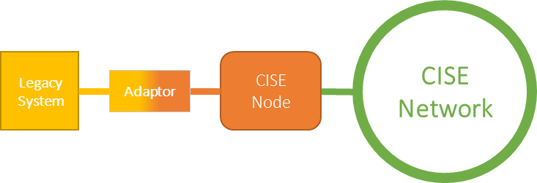
Figure 2: The CISE assets in the scope of the CISE-TP project.

Moreover, with the Work Item CDM 006 the ISG CDM has addressed for the first time the topic of validating the implementation of a CISE instance (i.e., a node or an adaptor) complying with CDM standards and capable of interoperating with other CISE instances implemented independently.
ETSI CDM 006 has fulfilled a gap analysis towards the realisation of a comprehensive test suite and an open platform aimed at hosting the assets coming from all relevant players. In this deliverable, a recommendation to properly address the testing activity together with the realisation of the ETSI CDM Testing Platform is provided.
This recommendation, generically framed under the label of “Future Work”, is detailing a comprehensive analysis of testing requirements, preparation of test specifications, and development of a Testing Suite. This work can be as extensive as needed since it depends on the maturity of the whole CISE project.
In addition, the development on the CISE technical solution carried out in the framework of the CISE Transitional Phase requires to be quickly and conclusively incorporated in related standardisation documentation in order to avoid technical divergencies. To this extent an effective update of normative standards is also needed.
All in all, the objectives of this project can be summarised as it follows:
- Design and implementation of all necessary tools for conformance and interoperability testing:
  - Identification of relevant test cases;
  - Selection of a set of functions for conformance testing in the CISE node internal structure;
  - Selection of a set of services (complying with the Service Model) for conformance testing in the CISE node-to-node interface (applicable to all communication patterns, i.e., Publish/Subscribe, Pull, Push);
  - Selection a set of queries (sending data and discovering services) for conformance testing of an Adaptor against a comprehensive set of target qualifications (e.g., Publish/Subscribe of Incident Services);
  - implementation of test procedures and test tools.
- Development of the Testing Platform:
  - Configuration of all hardware and software components aimed at validating all aforementioned functionalities.
  - Validation of base standards
  - Development of test specifications
- Update of base standards developed by ISG CDM:
  - align with concurrent technical development in the CISE transition phase and implement the fixes discovered through the validation activity of the base standards performed on the Testing Platform.

For the three above mentioned objectives, the following indicators can be defined:

Objective 1.: number of services to be tested (14) and related test cases per service (8)
CISE-TP will be considered successful if by the end of the project at least 90% of the target value stated above will be achieved.

Objective 2.: on-time delivery - development of the test specifications in line with the planned schedule
CISE-TP will be considered successful if by the end of the project all delivered test cases (matching Objective 1) will be validated on a fully implemented Testing Platform.

Objective 3.: on-time delivery - update of the base standards in line with the planned schedule CISE-TP will be considered successful if all considered normative documents will be effectively updated resolving any divergence between standardisation and CISE exploitation activities.

1.3 Complementarity with other actions and innovation
The Common Information Sharing Environment for the Maritime Domain (CISE) was initiated by the Commission in 2009, followed by a series of EU-funded projects that led to the development of a technical interoperability solution in 2019 as described in the Review of the Common Information Sharing Environment (CISE) for the maritime domain: 2014 – 2019, SWD(2019) 322 final. CISE supports several COM priorities: the EU Agenda for Migration, the Digital Single Market, and the jobs, growth and investment priority (as all development activities connected with the Blue Economy).

For the first time, CISE enables the cross-border and cross-sectoral information exchange between MS authorities and EU agencies with competences at Sea (approx. 400 entities), thus fostering interoperability and complementarity between European and MS institutions, improving maritime situational awareness, contributing to safer, cleaner and more secure seas, and supporting the development of the Blue Economy.

Several other CISE related projects call for the development of technical standards to promote interoperability. During the EUCISE2020 pre-operational validation project, stakeholders decided to conform to this requirement by creating the ISG CDM at ETSI in order to define the relevant technical specifications for CISE.

The CISE Transitional Phase, launched in 2019, has attracted numerous additional partners striving to connect national administrations to CISE. This leads to a growing demand for a testing environment that allows partners and respective industry to validate national solutions like legacy system adaptors against a common and trustworthy reference node.

Thus, CISE-TP matches the need of convergence coming from the CISE Transitional Phase and ISG CDM levels as depicted below.
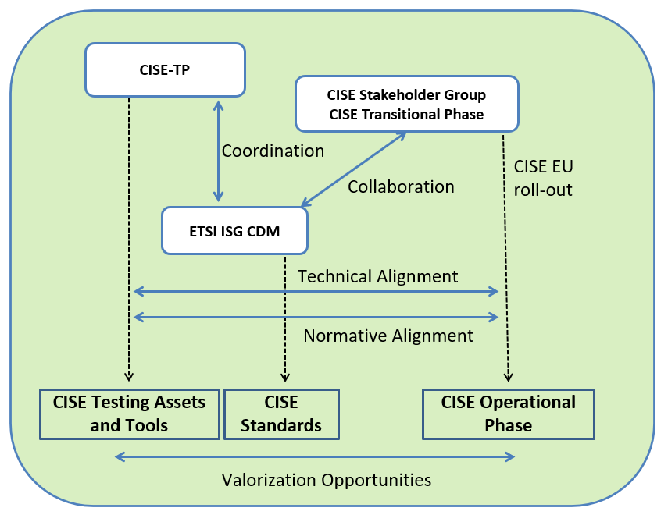
Figure 3: CISE-TP and complementary processes at the EU level.

Being respectful of the different roles, mandates, and obligations, in the figure above the overall international scenario is represented highlighting the new task implemented by the CISE-TP project .
Acknowledging that in the ETSI ISG CDM 2021/23 term a stronger collaboration with the CISE Transitional phase, managed by EMSA, is ongoing, by means of the CISE-TP work (in coordination with the ISG) a stronger technical and normative alignment will be reached among the Standards, the Operational Assets, and the Testing Assets and Tools in the global scope thus allowing for better valorisation opportunities.

CISE-TP will therefore allow organisations and European Industry to develop and test their national CISE (or CISE related) solutions on a validated testing platform.

In parallel to the CISE Transitional Phase, other CISE related projects like the HORIZON2020 ANDROMEDA and AI-ARC investigated the use of the CISE Service and Data model for their particular requirements, and demonstrated that the interoperability solution developed for CISE has all potential to be used for information exchange outside the maritime domain. This extension will also boost the application of the CISE standards in other domains, thus providing added value to the technical assets delivered by CISE-TP.

2. QUALITY

2.1 Concept and methodology
Any standard is a collection of requirements which, if implemented correctly, achieve certain objectives in a product or in a service. These requirements need to be unambiguous, precise and consistent.
Standards should follow established principles of standards writing, as follows:

- a well-defined and precise terminology should be used consistently in the standard;
- requirements should be clearly identified as mandatory or optional;
- different configurations and their associated parameters should be well-defined;
- the means of conforming to the standard should be clearly identified;
- definitions and requirements should not conflict with each other.
The purpose of validation is to ensure as far as possible that the requirements expressed in the standard do, in fact, meet the objectives.

Even a simple validation of a standard will identify specification errors that can be easily rectified and that, when corrected, will improve the overall quality of the document. Such improvements make the standard easier to understand and to implement in a product or a service, thus reducing the number of potential interoperability problems that might occur.

Problems found during validation can be classified as editorial or technical.
Technical issues are more damaging than editorial problems and it is important to find and correct them prior to real deployments. Examples include:

- Requirements that are incomplete or omitted from the specification;
- Requirements that are implied rather than expressly specified;
- Requirements that conflict with other requirements in the same or a referenced standard;
- Incorrect semantics used in a specification language;
- Requirements that cannot be achieved practically.

As addressed in Section 1.3, the normative standards in force developed by ETSI ISG CDM are not aligned with the technical specifications coming from the CISE Transition Phase.

CISE-TP will fix such shortcomings by accomplishing such alignment prior to the development of a test suite addressing the conformance and interoperability features of a candidate solution.

As recalled in Section 1.2, ETSI CDM 006 has addressed the objective of a standardised conformance and interoperability test specification. Such a specification comprises:

- a set of Test Purposes such as those specified in the TPLan notation;
- the definition of a test suite structure and of the implementation conformance/interoperability statement and the extra information for testing (often defined textually);
- an Abstract Test Suite (ATS) which is most often specified in TTCN-3 .

Addressing the aforementioned objectives CISE-TP will select a preliminary set of Test Cases (see Section 2.6) addressing the CISE architecture, the data, and service models. Those Test Cases are the ones that match all the following requirements:

- they are representative of the CISE main functionalities;
- they are sensitive to the node upgrade activities;
- they can be mapped into a bundle of Test Purposes.

In parallel with the selection of the Test Cases, a testing platform will be implemented permitting to host CISE candidate implementations (notably nodes and adaptors to national legacy systems). A Testing Platform operated independently from the actual providers of CISE candidates is the most convincing methodological choice to address the objectives stated above.

A pictorial view of the Testing Platform and its relations with the CISE testing and (pre-) operational network is represented in the figure below:
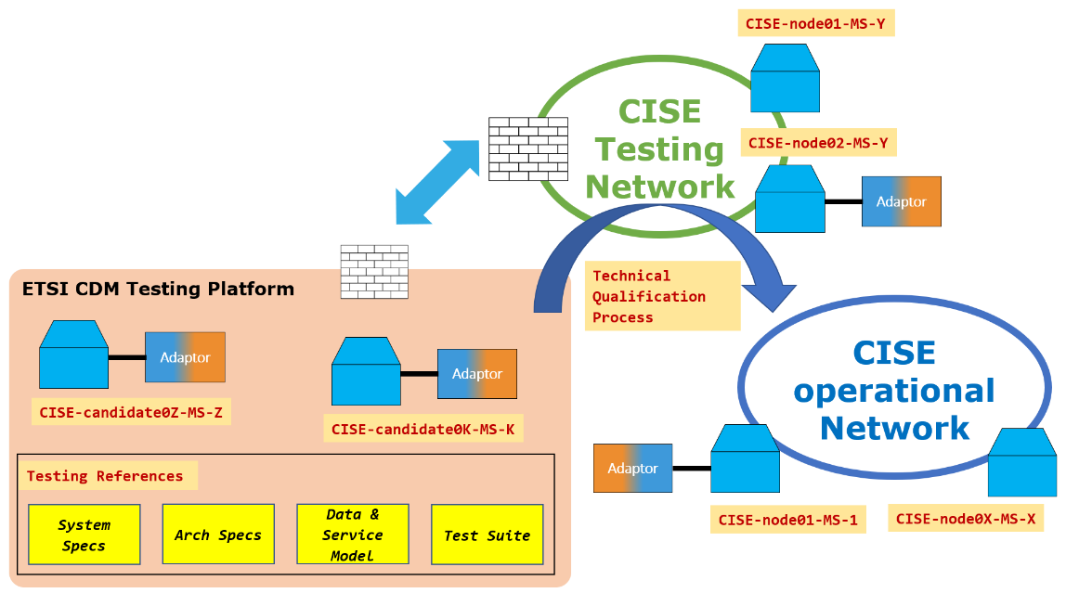
Figure 4 The envisaged qualification process of the CISE Nodes and Adaptors

The Platform will be organised in tenants to be associated with the actual providers of the CISE candidate implementations. A tenant will be allocated to ETSI for permitting to share technical resources (i.e.,VM or docker containers, test code, etc.) with the provider. It will first host the CISE reference implemented by EMSA (so-called CISE node version 2) in order to permit technical and normative alignment until the development is mature enough that future independent implementations can be fully tested.
At the end of the CISE-TP project the CISE community will rely on:

- a validated Testing Platform;
- a relevant set of Test Cases and the corresponding Test Suite;
- an updated set of CISE normative standards delivered by ETSI ISG CDM.

2.2 Consortium set-up
Not Applicable for ETSI

2.3 Project teams, staff and experts
Name and function | Organisation | Role/tasks/professional profile and expertise
Youssouf Sakho  Funded Activities Director | ETSI | Director of ETSI funded Projects planning and control and Director of ETSI Corporate travels
Léa Belloulou  Head of Funded Activities | ETSI | Head of ETSI funded Projects planning and control
Andrea Lorelli  Technical Officer | ETSI | ETSI Technical officer for the Industrial Standardization Group CDM
Technical Expert | ETSI | ETSI Technical Expert of ETSI Centre for Testing and interoperability

The project will be performed by a group of maximum three Companies/Organisations (Service Providers), accounting to an average of 4 full time equivalent specialists, that will collectively ensure the following mix of skills:
- Expert knowledge in the preparation of ETSI standards;
- Expert knowledge of ETSI test specifications and test adapters;
- Expert knowledge in distributed systems, data modelling and sharing;
- Expert knowledge of TTCN-3;
- Expert knowledge of distributed network and E2E accessibility;
- Expert knowledge in Platform and Software Layer technologies in a private cloud.
A project manager will be appointed from one of the Service Providers and will be responsible for co-ordinating the execution of the tasks assigned to the individual Service Providers, according to the project requirements and following the technical direction given by ETSI ISG CDM.
The project manager will possess project management experience, report-writing skills, experience of consensus building, presentation skills, experience of working in an international environment, and in liaising with other international organisations.

2.4 Consortium management and decision-making
Not applicable for ETSI

2.5 Project management, quality assurance and monitoring and evaluation strategy
According to ETSI Technical working procedure on the selection of the service providers, ETSI will issue a call for expertise to get the necessary skills and resources as described below.

CISE-TP is a very focused project aimed at setting up a testing facility opened to the industrial and institutional maritime communities under the supervision of ETSI ISG CDM. Coordinating such a project as well as opening to external stakeholders is a composite task that requires an efficient management and decision-making structure to ensure the:
• Consolidation of a unified view of the overall CISE-TP approach and objectives, at all times.
- Alignment with both the ETSI ISG CDM and the CISE Stakeholder Group, mandated by the DG MARE of the development of the CISE Transitional Phase.
• Oversight & completion of objectives (within agreed calendar, budget and quality of deliverables) both internally (within the consortium commitments) and externally (with respect to EISMEA, EU, the stakeholder community, the general audience).
• Early identification, management and mitigation of risks.
• Efficient and effective collaboration and synergistic effects between and among involved entities.
CISE-TP proponents have committed to collaborate for the timely implementation of the work plan, preparation of the deliverables and quality of results. Next to the risk management, the quality assurance is essential for reaching the overall project targets. The main target is to monitor the achievements of the project, i.e. the deliverables and milestones, and to establish adequate processes to get an optimum of high-quality results.
A combination of frequent on-line progress meetings, regular face-to-face meetings and internal progress reports will create a clear view of the progress. Over and above the management of individual WPs, a lean, yet rigorous management framework linking all project components will be implemented.
From previous projects in ETSI background a formal internal review process has proven to be the most effective way to ensure a high-quality orientation throughout the project. The main instrument will be the peer-review by at least two technical experts from within the project, the formal check of the deliverable by the ETSI secretariat and a final check by the CISE-TP Coordinator and WP1 leader.
In the initial phase the WP1 leader takes care for a harmonised peer-review process, i.e., the evaluation against defined scientific criteria and quality standards as proposed in the table below.

Criteria | Definitely | Satisfactorily | Somewhat | Not at all | Not applicable
Deliverable matches the expected requirements
Objectives are clear and in line with the planned activities?
Issues at project level are properly treated?
Author responds to readers’ needs?
Technical approaches used are appropriate?
Content is well organised?
Issues raised are relevant?
Contents contribute to the state of the art?
Conclusions (if any) are valid?
Deliverable is complete (no major parts missing)?
Deliverable is formally correct.

Major deliverables will be presented at the regular status meetings of the CISE-TP and at ETSI ISG CDM. The compliance to the plan will be reported in the Periodic Reports.

Quality assurance: All the 8 deliverables (6 Group Specifications, GS, and 2 Group Reports, GR) linked to this project will be developed according to the ETSI Technical Working Procedures defined in the ETSI Directives. The drafts approved and adopted by ISG CDM will be submitted to the ETSI Secretariat within fourteen 14 days of the ISG CDM approval. Providing that the drafts comply with the ETSI Drafting Rules and following a quality check, the Secretariat will publish the deliverables within 30 days. The ETSI drafting rules are specified rules for the structure and drafting of documents intended to become ETSI deliverables and are intended to ensure that all ETSI deliverables are drafted in as uniform a manner as is practicable, irrespective of the technical content. The quality check of a deliverable is related to the overall structure of the document, the completeness and the accuracy of all the requirements necessary to achieve its objectives and the consistency of its content. A quality check together with the application of the ETSI drafting rules will guarantee that the published deliverables will be of high quality (world class standards).
The indicators are defined in Section 1.2. The evaluation methods will be as follows:
Objective 1: being the indicator equal to the number of test cases (baseline: 100, target: 112), the methodology to monitor the progress of work is straightforward.
Objective 2 and 3: since the indicator is equal to the “on-time delivery”, the progress of the work will be monitored based on internal Intermediate Milestones (IMs) for the Work Items linked to the project deliverables as follows:
- IM1: early draft target date;
- IM2: stable draft target date;
- IM3: final draft for approval target date.
The IMs for the project deliverables will be visible on the ETSI Portal.

2.6 Cost effectiveness and financial management
Considering the quantitative objectives detailed in Section 1.2, a total of fourteen services will be tested in CISE-TP.
The effort needed to develop a Test Purpose (TP) is quoted to account for 3 full days of work by a specialist. It is expected to develop at least 8 TP per service, accounting to 112 TP in total as a target. This will lead to an estimated target total effort of 336 days of work for the development and validation of the Test Suite.
For the accomplishment of the update of normative documents 2 PM per standard (for alignment to CSG development and for actual versioning of the base standards) has been considered; it is assumed that the technical activity in CISE-TP will be mainly affecting the three standards related to the Network Architecture, the data model and the service model. A PM has been considered to be 20 working days long.
Taking into account the needed expertise, the daily rate is assumed to be 640 EUR and is based on the average market price.

Travels are strongly reduced as teleconferences will be the most common tool for organising technical meetings. Anyway travels are accounted to consider the participation to the ETSI CDM meetings as well as to conduct the dissemination activities described in Section 3.2 More specifically, considering the cost of travel in EU equal to 1 kEur, a total of 14 individual travels will be supported with the breakdown detailed in Section 4.

Each subcontractor is allocated to specific tasks with an expected level of contribution. The financial resources allocated to the subcontractor are calculated on this principle.
At the start of the project, ETSI develops a baseline cost plan. It is calculated with the cost of the tasks and the scheduled progress of task at each milestone cut-off date. This baseline cost plan provides the costs at each milestone cut-off date.
The milestone payment schedule for each subcontractor is then calculated by taking into account the baseline cost plan and the expected level of contribution. The milestone payment schedule is contractual
The subcontractors payment are submitted to the validation of the project milestones. The ISG and ETSI proceed to the validation of the milestone.

3. IMPACT

3.1 Impact and ambition
Data sharing is considered a strategic resource and an essential utility for economic progress worldwide. The huge quantity of public data held by the EU both centrally and through the Member States could bring substantial benefits in terms of growth and innovation if mechanisms for safe and secure sharing are introduced. The potential benefits of Government-to-Business (G2B) and Business-to-Government (B2G) data sharing are significant for Europe, as recognised by the EU Data Strategy.
In the maritime surveillance ecosystem, the exchange of information between the different maritime sectors as identified in EUCISE2020 FP7 project (i.e., Maritime Safety and Security, Border Control, Maritime Pollution and Marine Environment Protection, Fisheries Control, Customs, General Law Enforcement, Defence) is of paramount importance in order to facilitate decision making. This is the case not only within a given country but also among different countries (e.g. Homeland Security and Border Control). The benefit of such information sharing in the maritime sector is not new to this proposal as it has been extensively considered in the COOpP project (see Sec. 2.2 and references therein).
Since the exchange of information between “legacy systems” cannot take place directly for different designs and implementations, there is always the need to deploy gateways/adaptors for letting the stakeholders exchange information “in a standardised way”.
Without a suitable “Testing and Validation” process, integration of individual entities might generate problems that require re-engineering mitigation actions at a later stage with extra costs associated.
“Testing and validation” is therefore an essential activity in order to guarantee conformance to the applicable standards as well as interoperability. The lack of interoperability would undermine safety with the risk that (for instance) threats to shipping and borders would not be correctly identified, and no proper EU cooperative action would be taken in due time.
In the light of the upcoming CISE operational phase, CISE-TP will therefore support the evolvement of the CISE network in the short and mid-term by helping to reduce such risks.
At the same time, testing and validation are also a key factor in security related issues of a cross- sectoral and cross-country information exchange network as this process supports common security and system accreditation requirements that will also have to be addresses in the growing CISE network on the short and mid-term timeline.
The CISE Test and Evaluation Suite is directed at European SME that are involved in CISE related activities in their respective Member States. Those activities encompass the development of CISE entities like national legacy adaptors or CISE node technical infrastructure installation, as well as the development of additional national data and information exchange systems like national inter-institutional information systems, or sensor to operation center connections operating on the basis of the CISE technology. The CISE Test and Evaluation Suite will offer them the opportunity to test system components or entire entities against a reference node without the risk to interfere with live operating systems.
A chance will be opened as a follow-up action at the completion of the CISE-TP work, considering the organisation of a public Plugtests™. Feedback from the industrial sector is a measure of industrial readiness to enter this market and will be precious for the directorates of the EC involved in the deployment of the operational CISE network, notably DG MARE.
CISE-TP and the ISG will then invite industrial actors:
- already actively involved in other ETSI technical initiatives such as TC SmartM2M, ISG CIM (cross-cutting Context Information Management), and ISG PDL (Permissioned Distributed Ledger), …
- featuring background experience in CISE development (as the industries involved in the EUCISE2020 project);
- already undertaking activities in the development of the CISE node v2 (as European Dynamics, …);
- already actively involved in the maritime business framed into European cooperation or Member States programs (e.g. through public procurement, PPP, or exploiting internal R&D).

3.2 Communication, dissemination and visibility
Information will be provided on the effectiveness of activities related to the dissemination of project deliverables and efforts made to raise industry awareness of the activity. The project intends to disseminate results as follows:
- At least 2 presentations to ETSI groups that recently expressed interest in the ISG CDM work: TC SmartM2M, ISG CIM (cross-cutting Context Information Management), and ISG PDL (Permissioned Distributed Ledger);
- At least one news release (for example on the ETSI web site) on the work, detailing the achievement of important results;
- At least two presentations made to the CISE Stakeholder Group;
- At least one article in Enjoy!, the ETSI official magazine;
- The project will offer to DG MARE a presentation to be delivered at Member State Experts SubGroup (MSEsG) Maritime Security (MarSec), preferably in the preparation process for the CISE Operational Phase. This will give policy makers the opportunity to evaluate the impact of the CISE-TP on the design of the CISE Operational Phase.
- The project will offer to DG MARE a presentation to be delivered at the European Maritime Day complementary with CISE related workshops. With such a presentation, a wide range of stakeholders (public and private) involved in ocean governance will be relegated to the project.
- The project will be prepared and actively pursue to present the CISE-TP results at CISE related public events (like the envisaged CISE industry day) organised by CSG.
In all dissemination activities, we will make evident the funding coming from the EC to CISE-TP project, and a reference to the overarching CISE project funded by the EC: more specifically the EU flag logo and the CISE-TP grant number will be highlighted in all official presentations and press releases.

3.3 Sustainability and continuation
Once the deliverables (Group Specifications) linked to the project are published, there might be the need to update the CDM base standards if:
- the CISE node evolves
- the overall architecture evolves
- technical and/or editorial errors are discovered.
The evolution of the CISE NODE is linked to the activities that will take place after CISE enters into operation (expected date: 2023) and therefore it is not possible at this time to quantify the effort needed in order to update the CDM base standards after the end of the project.
For a. and b. it is anyway envisaged that also the test specifications will need to be updated. In general, the maintenance of the project deliverables follow the Technical Working Procedures as specified in the ETSI Directives.
Subsequent versions containing only editorial changes may be published by the Secretariat following confirmation by the ISG CDM Chairman and therefore with a minimal additional effort.
Subsequent versions containing technical updates are approved and adopted by the ISG CDM according to the ETSI decision-making procedures defined in the ETSI Directives.
An update of the base standards and/or the test specifications due to errors is expected to occur when these errors are discovered during the implementation of the CISE solution. If different implementations from different manufacturers are available, it would be advisable to organise one or more interoperability events (Plugtests™) which have the purpose to test the interoperability of different implementation. Since interoperability events have also the purpose to validate the standards, this will further improve the quality of the standardisation deliverables.
CISE is a general concept going well beyond the maritime domain. In this regard ETSI ISG CDM has already been working on the extension of the use cases and related requirements to the land surveillance domain, taking into account the results of the ANDROMEDA project (https://www.andromeda-project.eu/). The testing platform that will be developed in this project could therefore be reused for the validation of future extensions linked to the capabilities of CISE.
It is also worth mentioning that the 2022 Annual Union Work Program for European standardisation includes an action related to Climate-related data (Ref 28 in the ANNEX to the Commission Notice) requesting to “Develop standards ensuring data from both the private and public sector are recorded, collected and shared in a comprehensive and uniform way” which can be considered another application of CISE.

4. WORKPLAN, WORK PACKAGES, ACTIVITIES, RESOURCES AND TIMING

4.1 Work plan
CISE-TP is planned as a 18-month project. The project will be implemented in Work Packages (WP) each of them managed by ETSI and subcontracted specialists. The work plan is organised in 4 technical inter-related WPs and a management WP. In the figure below technical and management activities organisation are shown along with their correlation.
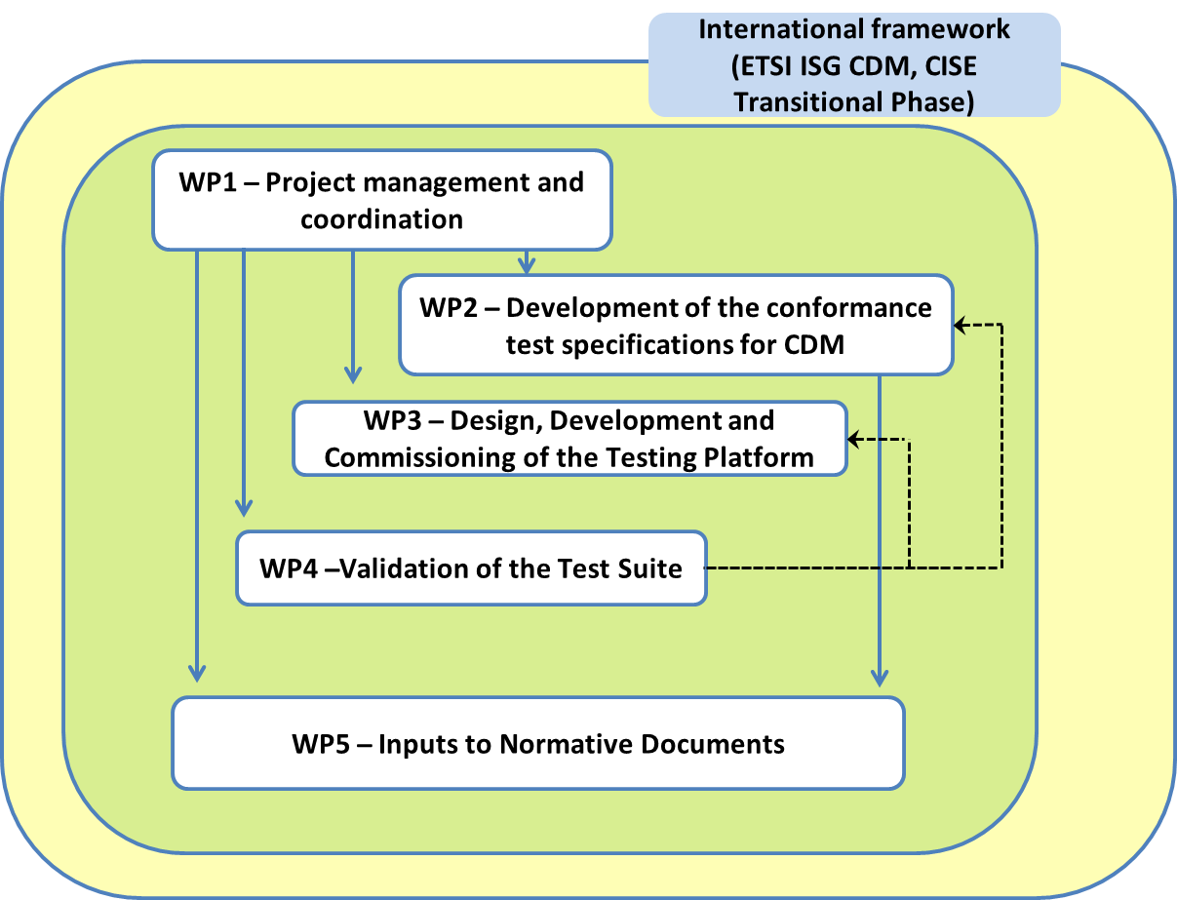
Figure 5: WP structure of CISE-TP.

WP1 deals with the implementation of the project plan (including the management of the open calls and the selection of the best candidatures). WP2 is in charge of the specification and implementation of the test suite. WP3 is in charge of the realisation of the Testing Platform where to host CISE candidates and testing tools. WP4 is framing the validation activities. In WP5 the actual base standards of ETSI CDM will be aligned with the most recent development of the specifications of the CISE node. The effectiveness of the proposed timing will be guaranteed considering the Risk Assessment and Contingency Plan (see Section 2.7).

4.2 Work packages, activities, resources and timing

Work Package 1

Work Package 1: Project management and coordination

Duration: |  | M1 – M18 |  | Lead Beneficiary: |  | ETSI
Objectives
▪ This WP is devoted to the management of the CISE-TP action and is therefore spanning the whole duration of the technical activities
Task No (continuous numbering linked to WP) | Task Name |  | Description |  | Participants |  |  | In-kind Contributions and Subcontracting (Yes/No and which)
 |  |  |  |  | Name |  | Role (COO, BEN, AE, AP, OTHER)
T1.1 | Project Setup |  | ETSI Secretariat and ETSI ISG CDM chair will interview the potential candidates and select those to best meet the work plan.  ETSI will make arrangements for project members (service contracts, etc.).  The coordinator (with the help of the project leader) checks that the objectives of all WPs are clearly recognised by the participants. The corresponding milestone is therefore set at Month 4 (MS1). |  | ETSI |  | COO | YES (In-kind)
T1.2 | Project Management |  | The overall management of the project will be under the responsibility of the project Leader. He will ensure an effective coordination among the different Tasks, working in close collaboration with the different Task Leaders and supervising them if needed, but also with ETSI ISG CDM representatives.  The overall management of the project consists in:  - Planning the work of the project members, ensuring that the timescales of the project deliverables are met  - Organising meetings to discuss the drafts, recording any major issues and resolutions of issues  - Reporting to ISG CDM on the progress of work  - Representing, or arranging for other project members to represent the project results at other external meetings as appropriate  - providing the project Reports to the ETSI Secretariat: the Progress Report (to be submitted to EISMEA after 12 months) and the Final Report (to be submitted to EISMEA at the end of the project). |  | N/A |  | OTHER | YES (subcontracting)

Milestones and deliverables (outputs/outcomes)
Public — fully open
Sensitive — limited under the conditions of the Grant Agreement
EU classified — RESTREINT-UE/EU-RESTRICTED, CONFIDENTIEL-UE/EU-CONFIDENTIAL, SECRET-UE/EU-SECRET under Decision 2015/444.
Milestone No (continuous numbering not linked to WP) | Milestone Name | Work Package No | Lead Beneficiary | Description |  | Due Date  (month number) | Means of Verification
PR.1 | Progress Report 1 | 1 | ETSI | Progress report approved by ETSI ISG CDM |  | M3 | Approval reported in the minutes of the ETSI CDM meeting
MS1 | All technical activities started | 1 | ETSI | The coordinator (with the help of the project leader) checks that the objectives of all WPs are clearly recognised by the participants and that the technical activities have started |  | M4 | Project meeting
PR.2 | Progress Report 2 | 1 | ETSI | Progress report approved by ETSI ISG CDM |  | M6 | Approval reported in the minutes of the ETSI CDM meeting
PR.3 | Progress Report 3 | 1 | ETSI | Progress report approved by ETSI ISG CDM |  | M9 | Approval reported in the minutes of the ETSI CDM meeting
MS3 | Intermediate results have been delivered | 1 | ETSI | In this milestone the coordinator (with the help of project leader) checks that the deliverables have been submitted in time and no prompt observation has been raised by EISMEA officer |  | M12 | Report by coordinator to EISMEA
PR.4 | Progress Report 4 | 1 | ETSI | Progress report approved by ETSI ISG CDM |  | M15 | Approval reported in the minutes of the ETSI CDM meeting
MS5 | Final results have been delivered | 1 | ETSI | In this milestone the coordinator (with the help of project leader) checks that the deliverables have been submitted in time and no prompt observation has been raised by EISMEA officer |  | M18 | Report by coordinator to EISMEA
Deliverable No (continuous numbering linked to WP) | Deliverable Name | Work Package No | Lead Beneficiary | Type | Dissemination Level | Due Date  (month number) | Description (including format and language)
D1.1 | Progress Report 1 | 1 | ETSI | R — Document, report | SEN — Sensitive | M3 | - Status of the work according to the time plan  - Eventual identified issues and implemented mitigation actions
D1.2 | Progress Report 2 | 1 | ETSI | R — Document, report | SEN — Sensitive | M6 | - Status of the work according to the time plan  - Eventual identified issues and implemented mitigation actions
D1.3 | Progress Report 3 | 1 | ETSI | R — Document, report | SEN — Sensitive | M9 | - Status of the work according to the time plan  - Eventual identified issues and implemented mitigation actions
D1.4 | EISMEA Interim Report | 1 | ETSI | R — Document, report | SEN — Sensitive | M12 | - The activities performed until month 12, the coordination work of the activities and the production of the expected deliverables anticipated in the work-plan.  - The latest drafts of the deliverables are available according to the time plan.  - Overview of ad-hoc meetings if necessary.  - The plan for the future activities to complete the deliverables and further expected (coordination) meetings.  - Quality intermediate report.
D1.5 | Progress Report 3 | 1 | ETSI | R — Document, report | SEN — Sensitive | M15 | - Status of the work according to the time plan  - Eventual identified issues and implemented mitigation actions

Work Package 2

Work Package 2: Development of the conformance test specifications for CDM

Duration: |  | M4 – M18 |  | Lead Beneficiary: |  | ETSI
Objectives
- After defining the actual content of the Testing Activity this WP is accomplishing the full implementation of the Testing Suite and Tools. The duration results from a dedicated analysis and from ETSI background experience

Activities (what, how, where) and division of work
Task No (continuous numbering linked to WP) | Task Name |  | Description |  | Participants |  |  | In-kind Contributions and Subcontracting (Yes/No and which)
 |  |  |  |  | Name |  | Role (COO, BEN, AE, AP, OTHER)
T2.1 | Requirements |  | - Selection of most notable features from base standards and ETSI CDM 006 recommendations  - Extraction of requirements |  | N/A |  | OTHER | YES (subcontracting)
T2.2 | Test Development |  | Development of the Test Purposes and the TTCN-3 code of Test Cases.  - Codec and Adaptation layer development  - Inputs and recommendations for the design and implementation of the Testing Platform (WP3) |  | N/A |  | OTHER | YES (subcontracting)

Milestones and deliverables (outputs/outcomes)
Public — fully open
Sensitive — limited under the conditions of the Grant Agreement
EU classified — RESTREINT-UE/EU-RESTRICTED, CONFIDENTIEL-UE/EU-CONFIDENTIAL, SECRET-UE/EU-SECRET under Decision 2015/444.
Milestone No (continuous numbering not linked to WP) | Milestone Name | Work Package No | Lead Beneficiary | Description |  | Due Date  (month number) | Means of Verification
MS4 | End of technical development | 2, 3, 4, 5 | ETSI | the test suite is finalised and validated on the Testing Platform and normative documents have been updated following the results on the reference node. |  | M16 | Joint meeting with ETSI ISG CDM with formal verification.
Deliverable No (continuous numbering linked to WP) | Deliverable Name | Work Package No | Lead Beneficiary | Type | Dissemination Level | Due Date  (month number) | Description (including format and language)
D2.1 | Common Information sharing environment service and Data Model (CDM); Testing; Conformance test specifications for CISE Node; Part 1: Test requirements and Protocol Implementation Conformance Statement (PICS) proforma  GS CDM 007-1 V1.1.1 Published version | 2 | ETSI | R — Document, report | SEN — Sensitive | M18 | Starting from the normative documents in force, the preliminary work published in ETSI CDM 006, and from a detailed list of requirements, the set of PICS to be filled by the implementers will be produced  (Final draft M16, Published version M18).
D2.2 | Common Information sharing environment service and Data Model (CDM); Testing; Conformance test specifications for CISE Node; Part 2: Test Suite Structure and Test Purposes (TSS & TP)  GS CDM 007-2 V1.1.1  Published version | 2 | ETSI | R — Document, report | SEN — Sensitive | M18 | In this deliverable, considering the preliminary work published in ETSI CDM 006, the structure of the test suite and the features/behaviour that will be considered for conformance testing will be produced.  (Final draft M16, Published version M18).
D2.3 | Common Information sharing environment service and Data Model (CDM); Testing; Conformance test specifications for CISE Node; Part 3: Abstract Test Suite (ATS) and Protocol Implementation eXtra Information for Testing (PIXIT)  GS CDM 007-3 V1.1.1  Published version | 2 | ETSI | R — Document, report  OTHER — software suite | SEN — Sensitive | M18 | In this deliverable, considering the preliminary work published in ETSI CDM 006 and the technical content published in D1 and D2, the actual test suite coded in TTCN-3 will be delivered jointly with the adaptation layer to be developed in the Testing Platform.  (Final draft M16, Published version M18).

Work Package 3

Work Package 3: Design, Development and Commissioning of the Testing Platform

Duration: |  | M1 – M7 |  | Lead Beneficiary: |  | ETSI
Objectives
- This WP is devoted to the hardware and software setup of the Testing Platform. The envisaged duration is the result of dedicated technical sessions with EMSA and the EC JRC that are leading the CISE Transition Phase on behalf of the EC.

Activities (what, how, where) and division of work

Task No (continuous numbering linked to WP) | Task Name |  | Description |  | Participants |  |  | In-kind Contributions and Subcontracting (Yes/No and which)
 |  |  |  |  | Name |  | Role (COO, BEN, AE, AP, OTHER)
T3.1 | Platform Development |  | - Development of the Testing Platform configuring all hardware and software components and preparation of the related documentation |  | N/A |  | OTHER | YES (subcontracting)
T3.2 | Tenant configuration |  | - The Testing Platform is segmented in tenants (i.e. VM or docker containers, test code, etc.). A tenant will be allocated to ETSI for sharing technical resources with all contributors. Another tenant, allocated to EMSA, will host the CISE reference implemented developed within the Transition Phase. |  | N/A |  | OTHER | YES (subcontracting)

Milestones and deliverables (outputs/outcomes)
Public — fully open
Sensitive — limited under the conditions of the Grant Agreement
EU classified — RESTREINT-UE/EU-RESTRICTED, CONFIDENTIEL-UE/EU-CONFIDENTIAL, SECRET-UE/EU-SECRET under Decision 2015/444.
Milestone No (continuous numbering not linked to WP) | Milestone Name | Work Package No | Lead Beneficiary | Description |  | Due Date  (month number) | Means of Verification
MS2 | Platform ready for testing | 3 | ETSI | In this milestone the platform is validated against some relevant behavior of the reference implementation. |  | M7 | On-line demonstration
MS4 | End of technical development | 2, 3, 4, 5 | ETSI | the test suite is finalised and validated on the Testing Platform and normative documents have been updated following the results on the reference node. |  | M16 | Joint meeting with ETSI ISG CDM with formal verification.
Deliverable No (continuous numbering linked to WP) | Deliverable Name | Work Package No | Lead Beneficiary | Type | Dissemination Level | Due Date  (month number) | Description (including format and language)
D3.1 | Common Information sharing environment service and Data Model (CDM); Testing Platform  GR CDM 008 V1.1.1 | 3 | ETSI | R — Document, report | PU — Public | M7 | In this document the Testing Platform is presented together with a report about its usage for conformance and interoperability tests for CISE implementations.

Work Package 4

Work Package 4: Validation of the test suite

Duration: |  | M3 – M18 |  | Lead Beneficiary: |  | ETSI
Objectives
- This WP has a twofold target: on one hand it effectively validates the Testing Suite and Tools, on the other hand it steers the technical development in WP2 to align the conformance tests with the reference implementation carried on in the Transition Phase.

Activities (what, how, where) and division of work
Task No (continuous numbering linked to WP) | Task Name |  | Description |  | Participants |  |  | In-kind Contributions and Subcontracting (Yes/No and which)
 |  |  |  |  | Name |  | Role (COO, BEN, AE, AP, OTHER)
T4.1 | Testing alignment |  | - Provide all necessary inputs to WP2 to align the test specifications with the updated design and architecture coming from the CISE Transition Phase |  | N/A |  | OTHER | YES (subcontracting)
T4.2 | Validation of the test suite |  | - Validation of the actual Test Suite developed in WP2, adapted, and installed in the Testing Platform. Preparation of the related test report (GR CDM 009) |  | N/A |  | OTHER | YES (subcontracting)
T4.3 | Assessment of the Testing Platform |  | - Provide feedback to WP3 for bug fixing on the Testing Platform |  | N/A |  | OTHER | YES (subcontracting)

Milestones and deliverables (outputs/outcomes)
Public — fully open
Sensitive — limited under the conditions of the Grant Agreement
EU classified — RESTREINT-UE/EU-RESTRICTED, CONFIDENTIEL-UE/EU-CONFIDENTIAL, SECRET-UE/EU-SECRET under Decision 2015/444.
Milestone No (continuous numbering not linked to WP) | Milestone Name | Work Package No | Lead Beneficiary | Description |  | Due Date  (month number) | Means of Verification
MS4 | End of technical development | 2,3,4,5 | ETSI | The test suite is validated on the Testing Platform. The related deliverable (GS CDM 009) is approved for publication. |  | M16 | Joint meeting with ETSI ISG CDM  CDM 009 is scrutinised by the project team, the ETSI ISG CDM as well as the ETSI Secretariat in order to verify that all the results from the validation task are duly recorded.
Deliverable No (continuous numbering linked to WP) | Deliverable Name | Work Package No | Lead Beneficiary | Type | Dissemination Level | Due Date  (month number) | Description (including format and language)
D4.1 | Common Information sharing environment service and Data Model (CDM); Validation of the Test Suite  GR CDM 009 V1.1.1 | 4 | ETSI | R — Document, report  OTHER — software suite | PU - Public | M18 | The final draft of the deliverable is approved for publication. All the results from the validation of the Test Suite are described. Publication will take place in M18.  (Final draft M16, Published version M18).

Work Package 5

Work Package 5: Update of CDM specifications

Duration: |  | M2 – M18 |  | Lead Beneficiary: |  | ETSI
Objectives
- This WP contributes to the update of the CDM base standards in consideration of the technical alignment with the CISE Transitional Phase and the output coming from the Testing Platform.

Activities (what, how, where) and division of work

Task No (continuous numbering linked to WP) | Task Name |  | Description |  | Participants |  |  | In-kind Contributions and Subcontracting (Yes/No and which)
 |  |  |  |  | Name |  | Role (COO, BEN, AE, AP, OTHER)
T5.1 | Specification alignment |  | - Alignment of CDM specifications with version 2 of the CISE node architecture as coming from the technical activities in the CISE Transition Phase |  | N/A |  | OTHER | YES (subcontracting)
T5.2 | Specification extension and update |  | - Identification of the needed extensions/fixes in CDM standards based on the validation performed on the Testing Platform  - Update of CDM standards (release 1): GS CDM 003, GS CDM 004 and GS CDM 005 |  | N/A |  | OTHER | YES (subcontracting)

Milestones and deliverables (outputs/outcomes)
Public — fully open
Sensitive — limited under the conditions of the Grant Agreement
EU classified — RESTREINT-UE/EU-RESTRICTED, CONFIDENTIEL-UE/EU-CONFIDENTIAL, SECRET-UE/EU-SECRET under Decision 2015/444.
Milestone No (continuous numbering not linked to WP) | Milestone Name | Work Package No | Lead Beneficiary | Description |  | Due Date  (month number) | Means of Verification
MS4 | End of technical development | 2,3,4,5 | ETSI | In this milestone the test suite is delivered and validated on the Testing Platform and normative documents have been updated following the results on the reference node. |  | M16 | Joint meeting with ETSI ISG CDM with formal verification.
Deliverable No (continuous numbering linked to WP) | Deliverable Name | Work Package No | Lead Beneficiary | Type | Dissemination Level | Due Date  (month number) | Description (including format and language)
D5.1 | Common Information sharing environment service and Data Model (CDM); CDM Architecture  GS CDM 003 V1.2.1  Published version | 5 | ETSI | R — Document, report | PU - Public | M18 | The deliverable, describing the CISE architecture, will be updated based on the development in the CISE transition phase and the outcome of the test and validation.  Before approving the deliverable for publication, it is scrutinised by the project teams, the ETSI ISG CDM as well as the ETSI Secretariat based on the outcome of GS CDM 009 (Validation of the Test Suite)  (Final draft M16, Published version M18).
D5.2 | Common Information sharing environment service and Data Model (CDM); Service Model  GS CDM 004 V1.2.1  Published version | 5 | ETSI | R — Document, report | PU - Public | M18 | The deliverable, describing the CISE service model, will be updated based on the development in the CISE transition phase and the outcome of the test and validation.  Before approving the deliverable for publication, it is scrutinised by the project teams, the ETSI ISG CDM as well as the ETSI Secretariat based on the outcome of GS CDM 009 (Validation of the Test Suite)  (Final draft M16, Published version M18).
D5.3 | Common Information sharing environment service and Data Model (CDM); Data Model  GS CDM 005 V1.6.1  Published version | 5 | ETSI | R — Document, report | PU - Public | M18 | The deliverable, describing the CISE service model, will be updated based on the development in the CISE transition phase and the outcome of the test and validation.  Before approving the deliverable for publication, it is scrutinised by the project teams, the ETSI ISG CDM as well as the ETSI Secretariat based on the outcome of GS CDM 009 (Validation of the Test Suite)  (Final draft M16, Published version M18).

Overview of Work Packages

Staff effort per work package
Work Package No | Work Package Title | Lead Participant No | Lead Participant Short Name | Start Month | End Month | Person-Months
1 | Project management and coordination | 1 | ETSI | M1 | M18 | 3
2 | Development of the conformance test specifications for CDM | N/A | N/A | M4 | M18 | 11
3 | Design, Development and Commissioning of the Testing Platform | N/A | N/A | M2 | M7 | 4
4 | Validation of the test suite | N/A | N/A | M3 | M18 | 4
5 | Inputs to Normative Documents | N/A | N/A | M2 | M18 | 6
 |  |  |  |  | Total Person- Months | 28

Total Project costs
Equipment
To align the Testing Platform with the technical requirements that the Member States are expected to match when deploying a CISE node, additional hardware resources (isolated and dedicated to such testing purposes) need to be procured. Such resources are the following:
- 2 CPU XEON 12 cores
- 512 GB RAM
- TB Storage SSD Raid 6
- 2 ethernet GB ports
- 2 SFP ports + 25GB (SAN storage)
- Remote management system
- Virtualisation environment and redundant SAN management

Travel
To guarantee the full success 14 travels are planned (each one quoted for a cost of Eur 1,000), for the project leader and the experts to participate to technical activities 11 travels are considered (all having a duration of 2 full days), and 3 more travels are considered for dissemination purposes (also having a duration of 2 full days).

Overall budget requests
The CISE-TP project requires a total budget of eligible costs of about 400 KEuros. This is the proposed budget breakdown:
- 89.7% is considered for Human Resources devoted to technical activities (10% allocated to coordination and project management);
- 3.5% is allocated to travels for F2F technical meetings and for communication and dissemination events as detailed in Section 3.2;
- 6.8% are allocated to hard goods and consumable equipment as detailed above.

Please consider that an interactive calculator is included as Appendix 1.

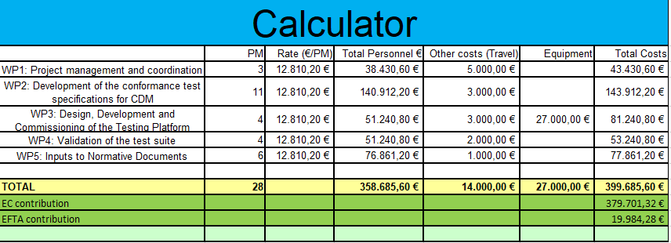

Subcontracting
Work Package No | Subcontract No  (continuous numbering linked to WP) | Subcontract Name  (subcontracted action tasks) | Description  (including task number and BEN to which it is linked) |  | Estimated Costs  (EUR) | Justification  (why is subcontracting necessary?) | Best-Value-for-Money  (how do you intend to ensure it?)
1-5 | N/A | N/A |  |  | 358 685.60 | Expertise not available inside the ISG CDM | Subcontractors are selected on a case-by-case basis in the context of an open call through a clearly defined process (typically one or more of the following, publication of the call through ETSI Collective letters to the membership, Technical Body mailing lists or explicit calls for tender).
Other issues:  If subcontracting for the project goes beyond 30% of the total eligible costs, give specific reasons. |  |  |  | ETSI Secretariat (Funded Activities, Technical officers…) will ensure the project planning and controlling with the Technical Committee without charging the related costs to the project whereas subcontractors will perform the development and technical execution of the project.

Timetable
ACTIVITY | MONTHS
 | M 1 | M 2 | M 3 | M 4 | M 5 | M 6 | M 7 | M 8 | M 9 | M 10 | M 11 | M 12 | M 13 | M 14 | M 15 | M 16 | M 17 | M 18
Task 1.1 – Project Setup
Task 1.2 – Project Management |  |  | D1.1 |  |  | D1.2 |  |  | D1.3 |  |  | D1.4 |  |  | D1.5
Task 2.1 - Requirements
Task 2.2 – Test Development |  |  |  |  |  |  |  |  |  |  |  |  |  |  |  |  |  | D2.1, D2.2, D2.3
Task 3.1 – Platform Development
Task 3.2 – Tenant Configuration |  |  |  |  |  |  | D3.1
Task 4.1 – Testing alignment
Task 4.2 – Test suite Validation
Task 4.3 – Testing Platform Assessment |  |  |  |  |  |  |  |  |  |  |  |  |  |  |  |  |  | D4.1
Task 5.1 – Specification alignment
Task 5.2 – Specification extension & update |  |  |  |  |  |  |  |  |  |  |  |  |  |  |  |  |  | D5.1, D5.2, D5.3

5. OTHER

5.1 Ethics

Not applicable.

5.2 Security

Not applicable.

6. DECLARATIONS

Double funding
Information concerning other EU grants for this project | YES/NO
We confirm that to our best knowledge neither the project as a whole nor any parts of it have benefitted from any other EU grant (including EU funding managed by authorities in EU Member States or other funding bodies, e.g. Erasmus, EU Regional Funds, EU Agricultural Funds, European Investment Bank, etc). If NO, explain and provide details. | YES
We confirm that to our best knowledge neither the project as a whole nor any parts of it are (nor will be) submitted for any other EU grant (including EU funding managed by authorities in EU Member States or other funding bodies, e.g. Erasmus, EU Regional Funds, EU Agricultural Funds, European Investment Bank, etc). If NO, explain and provide details. | YES

Financial support FROM third parties (if applicable)
EFTA Financing is equal to 19 984,28 EUR (5% of total budget)

CISE description
EU JOIN 2014/09
ETSI GS CDM 006 (V1.1.1): "Common Information sharing environment service and Data Model (CDM); Analysis for the specifications of a testing suite for the Common Information Sharing Environment (CISE); Preliminary analysis".
ETSI ES 202 553: "Methods for Testing and Specification (MTS); TPLan: A notation for expressing Test Purposes".
ETSI ES 201 873-1: "Methods for Testing and Specification (MTS); The Testing and Test Control Notation version 3; Part 1: TTCN-3 Core Language".
ETSI GS CDM 003 (V1.1.1): "Common Information sharing environment service and Data Model (CDM); CDM Architecture".
ETSI GS CDM 005 (V1.5.3): "Common Information sharing environment service and Data Model (CDM); Data Model".
ETSI GS CDM 004 (V1.0.0): "Common Information sharing environment service and Data Model (CDM); Service Model".

