ToR STF DL (TC INT)
Version: 1.3
Author: TC INT – Date: 19 March 2019
Last updated by: Giulio Maggiore– Date: 24 June 2019
page 1 of 16

Terms of Reference - Specialist Task Force
STF DL (TC INT)
“Validation of the Conformance Test Specifications for the Diameter Protocol over the Sh and Dh reference points”

Summary information
Approval status | Approved by TC INT#42 (12-14 March 2019)  Approved by Board#123 (12-14 June 2019)
Funding | Maximum budget :51 000 EUR ETSI FWP:  47 000 EUR manpower cost  4 000 EUR travel cost
Time scale | Sep 2019 – Nov 2020
Work Items | Test specifications  - RTS/INT-00160-1(revised version of TS/INT-103 571-1)  Diameter Conformance testing for Sh and Dh interfaces  Part 1: Protocol Implementation Conformance Statement (PICS)  - RTS/INT-00160-2 (revised version of TS/INT-103 571-2)  Diameter Conformance testing for Sh and Dh interfaces  Part 2: Test Suite Structure (TSS) and Test Purposes (TP)  - RTS/INT-00160-3(revised version of TS/INT-103 571-3)  Part 3: Abstract Test Suite (ATS) and partial Protocol Implementation eXtra Information for Testing (PIXIT) proforma specification
Board priority | Standards enablers/facilitators

Part I – Reason for proposing the STF

Rationale
The Diameter protocol was initially developed to provide an Authentication, Authorization, and Accounting (AAA) framework that could overcome the limitations of RADIUS. RADIUS had issues with reliability, scalability, security and flexibility. The Diameter protocol defines a policy protocol used by clients to perform Policy, AAA and Resource Control. Diameter is one of the major protocols within the context of LTE networks and is essential to guarantee reliable user authentication, policy management and charging procedures.

Application Servers (AS) host and execute services, and interface with the S-CSCF using SIP. An AS can be located in the home network or in an external third-party network. If located in the home network, it can query the Home Subscriber Server (HSS). The Open Service Access Service Capability Server (OSA SCS) interfaces SIP to the OSA framework and needs also to access the data stored in the Home Subscriber Server (HSS). The Sh interface that enables transfer of subscriber profile data for authenticating/authorizing user access to applications is located between the Application Server (AS) or the Open Service Access Service Capability Server (OSA SCS) and the Home Subscriber Server (HSS).

In case an Application Server (AS) or an Open Service Access Service Capability Server (OSA SCS) is located within a multi-HSS environment there is the need to find the correct HSS for any connecting user. This is done via the Service Locator Function (SLF). The Dh interface enables the AS or OSA SCS to determine the correct HSS and is located between the Application Server (AS) or the Open Service Access Service Capability Server (OSA SCS) and the Service Locator Function (SLF).

The protocol used on the two above interfaces is the Diameter protocol as defined in IETF RFC3588 and profiled for the Sh and Dh interfaces in ETSI TS 129 328 and ETSI TS 129 329.

In the following figure the named entities and interfaces are highlighted.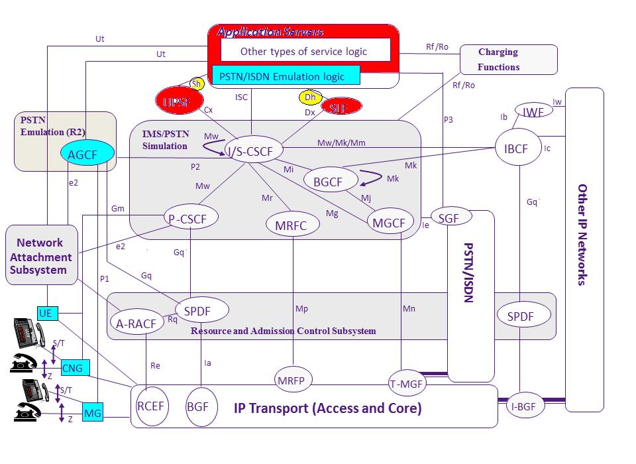
Figure 1: IMS logical architecture
Given that there are already a test specifications related to the Diameter protocol profile for the Sh and Dh reference points under implementation, it seems reasonable to validate those test specifications.
Following the methodologies developed and used by ETSI, the validation is based on the Abstract Test Suite of the Sh and Dh Test Specifications, which have been approved at the INT#42 meeting (Geneva, March 12-14, 2019).

Experience with the validation of other testing standards has shown that involvement of experts on conformance testing of protocols requires highly specialised knowledge in testing methodology, TTCN-3 language and dedicated tools. There is an advantage if testing experts are disjoint from experts developing the protocol specifications. In addition, the validation of this kind of specifications requires significant effort and it cannot be expected that this effort can be provided on a voluntary basis. Hence the involvement of testing experts is needed in order to assure timely completion and high quality of the test adaptors. These testing experts are not available on TC INT level and need to be recruited on a funded basis. The experts will use TTCN-3 platforms available at ETSI.
Past ETSI experience has shown that an STF, supported by the ETSI CTI, is the most effective and cost-efficient way to develop and validate test specifications.

Objective
Recently major efforts have been made by LTE component providers to inter-connect complete networks, i.e. connecting the single components that comprise an LTE network of different operators to allow seamless roaming. This is mainly done via the Sh and the Dh interfaces. Experiences from those trials have shown that there are implementations of the Diameter protocol that have massive interconnection issues due to different interpretation of the protocol standards.

Given that the test specifications related to the Diameter protocol profile for the Rx, the Gx, the S6a, the S9, the Cx and the Dx reference points have been validated by STF450, STF482 and STF500 against equipment of a significant number of vendors, it seems reasonable to extend the INT set of validated test specifications to also cover Diameter on the Sh and Dh reference point. Members of INT have already expressed the wish to provide access to equipment to validate against.

Experience with the validation of other testing standards has shown that involvement of experts on conformance testing of protocols requires highly specialised knowledge in testing methodology, TTCN-3 language and dedicated tools. There is an advantage if testing experts are disjoint from experts developing the protocol specifications. In addition, the validation of this kind of test specifications requires significant effort and it cannot be expected that this effort can be provided on a voluntary basis. Hence the involvement of testing experts is needed in order to assure timely completion and high quality of the Test Specifications. These testing experts are not available on TC INT level and need to be recruited on a funded basis. The experts will use dedicated software tools available at ETSI.

Relation with ETSI strategy and priorities

This action supports the ETSI Long Term Strategy item(s) to:
- create high quality standards for global use and with low time-to-market.
- establish leadership in key areas impacting members’ future activities

This action has a priority category of:
- Standards enablers/facilitators (conformance testing, interoperability, methodology)

Context of the proposal

ETSI Members support
ETSI Member | Supporting delegate | Motivation
Telecom Italia | Giulio Maggiore | Tests used to get detailed information from vendors about Interoperability Testing before coming to the market
Deutsche Telekom | Gerhard Ott | Tests needed for internal network testing
Orange France | Tayeb Benmeriem | Tests are part of the AFI verification strategy towards 5G
Iskratel | Primoz Kocar | Test will be used for quality enhancement of IMS&EPC products
Fraunhofer Fokus | Axel Rennoch/Marius Corici | Research Institute, advanced automated/standardized test solutions with TTCN-3 for Virtual environment
University of Gottingen | Dieter Hogrefe | The University of Gottingen is interested in the further development of TTCN-3 based on practical experience. The University of Göttingen is involved in several research and development projects where testing with TTCN-3 plays a central role."
ITALTEL SpA | Diego Saiu | Test will be used for quality enhancement of IMS&EPC products
Spirent Communications | Dirk Tepelmann | Provide the Test System for the test cases implementation and execution
Huawei | Fabio Faoro | Test will be used for quality enhancement of IMS&EPC products
Sigos | Shicheng Hu | Tool Provider, Provide the Test System for the test cases

Market impact

The availability of reliable and validated test specifications will allow implementers of LTE components and protocol stacks (for HSS, AS, OSA OCS, SLF) to test the conformance of their products against the protocol specifications. Conformance testing during the whole development phase of all LTE products will significantly reduce the time-to-market of the LTE architecture, as protocol conformant products will be of an enhanced quality level and will hence be less likely to cause interoperability problems with the products of other vendors.

Protocol conformant products will therefore provide the network operators with the means to deliver fully LTE compliant services to their end customers in a continuously high quality, with reliable service functionality, without communication failures and generally with the optimum quality of service for the transported media.

The tests for the Dh and Sh interface will consequently allow a faster rollout of the LTE networks due to well tested and interoperable LTE entities that are responsible for the key functionalities authentication and authorization.

Tasks for which the STF support is necessary
- LTE networks are currently being deployed in the telecoms industry. They must operate alongside and interwork correctly with the existing IMS networks already installed.
- Consequently there is the need to allow seamless roaming functionalities between the networks of different operators.
- Field trials showed massive interoperability problems related to Diameter implementations of different vendors. Therefore detailed Abstract Test Specifications are urgently required to complete the overall testing framework.
- To complete the testing work, and to capitalise on the investment done during the field trials, the corresponding Abstract Test Suite is urgently needed.
- The ETSI members do not have sufficient resources to create an Abstract Test Suite on time, and with the high quality that has been experienced with using STF resources for this purpose in the past.
- It is essential that this work is done in a timely manner in order to synchronise with global testing activities, especially in the context of LTE.

Related voluntary activities in the TB
The ETSI Members supporting the creation of the STF are committed to support this STF in terms of participation in the TC INT meetings, providing input and review to the STF, providing test bed structures and test tools.

Previous funded activities in the same domain
STF544 Conformance Test Specifications for the Diameter Protocol over the Sh and the Dh reference points. Resource: 48 060€

Consequences if not agreed
LTE networks are currently being deployed in telecoms networks during the progression towards fully LTE compliant network architectures. Thorough conformance testing will increase the level of confidence that equipment from various suppliers will interwork. This in turn will reduce implementation and rollout times. Not providing timely validated and reliable test specifications, would ultimately delay the deployment of LTE.

Part II - Execution of the work

Technical Bodies and other stakeholders

Reference TB
TC INT, Giulio Maggiore

Other interested ETSI Technical Bodies
- 3GPP CT1
- 3GPP CT3
- 3GPP SA3
- ETSI TC MTS

Other stakeholders
- GSMA NG

Base documents and deliverables

Base documents
Document | Title | Current Status
ETSI TS 129 328 Rel. 13 | IP Multimedia (IM) Subsystem Sh Interface; Signalling flows and message contents | Published (V13.6.0)
ETSI TS 129 329 Rel. 13 | SH interface based on the Diameter protocol; Protocol details | Published  (V13.0.0)
TS/INT-103 571-1 | Diameter Conformance testing for Sh and Dh interfaces; Part 1: PICS | TS/INT-103 571-1
TS/INT-103 571-2 | Diameter Conformance testing for Sh and Dh interfaces; Part 2: TSS&TP | TS/INT-103 571-2
TS/INT-103 571-3 | Diameter Conformance testing for Sh and Dh interfaces; Part 3: ATS&PIXIT | TS/INT-103 571-3
Table 1: Base documents

Deliverables
Deliv. | Work Item code  Standard number | Working title  Scope
D1 | RTS/INT-00160-1 | Diameter Conformance testing for Sh and Dh interfaces; Part 1: PICS
D2 | RTS/INT-00160-2 | Diameter Conformance testing for Sh and Dh interfaces; Part 2: TSS&TP
D3 | RTS/INT-00160-3 | Diameter Conformance testing for Sh and Dh interfaces; Part 3: ATS&PIXIT

Deliverables schedule:
- Start of work Sep-2019
- ToC and scope Sep-2019
- Early validation results Nov-2019 INT#44
- Further validation results Mar-2020 INT#45
- Final validation results Jun-2020 INT#46
- Stable draft of all docs Jun-2020 INT#46
- TB approval Nov-2020 INT#47
- Publication Dec-2020

Work plan, time scale and resources

Organization of the work

Development of test suite adaptation and validation

The work of the STF starts with development of the codec and test adapter(TA) for Diameter Sh/Dh test suite. Afterwards validation on different SUT’s in real time could be started and maintenance of the TTCN-3 code should be performed where needed.

A feedback loop will be installed to process findings from the validation steps into the existing Sh/Dh test specifications.

TC INT will follow and manage/monitor all the STF activities and will inform all identified interested bodies via liaison statements at regular intervals.

An administration task will be maintained handling the progress reports of the STF and the representation at the TC INT meetings during the lifetime of the STF.

Task description

Development of test specifications
Task 1 – Project Management
Objectives
Provision of progress reports for the TC INT meetings #44 through to #47. Presentation of reports and STF outputs during said meetings. Scheduling of common sessions, administration of STF resources.
Processing of feedback comments received from the stakeholders.

The STF leader will perform all actions required by this task.

Input
None

Output
Three STF progress reports and one final report.

Interactions
Presence at all TC INT meetings during the STF’s lifetime.

Task 2 –Codec and TA development
Objectives
ETSI TS 129 329 clause 5 states that the transport protocol Diameter messages over the Sh and the Dh interfaces shall make use of SCTP as defined in IETF RFC 4960. Therefore the Codec and TA shall support SCTP as transport protocol.

Note: The codec and TA software shall be delivered as source code including all source code modules needed for the compilation into an executable version of the software on the chosen test platform.

Input
ETSI TS 129 329

Task 3 –ATS validation
Objectives
Real equipment from the industry is needed for the validation phase. Concerned companies need to be contacted to identify potential partners for the validation phase. Test suite have to be validated against available configurations where conformance scenarios are able to be run.

Input
ETSI TS/INT-103 571-3 (ATS&PIXIT)
Codec and TA

Output
Internal test report

Interactions
Presentation of validation test report at INT#47 (Nov 2020)

Task 4 – Update/maintenance of test specifications
Objectives
Due to findings during validation under Task 3 maintenance of existing standards will be required.

Input
Issues found during validation under Task 3.

Output
ETSI RTS/INT-00160-1 (Update of PICS)
ETSI RTS/INT-00160-2 (Update of TSS/TP)
ETSI RTS/INT-00160-3 (Update of ATS&PIXIT)

Interactions
Presentation of a final draft for approval at INT#47 (Nov 2020).

Milestones

Development of test suite adaptation and validation
Milestone 1 –Progress report A & Early draft (D1-2-3)
Early draft (D1-2-3) to be made available and Progress report A to be approved at INT#44 (Nov 2019).

Milestone 2 –Progress report B & Early/Stable draft (D1-2-3)
Early/Stable draft (D1-2-3) to be made available and Progress report B to be approved at INT#45 (Mar 2020).

Milestone 3 –Progress report C& Early/Stable draft (D1-2-3)
Early/Stable draft (D1-2-3) to be made available Progress report C to be approved at INT#46 (Jun 2020).

Milestone 4 – Approval of updates on PICS, TSS/TP and ATS&PIXIT, Final report D
Approval of RTS/INT-00160-1, -2, -3 and Final report D at INT#47 (Nov 2020).
RTS/INT-00160-1, -2, -3 have to be made available at least two weeks before the start of INT#47.

Task summary
N | Task / Milestone / Deliverable | Target date | Estimated cost
M 0 | Start of work | Sep 2019
T 1 | Project Management | Sep 2019 – Nov 2020 | 4 000
T 2 | Codec and TA development | Sep 2019 – Mar 2020 | 12 000
M A | Early draft (D1-2-3) to be made available and Progress Report A to be approved at INT#44 | Nov 2019
T 3 | ATS Validation | Nov 2019 – Oct 2020 | 28 000
M B | Early/Stable draft (D1-2-3) to be made available and Progress Report A to be approved at INT#45 | Mar 2020
T 4 | Update/Maintenance of the test specifications | Mar 2019 – Oct 2020 | 3 000
M C | Early/Stable draft (D1-2-3) to be made available and Progress Report A to be approved at INT#46 | Jun 2020
M D | Final draft, Final report and test specifications to be approved at INT#47 | Nov 2020
Subtotal validation |  |  | 47 000

Year |  | 2019 |  |  |  | 2020
Task Milest. | Description | S | O | N | D | J | F | M | A | M | J | J | A | S | O | N
Validation
T 1 | STF Management
T 2 | Codec and TA development
M 1 | Progress Report A |  |  | X
T 3 | Validation
M 2 | Progress Report B |  |  |  |  |  |  | X
T 4 | Update/Maintenance of the documents
M 2 | Progress Report C |  |  |  |  |  |  |  |  |  | X
M 3 | Final report D |  |  |  |  |  |  |  |  |  |  |  |  |  |  | X

Working methods and travel cost

The work will be performed in a mix of remote sessions and common sessions at ETSI.
Task 1: Ongoing task, no common session needed, travel to INT meetings may be required
Task 2: 100% remote, task
Task 3 and 4: Coordination session on validation site might be required

Travel cost for working sessions (e.g. Tasks 3 and 4) will be included in the contract compensation (manpower cost). Presentation of results to TC INT will be reimbursed as real cost from the travel budget.

Expertise required

Team structure

The following experts are required to perform the work. The actual number of experts and mix of skills may depend on the actual applications received and will be decided when setting up the STF.

Number of experts required: 2-3

Providers must ensure the following mix of competence:
- Expert knowledge of DIAMETER protocols and LTE architecture
- Expert knowledge in procedures on the Sh and Dh interfaces
- Expert knowledge in validating DIAMETER test specification in TC INT
- Expert knowledge in implementing Abstract Test Suites in TTCN-3
- Expert knowledge in codec and adaptation layer development in C++/Java
- Awareness of outputs from earlier STFs on Diameter testing

Part III: Financial conditions

Maximum budget
The total estimated budget for this action is 51 000 €.

Manpower cost
The man power cost is detailed in the table in clause 7.4

 | Maximum estimated cost (€)
Service contracts | 47 000
Total cost | 47 000

Travel cost
Expected travels | Cost estimate
Travel to four INT meetings | 4 000€
Total cost | 4 000€

Other Costs
None

Part IV: STF performance evaluation criteria

Key Performance Indicators

Key performance indicators suitable for this kind of STF project are the following:

Contribution from ETSI Members to STF work
- TC INT meetings (number of participants on this issue/duration)
- Direct contribution of delegates (e.g. number of documents/comments/e-mail)
- Support to the STF work (e.g., provision of test–beds)

Contribution from the STF to ETSI work
- Contributions presented to TB meetings (number, type, comments received)

Liaison with other stakeholders
- Stakeholder participation in the project (category, business area)
- Cooperation with other standardization bodies
- Potential interest of new members to join ETSI/create new/updated agreements
- Liaison to identify requirements and raise awareness on ETSI deliverables
- Comments received on drafts

Quality of deliverables
- Approval of deliverables according to schedule
- Respect of time scale, with reference to start/end dates in the approved ToR
- Comments from Quality review by TB
- Comments from Quality review by ETSI Secretariat

Time recording
For reporting purpose, the STF experts shall fill in the time sheet provided by ETSI with the days spent for the performance of the services

In the course of the activity, the STF Leader will collect the relevant information, as necessary to measure the performance indicators. The result will be presented in the Final Report.

Document history
 | Date | Author | Status | Comments
0.1 | 19-March-2018 |  | Draft | Initial draft
1.0 | 18th April 2018 |  | Final Version
1.1 | 29 April 2019 | Youssouf Sakho | TB Approved | Editorials before Review Panel
1.2 | 23 May 2019 | Giulio Maggiore | TB Approved | Budget reduction after Review Panel arbitration
1.3 | 24 June 2019 | Youssouf Sakho | Board Approved | Editorials before CfE publication

