Draft ETSI TS 1XX XXX V<0.3.0> (2007-07)
Technical Specification
Telecommunications and Internet converged Services and Protocols for Advanced Networking (TISPAN);
Analysis of Location Information Standards produced by various SDOs

WI 03048

Reference
DTS-TISPAN-03048-EMTEL
Keywords
Emergency, location
ETSI
650 Route des Lucioles
F-06921 Sophia Antipolis Cedex - FRANCE

Tel.: +33 4 92 94 42 00 Fax: +33 4 93 65 47 16

Siret N° 348 623 562 00017 - NAF 742 C
Association à but non lucratif enregistrée à la
Sous-Préfecture de Grasse (06) N° 7803/88

Important notice
Individual copies of the present document can be downloaded from:
http://www.etsi.org
The present document may be made available in more than one electronic version or in print. In any case of existing or perceived difference in contents between such versions, the reference version is the Portable Document Format (PDF). In case of dispute, the reference shall be the printing on ETSI printers of the PDF version kept on a specific network drive within ETSI Secretariat.
Users of the present document should be aware that the document may be subject to revision or change of status. Information on the current status of this and other ETSI documents is available at http://portal.etsi.org/tb/status/status.asp
If you find errors in the present document, please send your comment to one of the following services:
http://portal.etsi.org/chaircor/ETSI_support.asp
Copyright Notification
No part may be reproduced except as authorized by written permission.
The copyright and the foregoing restriction extend to reproduction in all media.

© European Telecommunications Standards Institute yyyy.
All rights reserved.
DECTTM, PLUGTESTSTM and UMTSTM are Trade Marks of ETSI registered for the benefit of its Members.
TIPHONTM and the TIPHON logo are Trade Marks currently being registered by ETSI for the benefit of its Members. 3GPPTM is a Trade Mark of ETSI registered for the benefit of its Members and of the 3GPP Organizational Partners.
Contents
Intellectual Property Rights 5
Foreword 5
Introduction 5
1 Scope 6
2 References 6
3 Definitions and abbreviations 6
3.1 Definitions 6
3.2 Abbreviations 8
4 Introduction 15
4.1 Use of the Location Information 15
4.1.1 Call routing 15
4.1.2 Dispatching 15
4.1.3 Locating 15
4.2 Location Information 16
4.2.1 Geodetic locating information 16
4.2.1.1 X and Y coordinates 16
4.2.1.2 Z coordinate 16
4.2.2 Civic locating information 18
4.3 Coding principles for location information 18
4.3.1 Specific field definitions 18
4.3.2 Rigorously structured field definitions 19
4.3.3 Loosely structured field definitions 21
5 Developments in Europe (EU) 21
5.1 The CGALIES survey — Excerpt of Final Report 21
5.1.1 Type of areas 21
5.1.2 Type of information 22
5.1.3 Use of the Location Information 22
5.1.4 Accuracy 22
5.2 Void 23
6 Developments in Australia 23
7 Developments in North America 23
7.1 IETF, NENA, ATIS — Synopsis of Technical Report 23
7.1.1 Abstract 23
7.1.2 Introduction/Executive Summary 24
7.1.3 NENA i2 Architecture 24
7.1.4 Location Determination in Broadband Access Networks 25
7.1.5 LIS Operational Considerations 25
7.1.6 Location Acquisition Protocols 26
7.1.7 Location Parameter Conveyance 27
7.2 Void 27
8 Developments in the Far East 27
9 Handling of emergency sessions in 3GPP 27
9.1 Architecture 27
9.2 User equipment (UE) 28
9.2.1 Requirements 28
9.2.2 Emergency session establishment request 29
9.3 IMS Functional entities 29
9.3.1 Proxy Call Server Control Function (P-CSCF) 29
9.3.2 Emergency Call Server Control Function (E-CSCF) 29
9.3.3 Location Retrieval Function (LRF) 30
9.4 Procedures for IMS Emergency Services (Overview) 31
9.4.1 Procedures without Location Retrieval Function (LRF) 31
9.4.2 Procedures involving the Location Retrieval Function (LRF) 31
9.4.3 Acquiring location information from the UE and/or the network 32
10 Categories of impact on location information 33
10.1 Mobility 33
10.2 UE attachment 34
10.3 CPN Architecture 34
10.4 Location information 38
11 VOID 38
11.1 Void 38
Annex A (normative): Title of normative annex 40
Annex B (informative): Recommendation of the Commission (2003/558/EC) 41
B.1 Considerata 41
B.2 Recommendation 42
Annex C: Ad hoc network localisation 44
C.1 Step 1 – Time synchronization 44
C.2 Step 2 – Local coordinate system 44
C.3 Step 3 – Network coordinate system 46
C.4 The anchor and the seed 47
C.5 Bibliography 49
C.6 Abbreviations 49
Annex <N> (informative): Bibliography 50
History 51

Intellectual Property Rights
IPRs essential or potentially essential to the present document may have been declared to ETSI. The information pertaining to these essential IPRs, if any, is publicly available for ETSI members and non-members, and can be found in ETSI SR 000 314: "Intellectual Property Rights (IPRs); Essential, or potentially Essential, IPRs notified to ETSI in respect of ETSI standards", which is available from the ETSI Secretariat. Latest updates are available on the ETSI Web server (http://webapp.etsi.org/IPR/home.asp).
Pursuant to the ETSI IPR Policy, no investigation, including IPR searches, has been carried out by ETSI. No guarantee can be given as to the existence of other IPRs not referenced in ETSI SR 000 314 (or the updates on the ETSI Web server) which are, or may be, or may become, essential to the present document.

Foreword
This Technical Specification (TS) has been produced by ETSI Technical Committee Telecommunications and Internet converged Services and Protocols for Advanced Networking ((TISPAN)).

Introduction

1 Scope
The present document represents an analysis of the various ETSI work groups and worldwide standards bodies of location information for various networks. It also contains details on the protocols and any known deployment. The hypothetical accuracy of the coding of the emergency location fields as well as the accuracy achieved by by the assessing methods are also documented.

2 References
The following documents contain provisions which, through reference in this text, constitute provisions of the present document.
[1] International Organization for Standardization, ISO,"ISO 3166-1:2006, Codes for the representation of names of countries and their subdivisions -- Part 1: Country codes".
[2] NIMA Technical Report TR8350.2, "Department of Defence World Geodetic System 1984, Its Definition and Relationships With Local Geodetic Systems"; Third Edition; National Imagery and Mapping Agency, 4 July 1997.
[3] RFC 4676 "Dynamic Host Configuration Protocol (DHCPv4 and DHCPv6) Option for Civic Addresses Configuration Information".
[4] RFC 3825 " Dynamic Host Configuration Protocol Option for Coordinate-based Location Configuration Information".
[5] RFC 4119 " A Presence-based GEOPRIV Location Object Format".
[6] ……..

3 Definitions and abbreviations

3.1 Definitions
For the purposes of the present document, the [following] terms and definitions [given in ... and the following] apply:
access network | is the portion of the Telecommunications Network that provides access to the switching function and terminates the User Access signalling. In a PLMN this is a radio access via a Base Station  Note c.f. […Q.931, EN 300 403, ETSI TS 124.008].
Disaster | a serious disruption of the functioning of society, posing a significant, widespread threat to human life, health, property or the environment, whether caused by accident, nature or human activity, and whether developing suddenly or as the result of complex, long-term processes
disaster mitigation | measures designed to prevent, predict, prepare for, respond to, monitor and/or mitigate the impact of, disasters
Emergency | an urgent need for assistance or relief
emergency call | call from a user to an emergency control centre
emergency call facilities | emergency telephone stanchions/boxes, fire alarms, etc.  Note These facilities are either publicly accessible, or located within private premises.
emergency call service | a caller is given a fast and easy means of giving information about an emergency situation to the appropriate emergency organization (e.g. fire department, police, ambulance).
emergency caller | user who calls an emergency service via an emergency call
emergency control centre | facilities used by emergency organizations used to accept and handle emergency calls  Note A PSAP forwards emergency calls to the emergency control centres.
emergency number | A special short code or number which is used to provide callers with immediate access to the PSAP to to request assistance from the emergency services. There are two different types of emergency numbers in Europe:  1) European emergency number, 112:  unique emergency number for pan-European & GSM emergency services and used, for example, in EU member-states, Switzerland and other countries.  2) National emergency numbers:  each country may also have a specific set of emergency numbers.
emergency response organization | e.g. the police, fire service and emergency medical services
emergency service | A service that provides immediate and rapid assistance in situations where there is a direct risk to life or limb, individual or public health or safety, to private or public property, or the environment but not necessarily limited to these situations (Recommendation 2003/558/EC [x] and C(2003)2657)[x])
emergency situation | An abnormal situation of serious nature that develops suddenly and unexpectedly, of which the evolution is uncertain and which may turn into a crisis or cause damage and casualties.
enhanced 112 (E112) | an emergency communications service using the single European emergency call number, 112, which is enhanced with location information of the calling user (Recommendations 2003/558/EC and C(2003)2657)
enhanced 911 (E911)  wireless service | The wireless E911 program is divided into two parts - Phase I and Phase II. Phase I requires carriers, upon valid request by a local Public Safety Answering Point (PSAP), to report the telephone number of a wireless 911 caller and the location of the antenna that received the call. Phase II requires wireless carriers to provide far more precise location information, within 50 to 300 meters in most cases.
enhanced multi-level precedence and pre-emption service, eMLPP service | (tbd)
health hazard | a sudden outbreak of infectious disease, such as an epidemic or pandemic, or other event posing a significant threat to human life or health, which has the potential for triggering a disaster
Geoid | The equipotential surface of the Earth's gravity field which best fits, in a least squares sense, global mean sea level
location information | 1) in a public mobile telecommunications network, the data processed indicating the geographic position of a user's mobile terminal, and  2) in a public fixed network, data defining the physical address of the termination point.  (Recommendation 2003/558/EC [x] and C(2003)2657)[x]
natural hazard | event or process, such as an earthquake, fire, flood, wind, landslide, avalanche, cyclone, tsunami, insect infestation, drought or volcanic eruption, which has the potential for triggering a disaster
next generation network | public, broadband, diverse and scalable packet-based network evolving from the public switched telephone network, intelligent network and Internet, characterized by a core fabric enabling network connectivity and transport with periphery-based service intelligence
originating network | access network from which the emergency call was originated
priority call | a call that has been assigned some level of priority for processing by a telecommunications network such that it may be expected to achieve precedence over other traffic
priority service | provides for preferential treatment in the network to calls originating from and/or addressed to certain numbers in the order of path selection.
public safety answering point (PSAP) | a physical location where emergency calls are received under the responsibility of a public authority (Recommendation 2003/558/EC [x] and C(2003)2657[x])
relief operations | those activities designed to reduce loss of life, human suffering and damage to property and/or the environment caused by a disaster
telecommunication assistance | provision of telecommunication resources or other resources or support intended to facilitate the use of telecommunication resources
telecommunication resources | personnel, equipment, materials, information, training, radio-frequency spectrum, network or transmission capacity or other resources necessary to telecommunications
telecommunications | any transmission, emission, or reception of signs, signals, writing, images, sounds or intelligence of any nature, by wire, radio, optical fibre or other electromagnetic system
user access | point of access to a telecommunication network from which a call can be requested. This includes public telephones and "emergency call facilities"
widespread outage | sustained interruption of telecommunications services over a considerable area that will have strategic significance to government, industry and the general public

3.2 Abbreviations
For the purposes of the present document, the following abbreviations apply:
Editor's Note: The following table of abbreviations reflects a collection of abbreviations from various sources discussing location information for emergency telecommunications. When the document approaches approval, this table will be revised and only those terms will be kept that actually appear in the document; at that time, the table will also be brought to the ETSI style. Whether the removed abbreviations will be moved to an informative annex or be discarded needs to be decided later.

Acronym | Definition
3GPP | 3rd Generation Partnership Project
AAR | Association of American Railroads
ACA | Australian Communications Authority
ACB | All Circuits Busy
ACD | Automatic Call Distributor
ACMA | Australian Communications and Media
 | Authority
ACN | Automatic Collision Notification
ADA | Americans with Disabilities Act
ADEA | Age Descrimination in Employment Act
ADSL | Asymmetrical Digital Subscriber Line
A-GPS | Assisted Global Positionning System
AIS | Automatic Identification System
ALEC | Alternate Local Exchange Carrier
ALI | Automatic Location Identification
ALI DB | Automatic Location Identification
 | Database
AMPS | Advanced Mobile Phone Service
ANI | Automatic Number Identification
ANSI | American National Standards Institute
AOA | Angle of Arrival
APCO | Association of Public Safety
 | Communications Officials
API | Application Programming Interface
APSG | Americas Petroleum Survey Group
APU | Answering Position Unit
ASCII | American Standard Code
 | for Information Exchange
ASL | American Sign Language
ASLARRA | American Short Line and
 | Regional Railroad Association
ASP | Application Server Provider
ATA | Analogue Terminal Adapter
ATIS | Alliance for Telecommunications Industry
 | Solutions
ATM | Asynchronous Transfer Mode
BCD | Binary Coded Decimal
BellCore | Bell Communications Research
BLI | Busy Line Interrupt
BLV | Busy Line Verification
BOC | Bell Operating Company
BRI | Basic Rate Interface
BSC | Base Station Controller
BTS | Base Transmitting Station
BUI | Building Unit Identifier
C&C | Command and Control
CAD | Computer Aided Dispatch
CAMA | Centralized Automatic Message
 | Accounting
CAP | Competitive Access Provider
CAS | Call-path Associated Signalling,
 | Channel Associated Signalling
CBCH | Cell Broadcast CHannel
CBN | Call Back Number
CBR | Constant Bit Rate
CBRN | Chemical, Biological, Radiological or
 | Nuclear
CBS | Cell Broadcast Service
CCH | Computerized Criminal History
CCS | Common Channel Signalling
CCS7 | Common Channel Signalling 7
CDMA | Code Division Multiple Access
CdPN | Called Party Number
CDR | Call Detail Record
CEC | Commission of the European Communities
CEN | European Committee for Standardisation
CENELEC | European Committee for Electrotechnical
 | Standardization
CESID | Caller's Emergency Service Identification
CGALIES | Co-ordination Group on Access to Location
 | Information for Emergency Services
CGI | Common Gateway Interface
CGL | Calling Geodetic Location Parameter
CgPN | Calling Party Number
CHGN | Charge Number Parameter
CLASS | Custom Local Area Subscriber Services,
 | aka “Custom Calling” features
CLEC | Competitive Local Exchange Carrier or
 | Certified Local Exchange Carrier
CLF | Connectivity session Location and
 | repository Function
CLI | Calling Line Identity
 | Calling Line Identification
CLID | Calling Line Identification
CLLI | Common Language Location Identifier
CMRS | Commercial Mobile Radio Service
CO | Central Office
CODEC | enCOde/DECode
COG | Council of Government
COI | Common Open Interface
COMAH | Control Of Major Accident Hazards
CONUS | Continental United States
CoS | Class of Service
CPAS | Cellular Priority Access Service
CPC | Calling Party Category
CpCAT | Calling Party CATegory
CPE | Customer Premises Equipment
CPN | Calling Party Number
CPU | Central Processing Unit
CRDB | Coordinate Routing Data Base
CRN | Contingency Routing Number
CRT | Cathode Ray Tube
CRTC | Canadian Radio-television and
 | Telecommunications Commission
CTI | Computer Telephone Integration
CTIA | Cellular Telephone Industry Association
CTX-IP | Centrex–based Internet Protocol
CW | Call Waiting
DAB | Digital Audio Broadcasting
DBMS | Data Base Management System
DCE | Data Communications Equipment
DCS | Data Coding Scheme (see TS 123 028 [xx])
DECT | Digital Enhanced Cordless
 | Telecommunications
DHCP | Dynamic Host Configuration Protocol
DHS | United States Department of
 | Homeland Security
DID | Direct Inward Dialling
DMO | Direct Mode Operation
DMS | Data Management System
dMSID | Default Mobile Station Identity
DMT | Discrete Multi Tone
DN | Directory Number
DNS | Domain Name Server
DOD | Direct Outward Dialling
DOE | United States Department of Energy
DOJ | United States Department of Justice
DOL | United States Department of Labour
DOS | Disk Operating System
DP | Dial Pulse
DR | Disaster Recovery
DRP | Disaster Recovery Plan
DRX | Discontinuous Reception
 | (see TS 123 041 [xx])
DSL | Digital Subscriber Line
DSLAM | Digital Subscriber Line Access Multiplexer
DSP | Digital Signal Processing
DTE | Data Terminal Equipment
DTMF | Dual Tone Multi-Frequency
E112 | enhanced 112
E9-1-1 | Enhanced 9-1-1
E9-1-1M | Mobile E9-1-1, Mobile Emergency Service
EAP | Emergency Access Point
EAS | Emergency Alert Systems
EC | European Commission
ECC | Emergency Control Centre
ECOM | Essential Communications During
 | Emergencies
ECR | Emergency Call Register
ECRIT | Emergency Context Resolution with
 | Internet Technologies (IETF WG)
ECS | Emergency Call Server
E-CSCF | Emergency-CSCF
EEOC | Equal Employment Opportunity
 | Commission
EIA | Electronic Industry Association
 | Electronic Industry Alliance Recommended
 | Standard 232 (serial interface)
ELA | Emergency Line Access
ELD | Electro-Luminescent Display
ELIN | Emergency Location Identification Number
ELT | English Language Translation
EM | Emergency Message
EMS | Emergency Medical Service
 | Enhanced Message Service
EMT | Emergency Medical Technician
EMTEL | EMergency TELecommunications
ENS | Emergency Notification System
ENUM | E.164 Numbering in DNS (RFC 2916)
EOTD | Enhanced Observed Time Difference
EPROM | Erasable Programmable Read-Only
 | Memory
EPSG | European Petroleum Survey Group
ERDB | ESZ Routing Data Base
ERL | Emergency Response Location
ES | Emergency Service
ESA | Emergency Stand Alone
ESCO | Emergency Service Central Office
ESGW | Emergency Services Gateway
ESIF | Emergency Services Interconnection Forum
ESME | Emergency Services Message Entity
ESMR | Enhanced Specialized Mobile Radio
ESN | Emergency Service Number,
 | Electronic Serial Number, or
 | Emergency Service Network
ESNE | Emergency Services Network
 | Entity/Element
ESP | Emergency Services Provider, or
 | Emergency Services Protocol
ESQK | Emergency Service Query Key
ESQK | Emergency Services Query Key
ESQK | Emergency Service Query Key
ESRD | Emergency Services Routing Digit
ESRI | Environmental Services Research
 | Incorporated
ESRK | Emergency Service Routing Key
ESRN | Emergency Service Routing Number, or
 | Emergency Service Routing Name
ESZ | Emergency Services Zone
ETAS | Emergency Telephone Alert System
ETB | Emergency Transport Backup
ETNS | Emergency Telephone Notification System
ETS | Emergency Telecommunications Service
ETSI | European Telecommunications Standards
 | Institute
EU | European Union
EUMI | End User Move Indicator
FAQ | Frequently Asked Questions
FCC | Federal Communications Commission
FDDI | Fibre Optic interface
FFS | For Further Study
FGD | Feature Group D
FHA | United States Federal Highway
 | Administration
FLSA | Fair Labour Standards Act
FMLA | Family and Medical Leave Act
FQDN | Fully Qualified Domain Name
FRA | United States Federal Railway
 | Administration
FX | Foreign Exchange
GA | Go ahead
GAP | Global Address Parameter
GDP | Generic Digit Parameter
GEOPRIV | Geographic Location/Privacy (IETF WG)
GIS | Geographic Information System
GK | Gatekeeper
GMDSS | Global Maritime Distress and Safety
 | System
GMLC | Gateway Mobile Location Centre
GMT | Greenwich Mean Time
G-NAF | Geocoded National Address File
 | (Australia)
GNP | Geographic Number Portability
GNSS | Global Navigational Satellite System
GPS | Global Positioning System
GSM | Global Standard for Mobile
 | Communication
 | Global Standard for Mobile
 | Telecommunications
GTS | Global Telematics protocol System
HCO | Hearing Carry Over
HDSL | High bit rate Digital Subscriber Line
HDTV | High-Definition Television
HID | Hardware Identity
HIPPA | Health Insurance Portability and
 | Accountability Act
HLR | Home Location Register
HOH | Hard of Hearing
HTML | Hyper-Text Markup Language
HTTP | Hypertext Transfer Protocol
IAD | Integrated Access Device
IAM | Initial Address Message
IANA | Internet Assigned Number Authority
ICANN | Internet Corporation Assigned Names and
 | Numbers
ICR/IRR | Instant Call Recorder/Instant Recall
 | Recorder
ICS | Incident Command System
ICT | Information and Communication
 | Technologies
ID | Identified
IEC | International Electrotechnical Commission
IEEE | Institute of Electrical and
 | Electronics Engineers
IEPREP | Internet Emergency Preparedness
 | (IETF WG)
IETF | Internet Engineering Task Force
ILEC | Incumbent Local Exchange Carrier
IMEI | International Mobile Equipment Identity
IMS | IP Multimedia Subsystem
IMSI | International Mobile Station Identity
IMTC | International Multimedia Teleconferencing
 | Consortium
IN | Intelligent Network
INP | Interim Number Portability
IP | Internet Protocol
IP-CAN | IP-Connectivity Access Network
IPI | Imagery and Geospatial Plans and
 | Policy Branch
ipm | Interrupts per minute
IPSec | Internet Protocol Security
Ipv4 | Version 4 of the Internet Protocol
IRIG | Inter-Range Instrumentation Group
ISDL | ISDN Digital Subscriber Line
ISDN | Integrated Services Digital Network
ISO | International Standards Organization
 | International Organization for
 | Standardization
ISP | Internet Service Provider
ISUP | ISDN User Part, or
 | Integrated Services Digital Network User
 | Part
ITS | Intelligent Transportation System
ITSEC | Information Technology Security
 | Evaluation Criteria
ITSP | Internet Telephony Service Provider
ITU | International Telecommunications Union
ITU-T | International Telecommunications Union
 | — Telecommunications
IVR | Interactive Voice Response
IWS | Intelligent Workstation
KP | Key Pulse
KSU | Key Service Unit
KTS | Key Telephone System
KTU | Key Telephone Unit
LAN | Local Area Network
LATA | Local Access and Transport Area
LCD | Liquid Crystal Display
LCR | Least Cost Routing
LCS | Location Service
LDT | Location Determination Technology or
 | Line Digital to Trunk
LEC | Local Exchange Carrier
LED | Light Emitting Diode
LERG | Local Exchange Routing Guide
LI | Lawful Interception
LIE | Location Information Element
LIF | Location Interoperability Forum
LIS | Location Information Server
LIS-ID | Location Information Server Identifier
LK | Location Key
LNP | Local Number Portability
LO | Location Object
LOCUS | LOcation of Cellular Users for emergency
 | Services
LPN | Local Public Safety Number
LRF | Location Retrieval Function
LRO | Last Routing Option
LSMS | Local Service Management System
LSP | Local Service Provider
LSR | Local Service Request
LSSGR | LATA Switching Systems Generic
 | Requirements
MBMS | Multimedia Broadcast / Multicast Service
MDC | Mobile Data Communications
MDN | Mobile Directory Number
MDT | Mobile Data Terminal
MEID | Mobile Equipment Identity
MESA | Mobile Broadband Specifications for
 | Public Safety
MF | Multi-Frequency
MG | Media Gateway
MGCP | Media Gateway Control Protocol
MIN | Mobile Identified Number
MIS | Management Information System
MLP | Mobile Location Protocol
MLTS | Multi-Line Telephone System
MMI | Man Machine Interface
MMS | Multimedia Messaging Service, or
MNO | Mobile Network Operator
MOA | Memorandum of Agreement
MO-SM | Mobile Originated-Short Message
MOU | Memorandum of Understanding
MP | Mobile Phone
MPC | Mobile Positioning Centre
MPLS | Multi-Protocol Label Switching
MPOA | Multi-Protocol Over ATM
MS | Mobile Station
ms | Millisecond
MSA | Metropolitan Statistical Area
MSAG | Master Street Address Guide
MSC | Mobile Switching Centre
MSD | Minimum Set of Data
MSID | Mobile Station Identity
MSISDN | Mobile Subscriber ISDN Number, or
MSISDN | Mobile Station ISDN Number
MSO | Mobile Switching Office
MSRN | Mobile Station Routing Number
MSS | Mobile Satellite Services
MTA | Multimedia Terminal Adapter
MTID | Mobile Terminal Identity
MTP | Message Transfer Point
MT-SM | Mobile Terminated-Short Message
MTSO | Mobile Telephone Switching Office
NAD83 | North American Datum 83
NANP | North American Numbering Plan
NANPA | North American Numbering Plan
 | Administration
NAS | Network Access Server
NASNA | National Association of State 9-1-1
 | Administrators
NBMA | Non-Broadcast Multiple Access
NCAS | Non Call-path Associated Signalling
NCIC | National Crime Enforcement Centre
NCSA | National Certification Security Agency
NECA | National Exchange Carrier Association
NENA | National Emergency Numbering
 | Association
NGA | United States National Geospatial
 | Intelligence Agency
NGN | Next Generation Network
NGS | National Geodetic Survey
NGO | Non-Governmental Organization
NHTSA | National Highway Traffic Safety
 | Administration, United States
 | Department of Transportation
NIP | NYNEX Information Publication
NIS | Not In Service
NIST | National Institute of Standards and
 | Technology
NNSA | United States National Nuclear Security
 | Administration
NOAA | National Oceanic Atmospheric
 | Administration
NOCC | Network Operations Control Centre
 | (for wireless carriers)
NORAD | North American Aerospace Defence
 | Command
NPA | Numbering Plan Area
NPAC | Number Portability/Pooling
 | Administration Centre
NPD | Numbering Plan Digit
NPRM | Notice of Proposed Rulemaking
NRC | National Reliability Council
NRF | No Record Found
NRIC | National Reliability and
 | Interoperability Council
NRTL | National Recognized Testing Laboratory
NSI | Non-Subscriber Initialized (as in phones)
NTIA | National Telecommunications and
 | Information Administration,
 | United States Department of Commerce
NTP | Network Time Protocol
NTSB | United States National Transportation
 | Safety Board
NXX | Telephone Numbering Code for
 | Exchange Code
OCG | Operational Co-ordination Group
OID | Operational Information Document
OLI | Originating Line Identification parameter
OMA | Open Mobile Association
OSI | Open Systems Interconnection
OST | United States Office of Secure
 | Transportation
pALI | Pseudo Automatic Location Identification
PAM | PSAP to ALI Message specification
pANI | Pseudo Automatic Number Identification
PAS | Priority Access Service
PBX | Private Branch Exchange
P-CBN | PSAP Call Back Number
PCIA | Personal Communications Industry
 | Association
PCS | Personal Communications Service
PCSC | Personal Communications Switching
 | Centre
PDA | Personal Digital Assistant
PDE | Position Determining Entity
pESN | Pseudo Electronic Serial Number
PGID | Paging Identity
PID | Protocol IDentifier
PIDF | Presence Information Data Format
PIDF-LO | Presence Information Data Format —
 | Location Objects
PLMN | Public Land Mobile Network
POSC | Petrotechnical Open Software Corporation
POTS | Plain Old Telephone Service
PPP | Point-to-Point Protocol
PRI | Primary Rate Interface/ISDN
PSA | Public Safety Agency, Public Service
 | Announcement
PSALI | Private Switch ALI
PSAP | Public Safety Answering Point or
 | Primary Public Safety Answering Point
PSAP-ECR | Public Safety Answering Point —
 | Emergency Call Register
PSMA | Public Sector Mapping Agencies
 | (Australia)
PSQM | Perceptual Speech Quality Measurements
PSRN | Public Safety Radio Network
PSTN | Public Switched Telephone Network
PTT | Push To Talk
PTY | Programme TYpe
PVC | Permanent Virtual Circuit
Q | or QQ Indicates a question
QOP | Quality Of Position
QoS | Quality of Service
R&TTE | Radio equipment and Telecommunications
 | Terminal Equipment
RAN | Radio Access Network
RAS | Remote Access Server
RCC | Remote Call Centre
RDF | Routing Determination Function
RDO | Route Discovery Operator
RDS | Radio Data System for VHF/FM
 | Broadcasting
RF | Radio Frequency
RFC | Request for Comment
RMS | Records Management System
RPC | Remote Procedure Call
RSPCA | Royal Society for the Prevention of
 | Cruelty to Animals
RSU | Remote Switching Unit
RSVP | Resource Reservation Protocol
RTP | Real Time Transport Protocol
S/MIME | Secure Multipurpose Internet Mail
 | Extensions
SAE | Society of Automotive Engineers
SBS | Straight Binary Seconds
SC | Service Centre
SC EMTEL | Special Committee on EMTEL
SCCP | Signalling Connection Control Part
SCN | Switched Circuit Network
SCP | Service Control Point or
 | Switching Control Point
SDCCH | Stand-alone Dedicated Control Channel
SDO | Standards Development Organization
SDSL | Symmetrical Digital Subscriber Line
SFG | Simulated Facility Group
SIF | Signalling Information Field
SIM | Subscriber Identification Module, or
SIO | Service Information Octet
SIP | Session Initiation Protocol
SIP-T | SIP for Telephony (IETF)
SKSK | Stop keying, stop keying.
 | (officially ends a TDD conversation)
SLA | Service Level Agreement
SMLC | Serving Mobile Location Centre
SMS | Short Message Service
SMS-SC | Short Message Service-Service Centre
SMS-SC | (as SC above)
SMTP | Simple Mail Transfer Protocol
SNA | System Network Architecture
SNL | Sandia National Laboratories
SNMP | Simple network management protocol
SNTP | Simple Network Time Protocol
SOAP | Simple Object Access Protocol
SOHO | Small Office/Home Office
SOI | Service Order Input
SONET | Synchronous Optical NETwork
SOP | Standard Operating Procedures
SPCS | State Plane Coordinate Systems
SPID | Service Provider Identifier
SPVC | Soft Permanent Virtual Circuit
SR | Selective Router [a.k.a., E9-1-1
 | Tandem, or E9-1-1 Control Office]
SR | Selective Routing, Selective Router
SRDB | Selective Routing Database
SS | Serving System
SS7 | Signalling System No 7
SS-ECR | Serving System – Emergency Call Register
SSP | Signal Switching Point
ST | Start
STP | Start Prime or Signal Transfer Point
SVC | Switched Virtual Circuit
TA | Technical Assistance
 | Technical Advisory
 | (published by Bellcore)
TB | Technical Body
TC | Telecommunications Carrier
TCAP | Transaction Capabilities Application Part
TCP | Transport/Transmission Control Protocol
TCP/IP | Transmission Control Protocol/Internet
 | Protocol
TDD | Telecommunications Device for the Deaf
TDM | Time Division Multiplexing
TDMA | Time Division Multiple Access
TDOA | Time Difference of Arrival
TDR | Telecommunications for Disaster Relief
TELCO | Telephone Company
TETRA | TErrestrial Trunked RAdio
TIA | Telecommunications Industry
 | Association
TID | Technical Issues Director, or
 | Technical Information Document
 | (published by NENA)
TLDN | Temporary Long Distance Number
TLS | Transport Layer Security
TMSI | Temporary Mobile Station Number
TN | Telephone Number
TR | Technical Reference (published by
 | Bellcore)
TRS | Telecommunications Relay Service
TSP | Telephone Service Priority or
 | Telecommunications Service Provider
TTL | Transistor to Transistor Logic
TTY | Teletypewriter (also known as TDD)
TU | Telematics Unit
TVSS | Transient Voltage Surge Suppression
TWC | Three-Way Calling
UA | User Agent
UAC | User Agent Client
UAS | User Agent Service
UBR | Unavailable Bit Rate
UDDI | Universal Description,
 | Discovery and Integration
UE | User Equipment (see clause 3.1)
UIM | User Identity Model
UL | Underwriters Laboratories
uLPN | Unique Local Public Safety Number
UMTS | Universal Mobile Telecommunications
 | System
 | Universal Mobile Telecommunication
 | Service
UNI | Unbundled Network Interface
UPS | Uninterruptible Power Supply
URI | Uniform Resource Identifier
URL | Universal Resource Locator
USGS | United States Geological Survey
USIM | Universal Subscriber Identity Module
USMC | United States Marine Corps
USNG | United States National Grid
USNO | United States Naval Observatory
USPS | United States Postal Service
USSD | Unstructured Supplementary Service Data
USTA | United States Telephone Association
UTC | Universal Coordinated Time
VBI | Voice Break-In
VBRnrt | Variable Bit Rate non-real time
VBRrt | Variable Bit Rate real-time
VCO | Voice Carry Over
VDB | Validation Data Base
VDSL | Very high-speed Digital Subscriber Line
VEP | VoIP End Point
VESA | Valid Emergency Services Authority
VFG | Virtual Facility Group
VLR | Visited Location Register
VLR | Visitor Location Register
VoATM | Voice over ATM
VoDSL | Voice over Digital Subscriber Link
VoFR | Voice over Frame Relay
VoIP | Voice over Internet Protocol, or
 | Voice over IP
VoP | Voice over Packet
VPC | VoIP Positioning Centre
VPN | Virtual Private Network
VSP | VoIP Service Provider
WAN | Wide Area Network
WCM | Wireline Compatibility Mode
WERT | Wireless Emergency Response Team
WGS84 | World Geodetic System 1984
WLAN | Wireless LAN
WSDL | Web Service Definition Language
WSP | Wireless Service Provider
WWW | World Wide Web
XML | eXtensible Markup Language

4 Introduction
<Text>

4.1 Use of the Location Information
There exist three phases of an emergency call, all of which have different requirements on location information:
- Initial call routing, i.e., routing of the call to the correct PSAP;
- Routing for the purpose of dispatch, i.e., dispatch the most appropriate emergency response team; and
- Location of the caller and/or incident site.
Where for the most emergency calls on the fixed network location accuracy is not an issue, in mobile networks accurate location information may be difficult to obtain. The accuracy requirements are discussed below.

4.1.1 Call routing
For call routing the following accuracies on the location information are required:
 | Rural | Suburban | Urban | Dense Urban | Indoor
Mobile calls | < 35 km | < 10 km | < 1 km | < 1 km | < 1 km

Special considerations may need to be given if the emergency call originates close to a political border such as country boundaries, county boundaries, town boundaries, etc.

4.1.2 Dispatching
The accuracy requirements for dispatching are the same as for call routing with the added considerations for geographical borders, e.g., lake shores, highways (which side), etc.
The location information could also be used to recognize that several emergency calls are for the same incident (emergency call clusters). In this case, the accuracy requirements of the location information are as follows:
 | Rural | Suburban | Urban | Dense Urban | Indoor
Emergency call cluster detection | < 500 m | < 500 m | < 150 m | < 150 m | < 150 m

4.1.3 Locating
Finding the caller or the incident is based on a location estimate (see §§ 4.1.1 and 4.1.2) and information provided directly by the caller. There exist three cases:
1) No location estimate exists but the caller provides accurate enough location information, this information is considered unverified, though;
2) A location estimate is available and the caller provides location information, if this information corroborates the estimate lies within the accuracy requirements for call clusters (see § 4.1.2), the location is considered verified; and
3) If a location estimate is available but the caller is unable to provide further location information, the accuracy requirements are becoming more stringent.
The accuracy requirements of the location information are as follows:
 | Rural | Highway | Suburban | Urban | Indoor
Caller provides location information | 50 … 100 m | 20 … 100 m | 30 … 100 m | 10 … 50 m | 10 … 50 m
Caller provides no information | 10 … 100 m | 10 … 100 m | 10 … 100 m | 10 … 50 m | 10 … 50 m

The location information should be available a few seconds after call initiation.

4.2 Location Information
Location information can be presented by one of two methods: Geodetic or civic. Geodetic location information refers to a standardized coordinate system where civic location information reflects the postal address system augmented for emergency application with additional information, e.g., floor level.
Geodetic location information is by definition unambiguous; it is based on a grid of latitudes, longitudes, and elevations.
On the other hand, civic location information adheres to different traditional structures in different areas and might not be amenable to be cast into a common data structure. In addition, the information can be inaccurate, imprecise, incomplete, etc. Hence, before civic location information is presented to the PSAP, it needs to be validated by the MSAG (Master Street Address Guide).

4.2.1 Geodetic locating information
Geodetic locating information is based on a geocentric model abstracting the earth. It is geodetic practice — contrary to the mathematical convention — to let the x axis point to the North and the y axis to the East.

4.2.1.1 X and Y coordinates
The X-coordinate represents the latitude and is described by a real number. The precision provided by GPS is to six decimal places reflecting a resolution of approximately 10 cm. The values lie within the range –90 … 90 degrees. Positive numbers indicate locations north of the equator.
The Y-coordinate represents the longitude and is described by a real number. The precision provided by GPS is to six decimal places reflecting a resolution of approximately 10 cm at the equator. The values lie within the range –180 … 180 degrees. Positive numbers indicate locations east of the prime meridian (Greenwich).

4.2.1.2 Z coordinate
For engineering purposes, height in meters above the mean sea level is used. Mean sea level is represented by a hypothetical construct called a “geoid”. The geoid is essentially the figure of the Earth abstracted from its topographic features. It is an idealised equilibrium surface of sea water, the mean sea level surface taking into account all local gravity variations in the absence of currents, air pressure variations etc. and is continued under the continental masses. The geoid, unlike the ellipsoid, is irregular and too complicated to serve as the computational surface on which to solve geometrical problems such as point positioning.
GPS provides height information in metres above an ellipsoid. The reference ellipsoid, customarily chosen to have the same volume as the geoid, is described by its semi-major axis (equatorial radius) a and flattening f. The quantity f = (a-b)/a, where b is the semi-minor axis (polar radius), is a purely geometrical one. The mechanical ellipticity of the earth (dynamical flattening) is determined to high precision by observation of satellite orbit perturbations.
The geometrical separation between the reference ellipsoid and the geoid is called the geoidal undulation. It varies globally between ±110 m.
The schematic diagram in Figure 1 shows some of the "level surfaces" of the Earth, including the geoid, and their relation to the Earth's crust and local mean sea level.
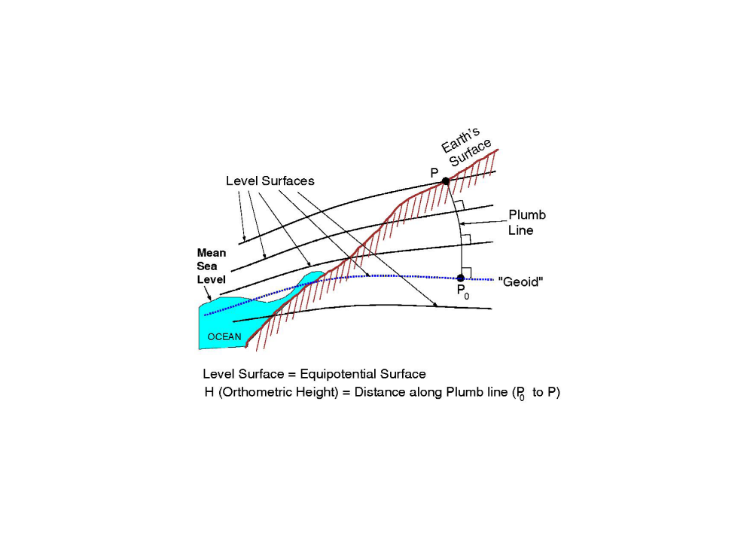
Figure 1: Orthometric height
Figure 2 is a schematic diagram showing the relationship between the geoid, orthometric heights and ellipsoid.
Note: The ellipsoid is drawn above the geoid. This is the actual case for all points in the conterminous United States. Also note that the ellipsoid does not coincide with any level surface, but rather cuts across them. This is because the ellipsoid is a geometric invention, and not defined by the actual gravity field of the Earth itself.
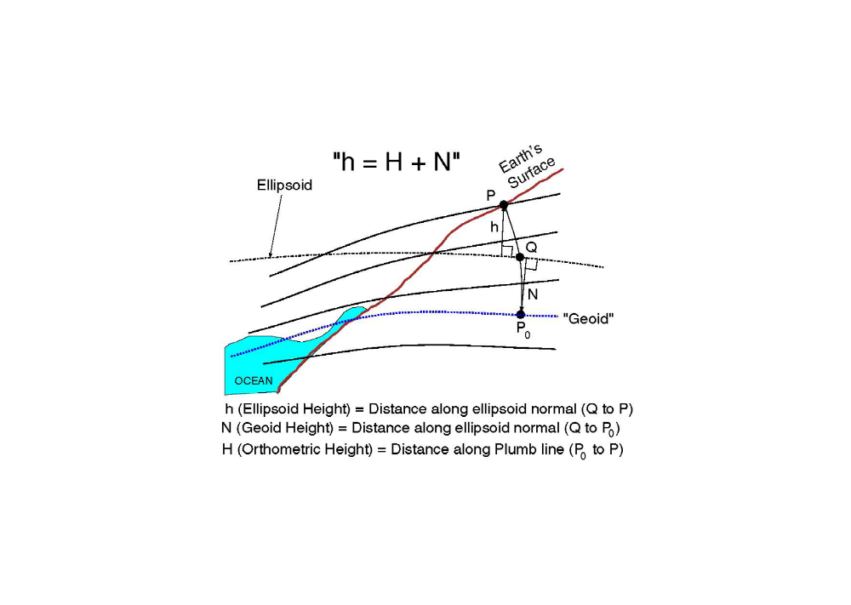
Figure 2: Ellipsoid and orthometric height
Editor's Note: Source of figures and accompanying text: <http://www.ngs.noaa.gov/GEOID/geoid_def.html>
For emergency purposes, neither orthometric nor ellipsoidal height is of much value; height above (average) ground level is required. On the other hand, either orthometric or ellipsoid height of average ground can be kept in local databases in a sufficiently narrow mesh such that height above ground level can be by a database lookup and a subtraction.

4.2.2 Civic locating information
Civic locating information takes a similar format to a postal address, However, additional informational or vanity fieldssuch as company names, job titles or professional credentials might be included, none of which is strictly necessary to identify the location. In Figure 3 two extreme examples can be found.
Dr. med. dent. David M. Newfield  Deputy Director  Room 488  Dental Tools Ltd.  Silver Tower  4623 E Lower Broadway NW  Great Falls, MT 12345-6789  U.S.A. | Rolf Schmidt  Wässeristrasse 34  CH-8340 Hinwil
Figure 3: Example civic addresses

4.3 Coding principles for location information
Three different coding principles for location information are shown in this clause:
- Specific field definitions with binary values,
- Rigorously structured field definitions with textual information, and
- Loosely structured field definitions with textual information.

4.3.1 Specific field definitions
In RFC 4676 "Dynamic Host Configuration Protocol (DHCPv4 and DHCPv6) Option for Civic Addresses Configuration Information" [3] the information element as shown in Figure 4. The "what" field indicates what the location designates (DHCP server, network element believed to be closest to the client, or client itself), the country code is coded according to ISO-3166-1's two letter country code [1], and the civic address elements are a sequence of elements as indicated in Table 1 (see § 4.3.2).
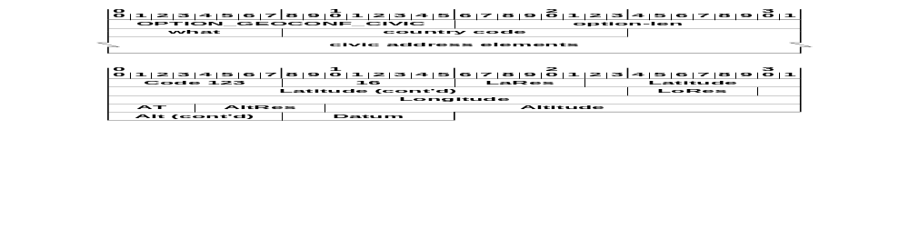
Figure 4: The DHCPv6 civic address option (Example)
For geodetic location information, RFC 3825 " Dynamic Host Configuration Protocol Option for Coordinate-based Location Configuration Information" [4] defines the following Information element. Latitude, Longitude, and Altitude are fixed decimal point real values, LaRes, LoRes, and AltRes indicate the acccuracy of the values. The datum designates the particular international Earth coordinate system, e.g., WGS84 [2].
Note: LaRes, LoRes, and AltRes can be used to indicate a volume of space.
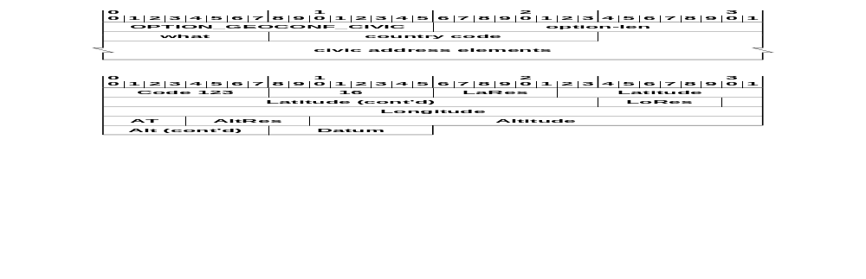
Figure 5: Location Configuration Information (LCI) Elements (Example)

4.3.2 Rigorously structured field definitions
The following example of an XML structure assumes the presence of the civic address fields as shown in Table 1.
Table 1: Civic address structure (North America)
Label | Description | Example
country | The country is identified by the two-letter ISO 3166 code [1] | US
A1 | national subdivisions (state, region, province, prefecture) | New York
A2 | county, parish, gun(JP), district (IN) | King's County
A3 | city, township, shi (JP) | New York
A4 | city division, borough, city district, ward, chou (JP) | Manhattan
A5 | neighborhood, block | Morningside Heights
A6 | street | Broadway
PRD | Leading street direction | N, W
POD | Trailing street suffix | SW
STS | Street suffix | Avenue, Platz, Street
HNO | House number, numeric part only. | 123
HNS | House number suffix | A, ½
LMK | Landmark or vanity address | Low Library
LOC | Additional location information | Room 543
FLR | Floor | 5
NAM | Name (residence, business or office occupant) | Joe's Barbershop
PC | Postal code | 10027-0401
BLD | Building (structure) | Hope Theatre
UNIT | Unit (apartment, suite) | 12a
ROOM | Room | 450F
PLC | Place-type | Office
PCN | Postal community name | Leonia
POBOX | Post office box (P.O. box) | U40
ADDCODE | Additional Code | 13203000003
SEAT | Seat (desk, cubicle, workstation) | WS 181
RD | Primary road or street | Broadway
RDSEC | Road section | 14
RDBR | Road branch | Lane 7
RDSUBBR | Road sub-branch | Alley 8
PRM | Road pre-modifier | Old
POM | Road post-modifier | Extended

Figure 6 shows the XML structure extracted from RFC 4119 " A Presence-based GEOPRIV Location Object Format" [5] and Figure 7 shows a coding example from the same source.
<?xml version="1.0" encoding="UTF-8"?>
<xs:schema
targetNamespace="urn:ietf:params:xml:ns:pidf:geopriv10"
xmlns:tns="urn:ietf:params:xml:ns:pidf:geopriv10"
xmlns:gbp="urn:ietf:params:xml:ns:pidf:geopriv10:basicPolicy"
xmlns:xs="http://www.w3.org/2001/XMLSchema"
elementFormDefault="qualified" attributeFormDefault="unqualified">

<xs:import namespace=
"urn:ietf:params:xml:ns:pidf:geopriv10:basicPolicy" />

<!-- This import brings in the XML language attribute xml:lang-->

<xs:import namespace="http://www.w3.org/XML/1998/namespace"
schemaLocation="http://www.w3.org/2001/xml.xsd"/>

<xs:element name="geopriv" type="tns:geopriv"/>

<xs:complexType name="geopriv">
<xs:sequence>
<xs:element name="location-info" type="tns:locInfoType"
minOccurs="1" maxOccurs="1"/>
<xs:element name="usage-rules" type="gbp:locPolicyType"
minOccurs="1" maxOccurs="1"/>
<xs:element name="method" type="tns:locMethod"
minOccurs="0" maxOccurs="1"/>
<xs:element name="provided-by" type="tns:locProvidedBy"
minOccurs="0" maxOccurs="1"/>
<xs:any namespace="##other" processContents="lax" minOccurs="0"
maxOccurs="unbounded"/>
</xs:sequence>
</xs:complexType>

<xs:complexType name="locInfoType">
<xs:sequence>
<xs:any namespace="##other" processContents="lax" minOccurs="0"
maxOccurs="unbounded"/>
</xs:sequence>
</xs:complexType>

<xs:complexType name="locMethod">
<xs:simpleContent>
<xs:extension base="xs:string">
<xs:attribute ref="xml:lang" />
</xs:extension>
</xs:simpleContent>
</xs:complexType>

<xs:complexType name="locProvidedBy">
<xs:sequence>
<xs:any namespace="##other" processContents="skip"
minOccurs="1" maxOccurs="unbounded"/>
</xs:sequence>
</xs:complexType>

</xs:schema>
Figure 6: XML structure of civic address
<?xml version="1.0" encoding="UTF-8"?>
<presence xmlns="urn:ietf:params:xml:ns:pidf"
xmlns:gp="urn:ietf:params:xml:ns:pidf:geopriv10"
xmlns:cl=" urn:ietf:params:xml:ns:pidf:geopriv10:civicLoc"
entity="pres:geotarget@example.com">
<tuple id="sg89ae">
<status>
<gp:geopriv>
<gp:location-info>
<cl:civicAddress>
<cl:country>US</cl:country>
<cl:A1>New York</cl:A1>
<cl:A3>New York</cl:A3>
<cl:A6>Broadway</cl:A6>

Figure 7: Example XML structured data (Part 1)
<cl:HNO>123</cl:HNO>
<cl:LOC>Suite 75</cl:LOC>
<cl:PC>10027-0401</cl:PC>
</cl:civicAddress>
</gp:location-info>
<gp:usage-rules>
<gp:retransmission-allowed>yes</gp:retransmission-allowed>
<gp:retention-expiry>2003-06-23T04:57:29Z</gp:retention-expiry>
</gp:usage-rules>
</gp:geopriv>
</status>
<timestamp>2003-06-22T20:57:29Z</timestamp>
</tuple>
</presence>

Figure 7: Example XML structured data (Part 2)

4.3.3 Loosely structured field definitions
Figure 8 shows an example of a loosly structured location information. One or more names are separated from one or more general address lines; the fields for town, zip code, and country are distingushable. ISO-3166-1's two letter country code [1] gives an unambiguous, short, and well known value to designate a country.
name=Adalbert H. Miller
name=Adelheide Roslin
a=Silver Tower
a=Floor 15
a=411 Lower Riverside Ave
town=Ottawa
zip=Ont. Q3X 4T0
country=CA

Figure 8: Loosly structured location information (Example)
Note: Under the assumption that emergency calls are relatively local and that the civic location information is prepaired by trained personell, a heavily detailed structure as shown in § 4.3.2 might not be necessary. Indeed, the additional fields may only cause confusion.

5 Developments in Europe (EU)
<Text>

5.1 The CGALIES survey — Excerpt of Final Report

5.1.1 Type of areas
- Rural environment: Sparsely inhabited areas, fields, forests, etc.
- Rural extreme environment: A rural environment with a very large cell size.
- Suburban environment: Populated areas, residential houses, villages.
- Suburban extreme environment: A suburban environment with abundant shadowing, blocking and multi-path possibilities.
- Urban environment: Densely populated areas, multi-story buildings, offices, city centres.
- Urban extreme environment: Extremely densely populated areas, high-rise buildings
- Indoor environment: …
- Highway and Crossroad environment: …

5.1.2 Type of information
- Master Street Address Guides (MSAGs) must be established for fixed lines.
- Master Street Address Guides (MSAGs) must contain both tabular (physical streets and boundaries) and spatial (X- and Y-coordinates).
- Master Street Address Guides (MSAGs) must be available for all fixed line numbers, i.e., include private, non-listed, and MSN numbers.
- An Automatic Location Identification (ALI) database must be updated at least every 24 hours.
- The tabular information must include an indication whether the Calling Line Identity (CLI) is an entry to a customer network (company or private).
- Customer networks should maintain their own Automatic Location Identification (ALI) database and provide this information to outgoing emergency calls.
- In urban environments the height should be indicated.
- Emergency services indicate that the provision of the caller's direction and speed would be useful in the following situations:
- Detection whether the caller is moving or static;
- Establish whether the caller could be a "Good Samaritan";
- Establish whether the caller is involved in the reported incident;
- Locate the caller during a suspected kidnapping incident;
- Estimate speed and direction as an estimate of the location of the reported incident; and
- Determine which side of a carriageway an incident has occurred.
Note: Interpretation of multiple location estimates (location history) can be used to provide direction and speed indication.
- The direction and speed indication should be provided at the time the call is initiated.
Note: It may also be acceptable if the information is provided as a separate update during the call or even after call completion.
- Location and velocity (i.e., direction and speed) information can be used to identify whether multiple calls refer to the same incident or whether the call originates from a "Good Samaritan".

5.1.3 Use of the Location Information
- Routing: The Location Information is used to route the call to the correct stage 1 Pubic Safety Answering Point (PSAP).
- Dispatching: The Location Information is used to route the call to the correct stage 2 Pubic Safety Answering Point (PSAP) and/or Emergency Service Centres (i.e., fire, police, ambulance/medical)
- Finding: The Location Information is used to find the caller and/or incident.
- X- and Y-coordinates: Routing, dispatching, and finding shall be based on X/Y-coordinates. Tabular information may be useful for finding the final steps to the caller.

5.1.4 Accuracy
- First rough estimate: This estimate is used for routing and dispatching and should be available within 7 seconds after call initiation. The required accuracy for this initial location information is between 200 to 300 m for all environments.
- The caller’s location information for caller finding must be available within 30 seconds after call initiation. The accuracy requirements are summarized in the following table.
 | Caller can provide general information | Caller cannot provide general information
Indoor | 010 … 050 m | 010 … 050 m
Urban | 025 … 150 m | 010 … 150 m
Suburban | 050 … 500 m | 010 … 500 m
Rural | 100 … 500 m | 010 … 500 m
Highway / crossroads | 100 … 500 m | 010 … 500 m

- The vertical accuracy requirement for caller finding in urban environments is 10 … 15 m. There exists no requirement for other environments.

5.2 Void
<text>

6 Developments in Australia
<text>

7 Developments in North America
<text>

7.1 IETF, NENA, ATIS — Synopsis of Technical Report
This clause provides a synopsis of the ATIS draft Technical Report “Location Acquisition and Location Parameter Conveyance for Internet Access Networks in Support of Emergency Services”. The 50 page document has been circulated widely to SDOs and was received by ETSI TC TISPAN and SC EMTEL as a liaison statement on which ATIS requested comments. This synopsis, compiled by STF315 is intended to assist TISPAN AND EMTEL delegates in their consideration of the ATIS document. Note that we have not intentionally expressed any opinions regarding the content of the report. Annex A contains a list of acronyms used in this synopsis.

7.1.1 Abstract
The ATIS document describes the specific areas of location acquisition and location parameter conveyance in IP access networks and is concerned with both the architectures and protocols for supporting these functions. It describes the manner in which IP devices request location information from the LIS function in an access network and the manner in which the LIS function obtains information from the access net-work supporting the requesting IP device in order to calculate the device’s location.
The LIS function is identified as an essential component of the NENA-defined i2 architecture for VoIP emergency services and continues to be required in the i3 architecture currently under definition. The ATIS document describes the LIS requirements, as specified by NENA in terms of those architectures, examines the candidate protocols for location acquisition (HELD, DHCP, LLDP-MED) and provides a gap analysis.
The concepts of location parameter conveyance are described and a specific architecture (the LIS-ALE architecture) is described. A flexible LIS-ALE protocol is described (FLAP) and examples are provided of its application in some common forms of broadband access networks.
The technical report is intended to be used as input to further decision-making processes leading to any necessary policy and/or American National Standards formulation and as a vehicle for communicating concepts in liaisons with other relevant SDOs.

7.1.2 Introduction/Executive Summary
The NENA VoIP migratory working group defined the i2 network architecture to support emergency service calls originating from VoIP services on the Internet. The architecture identifies a network element called the Location Information Server (LIS) that provides location data used for call routing and for display at the PSAP operator terminal.
The i2 specification did not detail the protocol to be used by the LIS for providing location information to the VoIP device or proxy nor the manner in which location should be determined for different Internet access technology types. A separate NENA document defined the requirements for the LIS.
The document divides the subject into two areas. The first is “Location Acquisition” which describes the manner in which LIS clients interact with the server to obtain location. Candidate location acquisition protocols (DHCP, LLDP-MED, HELD, and RELO) are compared against the NENA defined requirements. The second area is “Location Determination” which is the manner in which a LIS determines the location of a device in specific access network types. A variety of access technologies are examined and a generic architecture based on access location entities (ALE) providing network parameters to the LIS is described. A protocol called the Flexible LIS-ALE Protocol (FLAP) is described which supports this architecture.
The results of the location acquisition protocol comparison and the description of the LIS-ALE architecture and FLAP protocols are provided as a basis for discussion and decision-making. Input from a range of SDOs in response to this document is solicited.

7.1.3 NENA i2 Architecture
The NENA i2 initiative was proposed with the intent of addressing the immediate need of providing standard emergency services support to next generation Residential Broadband VoIP phone users. The NENA architecture is shown in Figure 9.
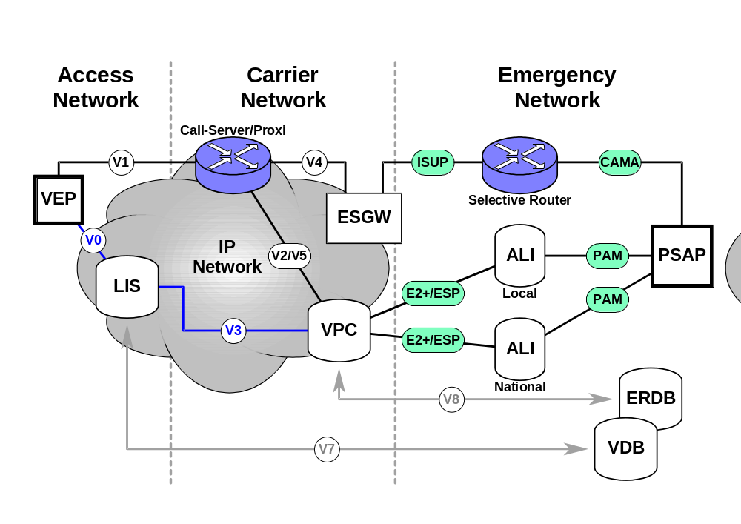
Figure 9: NENA i2 architecture
The requirements for the LIS (Location Information Server) cover the following three areas:
- Location determination and acquisition (DA)
- Location representation (Rep)
- Location security and dependability (LocSec)
The NENA i2 architecture and global interoperability
The ATIS document asserts that global inter-operability could be enhanced if the i2 architecture were widely adopted and that the two key functions of emergency call routing and the delivery of location information that the i2 architecture provides are common to emergency services world-wide. In support of this assertion, the report notes the requirement to service roaming and nomadic subscribers and suggests that rather than requiring a call server implementation to adapt to an arbitrary number of systems, protocols, and interfaces, there might be a major benefit if all jurisdictions adopt the same approach.

7.1.4 Location Determination in Broadband Access Networks
This section of the ATIS report examines a range of common access technologies and provides examples of how location determination is possible, and the key parameters that need to be captured in order to permit location determination. The examples provided are illustrative and not comprehensive nor definitive. The descriptions of ADSL, cable, and 3G technologies appear to be accurate in terms of representing actual deployment topologies and signalling scenarios though there is scope for variation in detail in the real world. WiMAX standards are still under definition by the IEEE and references to the types of network parameters that contribute to location determination and the signalling scenarios by which those parameters may be extracted from the network are more speculative.

7.1.5 LIS Operational Considerations
The conceptual role of the Location Information Server (LIS) is to provide location information (optionally digitally signed) to its clients. This is straightforward from a conceptual perspective but may have significant operational implications. For example, the organization that delivers broadband Internet access to users may actually be made up of separate business entities and the relationship between the different entities impacts the practical implementation of the, otherwise logical, LIS function and has a bearing on the specific functionality that a given LIS entity will have.
The types of LIS operators (organizational entities that may own and operate a LIS) include, though may not be limited to, the following:
- Access infrastructure providers
- RBPs for DSL, Cable, 3G, WiMAX etc.
- Municipal and community WiFi network operators
- Internet Service Providers
- Providers of Internet access to the public
- May own or use third party access infrastructure
- Geo-distributed LAN operators
- Commercial enterprise with broad geographic coverage
- Government enterprise operator
- Academic and research network operator
- Extensive private estate network operator
- Geo-point LAN operator
- Residential LAN
- Single access point hotspot
As described in the introductory text, the form and function of the LIS implementation in each of the above cases will vary. The form and function that a specific instance of a LIS has will vary depending on the nature of the network it is supporting and the role that the operator of that network plays in the larger picture of Internet access. The specifics of form and function will inevitably be influenced by these aspects and the business and other relationships that exist between network types.
Some variants of LIS implementation that can be identified from these different network scenarios can be labelled as
- General LIS;
- Gateway LIS;
- Proxy LIS; and
- Relay LIS.
Figure 10 shows an overall network topology illustrating the relationships between these types of LIS implementations.
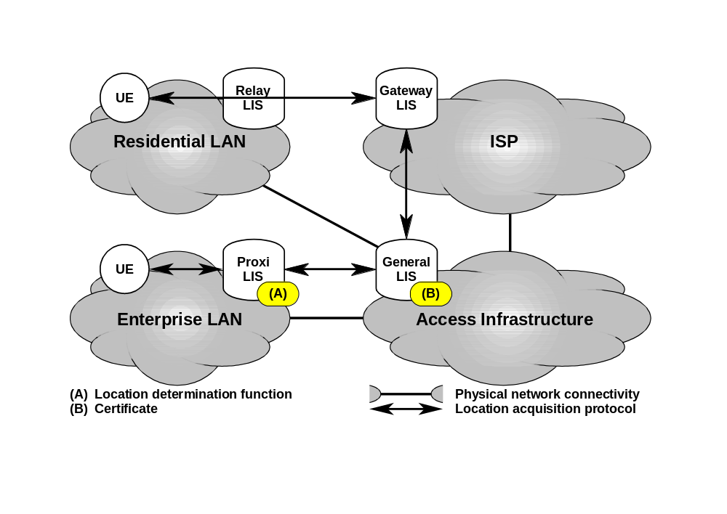
Figure 10: LIS Types and associated network types

7.1.6 Location Acquisition Protocols
The term “location acquisition” refers to the process of a client device or application requesting, and receiving, location information from the LIS. There is a number of approaches and philosophies related to this acquisition process and the protocols that support it. The following candidates are analyzed:
- Dynamic Host Configuration Protocol (DHCP) RFC3825;
- Link Layer Discovery Protocol for Media Endpoint Devices (LLDP-MED);
- HTTP Enabled Location Delivery (HELD);
- Retrieving End-System LOcation information (RELO);
- A Location Reference Event Package for the Session Initiated Protocol (LREP-SIP); and
- Location Configuration Protocol (LCP).
Table 2 is the result of a gap analysis and shows the support of the 23 NENA provided applicable requirements on location acquisition and determination by the candidate protocols.
Table 2: Support of the NENA requirements
Protocol | full support | partial support | no support | not applicable
DHCP | 10 | 2 | 8 | 3
LLDP-MED | 10 | 1 | 9 | 3
HELD | 21 | — | — | 2
RELO | 13 | 1 | 6 | 3
LREP-SIP | 13 | — | 8 | 2
LCP | 12 | 1 | 7 | 3

7.1.7 Location Parameter Conveyance
To capitalize on this common characteristic, a logical network function called an Access Location Entity (ALE) can be defined. The function of the ALE is to provide the LIS with the set of network parameters pertinent to location determination for the particular type of access network with which the ALE is associated. While the ALE is technology specific, the communication of a “set of network parameters” to the LIS is a common function. For this purpose, the Flexible LIS-ALE Protocol (FLAP) is proposed.
FLAP is currently only informally documented and has not been specified under the auspices of any SDO. Location measurement has, in the past, typically been done on a technology specific basis.

7.2 Void
<text>

8 Developments in the Far East
<text>

9 Handling of emergency sessions in 3GPP
This clause is an excerpt of 3GPP TS 23.167 V7.4.0 [xx]

9.1 Architecture
The architecture for the handling of emergency IMS sessions is shown in Figure 11.
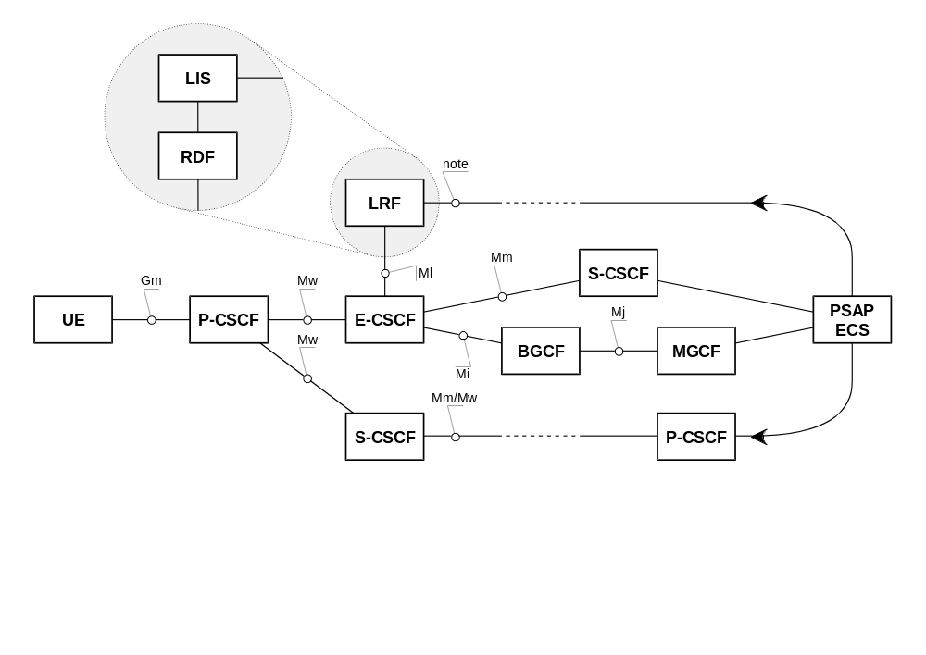
Note: This interface is not standardized by 3GPP, there might even exist regional differences depending on regulations and application services. TS 123271 recognizes four different categories of location services. These are the Commercial LCS, the Internal LCS, the Emergency LCS and the Lawful Intercept LCS.
Figure 11: E-CSCF and reference architecture
P-CSCF and E-CSCF are always located in the same network; this may be a visited network.
For simplicity, some functional components, e.g. IBCF, I-CSCF, MGCF and BGCF, are not shown in this figure.
It shall be possible to support configurations where the Location Retrieval Function (LRF) may consist of a Routing Determination Function (RDF) and a Location Information Server, the interface between Location Information Server and RDF is out of scope of the 3GPP specification. On the other hand, the RDF may be integrated in the Location Information Server (e.g. in the LRF).

9.2 User equipment (UE)

9.2.1 Requirements
1) The UE should be able to detect an emergency session establishment and include an appropriate indication in the request.
2) The UE should use a special emergency Public User Identifier in the IMS emergency registration request.
3) The UE may perform an IMS emergency session establishment without prior emergency registration when already IMS registered and it is in the home network.. Otherwise, the UE shall perform an IMS emergency registration.
4) The UE should include an emergency service indication in the emergency session request.
5) The UE should include an equipment identifier in the request to establish an emergency session for "anonymous user".
Note: "Anonymous user" in this context is the person who does not have sufficient credential for IMS registration.
6) The UE should attempt the emergency call in CS domain, if capable.
7) The UE should handle a 380 (Alternative Service) response with the type set to "emergency" as a result of emergency attempt.
8) The UE should handle a response with an indication, IMS emergency registration required as a result of emergency session establishment attempt.

9.2.2 Emergency session establishment request
The UE initiates the emergency session establishment request, and for the purpose of processing the request properly in the network the following specific information is supplied in the request message.
- Emergency session indication;
- Emergency Public User Identifier if an IMS emergency registration is performed. If not, any registered Public User Identifier is used;
- Optionally, type of emergency service. It could be implied in the above emergency session indication;
- UE's location information, if available; and
- The Tel URI associated to the emergency Public User Identifier, if available.

9.3 IMS Functional entities

9.3.1 Proxy Call Server Control Function (P-CSCF)
Upon receipt of an emergency session establishment request from a UE the P-CSCF shall perform the following actions:
- The P-CSCF shall handle registration requests with an emergency Public User Identifier like any other registration requests. The P-CSCF may set the proposed registration expiration time according to the local policy and change the expiration value in the REGISTER requests, and then forward the request to the IBCF or I-CSCF in the user's home network.
Note: If the registration expiration time is changed by the P-CSCF in the visited network, the S-CSCF in the home network should obtain the proposed registration expiration value from the REGISTER request and use the same registration expiration time.
- The P-CSCF shall detect an emergency session establishment request. Dependent on local policies, it shall reject or allow unmarked or anonymous emergency requests.
- The P-CSCF shall prevent the assertion of an emergency Public User Identifier in non-emergency requests
- The P-CSCF may query IP-CAN for a location identifier.
- The P-CSCF shall select an E-CSCF in the same network to handle the emergency session request. This selection is based on local procedures.
- The P-CSCF shall establish the emergency session with the locally defined priority for emergency sessions.
- The P-CSCF shall check the validity of the caller Tel URI if provided by the UE and shall provide the Tel URI in the session establishment request if it is aware about the Tel URI associated with the emergency Public User Identifier.
- The P-CSCF may respond to the UE with an indication, IMS emergency registration required as a result of processing the emergency session establishment attempt.
- The P-CSCF should be able to identify the service data flow associated with emergency service and inform PCRF accordingly.

9.3.2 Emergency Call Server Control Function (E-CSCF)
Upon receipt of an emergency session establishment request from a P-CSCF the E-CSCF shall perform the following actions:
- If location information is not included in the emergency request or additional location information is required, the E-CSCF may request the LRF to retrieve location information.
- If required, the E-CSCF requests the LRF to validate the location information if included by the UE.
- The E-CSCF determines or queries the LRF for the proper routing information/PSAP destination.
- The E-CSCF shall route emergency session establishment requests to an appropriate destination including anonymous session establishment requests.
- Subject to national requirements, the E-CSCF may send the contents of the P-asserted ID or UE identification to the LRF.
- Based on local policy, the E-CSCF may route the emergency IMS call to an ECS for further call process.

9.3.3 Location Retrieval Function (LRF)
The LRF is responsible for retrieving the location information of the UE that has initiated an IMS emergency session. It shall be possible to support configurations where the LRF may consist of a Routing Determination Function (RDF) and a Location Information Server (LIS), the interface between LIS and RDF is out of scope of the 3GPP specification.
The LRF utilises the RDF to provide the routing information to the E-CSCF for routing the emergency request. The RDF can interact with a location functional entity that provides real-time information about the location of Mobile Station and manage ESQK allocation and management. The ESQK is used by the PSAP to query the LRF for location information and optionally a call-back number. The LRF-PSAP interactions are outside the scope of the 3GPP specification.
Information provided by the LRF to the E-CSCF includes the routing information and other parameters necessary for emergency services, which are subject to local regulation. For example, this information may include the ESQK, ESRN, PSAP SIP URI or Tel URI.
In order to provide the correct PSAP destination address to the E-CSCF, the LRF may require interim location information for the UE.
Note: In some regions, for example in the North American region, it may be a requirement to provide the PSAP with an accurate initial location estimate for the UE and possibly to provide an accurate updated location estimate for the UE if requested by the PSAP. When this requirement exists, the LRF may store a record of the emergency session including all information provided by the E-CSCF and shall only release this record when informed by the E-CSCF that the emergency session has terminated. The information provided by the LRF to the E-CSCF (e.g. ESQK) shall then include correlation information identifying both the LRF and the emergency session record in the LRF. This correlation information shall be transferred to the PSAP during session establishment (e.g. in a SIP INVITE or via SS7 ISUP signalling from the MGCF). The PSAP may use this information to request an initial location estimate from the LRF and/or to request an updated location estimate.

9.4 Procedures for IMS Emergency Services (Overview)

9.4.1 Procedures without Location Retrieval Function (LRF)
Figure 12 contains a high level description of the emergency service procedures performed when the UE can detect the emergency session is being requested.
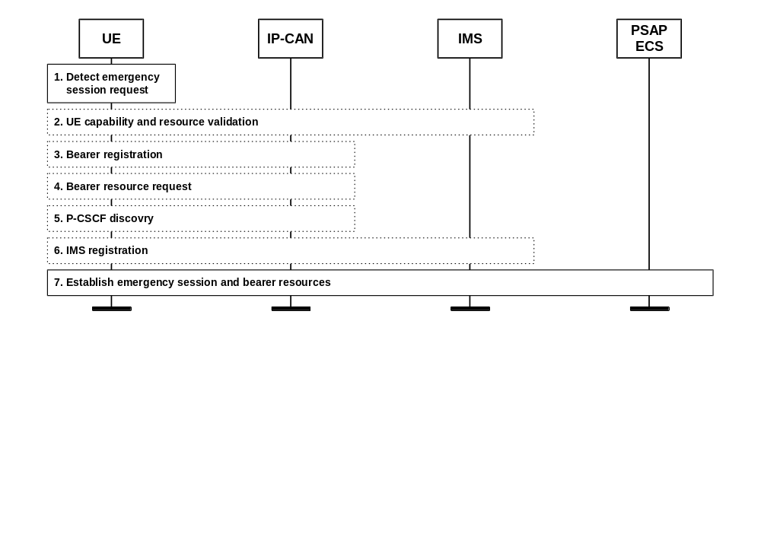
Figure 12: UE detected emergency call

9.4.2 Procedures involving the Location Retrieval Function (LRF)
Figure 13 illustrates a high level call flow for the IMS emergency session establishment procedure using LRF/RDF to retrieve location and routing information.
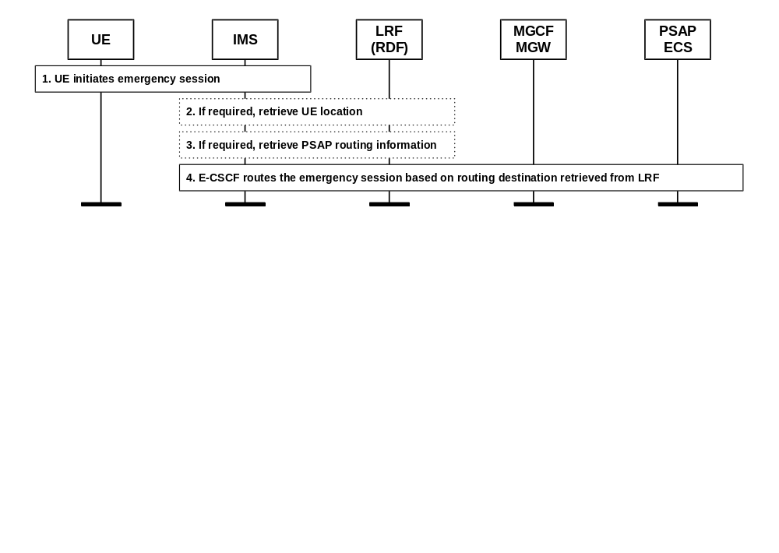
Figure 13: Emergency Session Establishment procedure using LRF/RDF

9.4.3 Acquiring location information from the UE and/or the network
Figure 14 shows a high level sequence of flows that illustrate the location information acquisition of both the UE, the IMS core, and the PSAP.
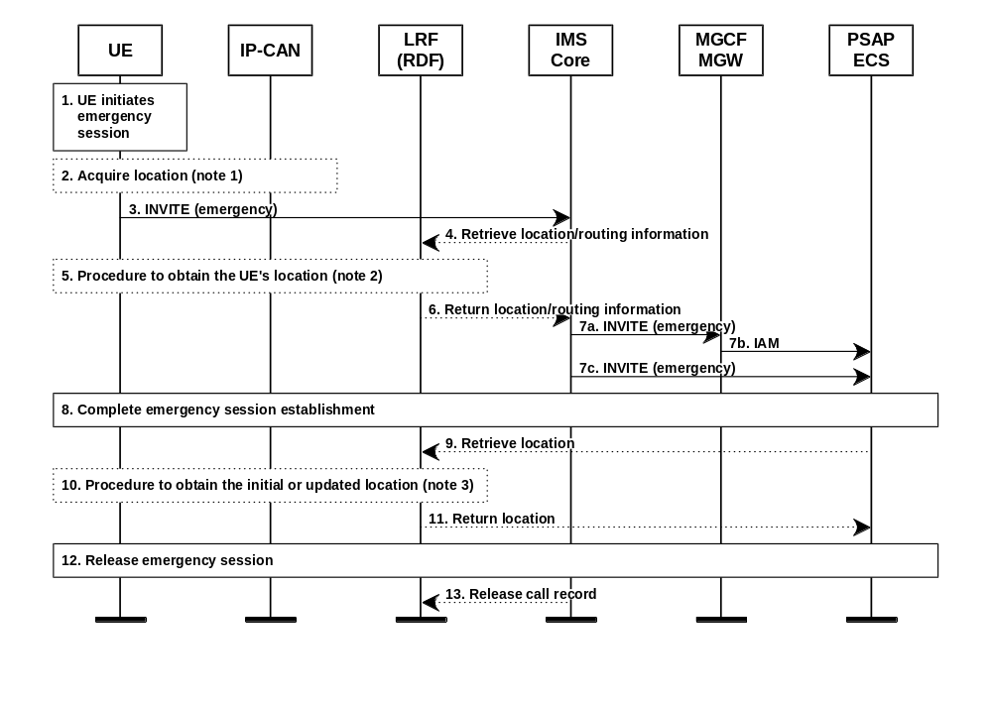
Note 1: The UE determines its own location or location identifier if possible. If the UE is not able to determine its own location, the UE may, if capable, request its location information from the IP-CAN, if that is supported for the used IP-CAN. If applicable, the IP-CAN delivers to the UE the UE's geographical location information and/or the location identifier.
Note 2: The LRF may already have the information requested by IMS core or LRF may request the UE's location information. The means to obtain the location information may differ depending on the access technology the UE is using to access the IMS.
Note 3: The LRF determines the target UE's location using one the same means as in step 5. The LRF may use the correlation information received in step 9 to retrieve information about the UE that was stored in step 5.
Figure 14: Handling of location information in IMS emergency calls

10 Categories of impact on location information

10.1 Mobility
The mobility categories are listed in Table 3.
Table 3: Mobility categories
Category | Attachment | Hand-over | Access provider | Responsibility
1) wired  2) wireless  3) nomadic  4) mobile  5) roaming | wired  wireless  wireless  wireless  wireless | N/A  not supported  not supported  supported  supported | N/A  home network  visited network  home  visited network | TISPAN  TISPAN 3GPP  TISPAN 3GPP  3GPP  3GPP

Note: In TR 180 000 the terms "nomadism", "mobility", and "roaming" are defined as follows:
Nomadism: Ability of the user to change his network access point; when changing the network access point, the user's service session is completely stopped and then started again, i.e., there is no session continuity or hand-over possible. It is assumed that normal usage pattern is that users shutdown their service session before changing to another access point.
Mobility: The ability for the user or other mobile entities to communicate and access services irrespective of changes of the location or technical environment. The degree of service availability may depend on several factors including the Access Network capabilities, service level agreements between the user's home network and the visited network (if applicable), etc. Mobility includes the ability of telecommunication with or without service continuity.
Roaming: The ability of users to access services while outside of their subscribed home network, i.e. by using an access point of a visited network. This is usually supported by a roaming agreement between the respective network operators.
1) Wired:
This category represents the situation where the UEs are not moved or stay within the accuracy requirements discussed in clause 4.1 (i.e., limited by the length of the attachment cable).
2) Wireless:
This category represents the situation where the UEs are attached to the home network via WiFi or DECT technology.
3) Nomadic:
This category represents the situation where the UEs are attached to a visited network via WiFi or DECT technology.
4) Mobile:
This category represents the situation where the UEs are operating in the home network using UMTS technology.
5) Roaming:
This category represents the situation where the UEs are operating in a visited network using UMTS technology.

10.2 UE attachment
The UE attachment categories are listed in Table 4.
Table 4: UE attachment categories
Category | Comment
1) wireline  2) WiFi / DECT  3) Tunnel | static  wireless, reach ~ 30 m  point-to-point

1) Wireline:
The wireline UE attachment is a static situation, the UE is capable of moving only up to the length of the cord. This is even in extreme cases within the accuracy requirements of the PSAPs and ECCs.
2) WiFi / DECT:
WLAN and DECT attachment are both wireless attachment methods. The reach of the wireless part of the attachment is in both cases within the accuracy requirements of the PSAPs and ECCs, i.e., movement of the UE is irrelevant for the purpose of the emergency location. For the discussion of emergency location there exists no need to distinguish between WiFi and DECT.
3) Tunnel:
The attachment of a UE via a tunnel, e.g., VPN tunnel, is comparable to a wireline attachment with the difference that the attachment can be anywhere. At different times, the far end of the tunnel may be at different (geographically widely separated) locations. The tunnel is transparent in the sense that the information transported is not interpreted (LI excluded).

10.3 CPN Architecture
The CPN Architecture categories are listed in Table 5. The table shows the different categories and their classification depending on:
- The number of access network providers (ANP);
- The boundary of the different network attachments to be within or beyond the accuracy requirements of the PSAPs and ECCs (NT Spread); and
- The boundary of the different UEs to be within or beyond the accuracy requirements of the PSAPs and ECCs (UE Spread).
Table 5: CPN Architecture categories
Category | ANP | NT Spread | UE Spread
1) CPN non-existent  2) CPN / one geographical area  3) CPN / different geographical areas  4) CPN / multi-homing, different areas  5) CPN / multiple access providers, one area  6) CPN / multiple access providers, different areas | one  one  one  one  multiple  multiple | single  within accuracy  within accuracy  beyond accuracy  within accuracy  beyond accuracy | within accuracy  within accuracy  beyond accuracy  beyond accuracy  within accuracy  beyond accuracy

1) CPN non-existent
This category represents the typical traditional attachment of UEs directly to an NT. Multiple UEs may be attached to the NT, nevertheless, there exist no switching functionality to allow direct communication between those UEs. All UEs are located within the accuracy requirements of the PSAPs and ECCs (see Figure 15).
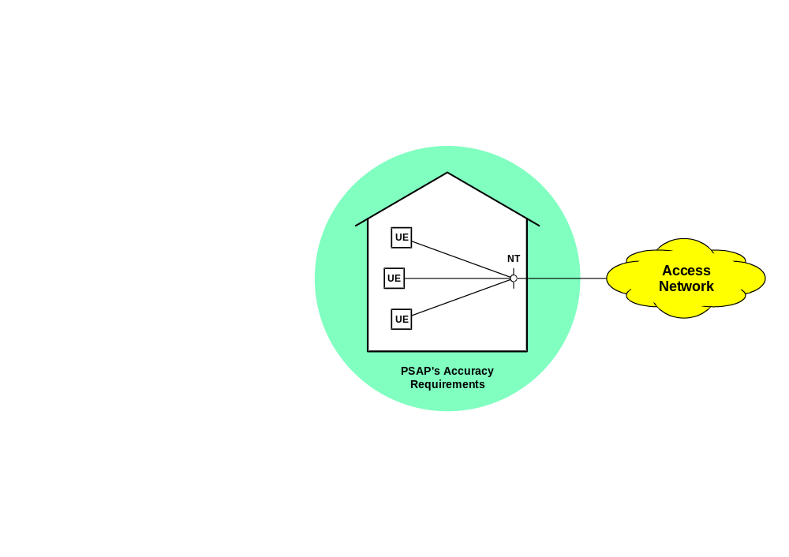
Figure 15: Example CPN category 1
2) CPN / one geographical area
This category represents local area networks typically present in residential or SME situations; these LANs allow communication among the different UEs. All UEs are located within the accuracy requirements of the PSAPs and ECCs (see Figure 16).
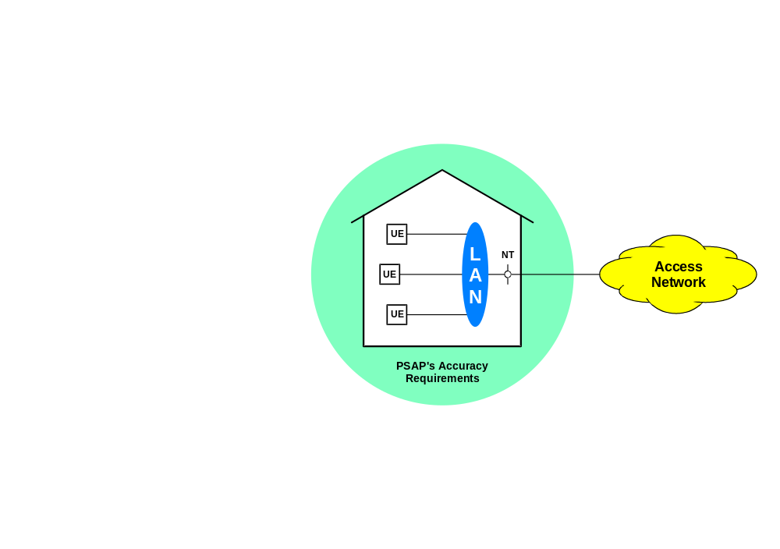
Figure 16: Example CPN category 2
3) CPN / different geographical areas
This category represents local area networks in larger complexes where one access network provider uses one or more NTs for the LAN attachment all within the accuracy requirements of the PSAPs and ECCs. On the other hand, the UEs are spread beyond the accuracy requirements of the PSAPs and ECCs, e.g., in multiple buildings (see Figure 17).
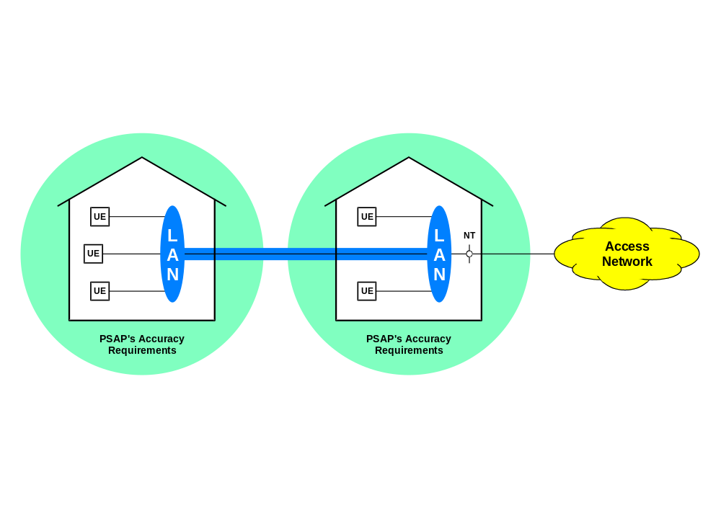
Figure 17: Example CPN category 2
4) CPN / multi-homing, different areas
This category represents local area networks for corporations that consist of offices dispersed for example throughout a country. One access network provider realises LAN attachments at more than one location and those NTs are spread beyond the accuracy requirements of the PSAPs and ECCs, e.g., in widely separated offices (see Figure 18).
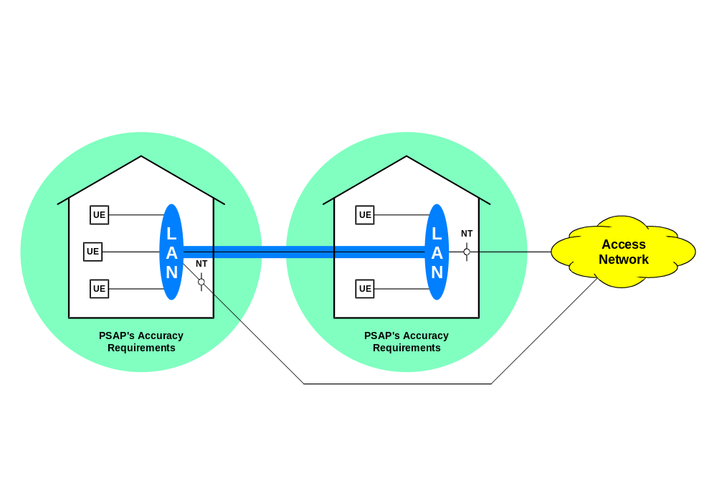
Figure 18: Example CPN category 2
5) CPN / multiple access providers, one area
This category represents local area networks similar to category 4 above. The NTs, however, represent attachments from different access network providers; this may augment the fail-save capability of the attachment (see Figure 19).
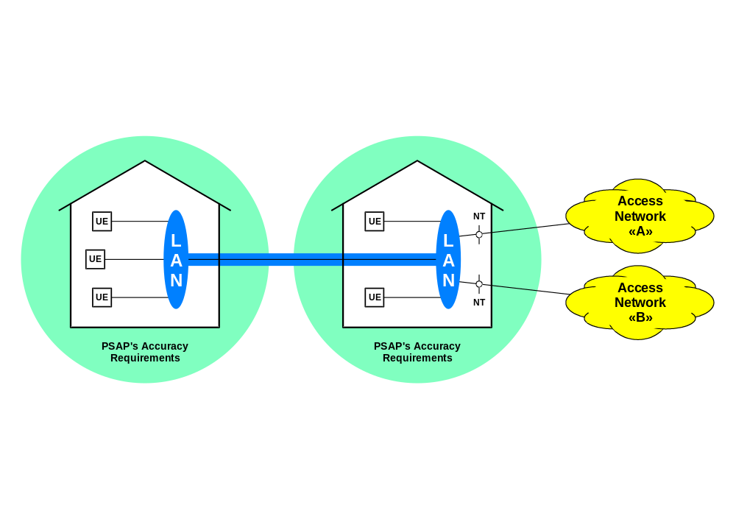
Figure 19: Example CPN category 2
6) CPN / multiple access providers, different areas
This category represents local area networks similar to category 5 above. The NTs, however, represent attachments from different access network providers. Such different attachments might be required if the "local" network crosses country boundaries or be required for an augmented fail-save capability (see Figure 20).
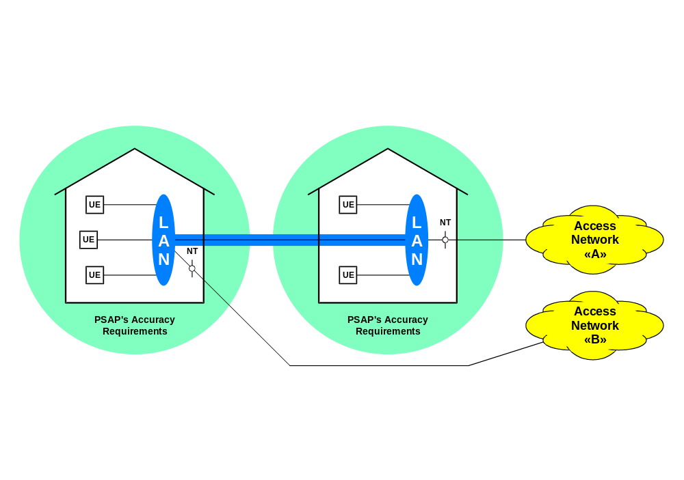
Figure 20: Example CPN category 2

10.4 Location information
The location information categories are listed in Table 6.
Table 6: Location information categories
Category | Comment
1) User Equipment  2) WiFi Access Point / DECT Base  3) Network Termination | maintained by GNSS client capability  maintained by CPN administration and DHCP Relay Agent Information  maintained by access provider

1) User Equipment:
If the UE is enabled with a GNSS client capability, this is the most accurate location for the origin of the emergency communication. In addition, it also provides accurate speed and direction of movement.
2) WiFi Access Point / DECT Base:
Where the location of a DECT base can be maintained by the same procedures as the location of wireline endpoints, the WiFi Access Points require the support of the DHCP Relay Agent Information Option [xx] and the option for Location Configuration Information [xx]. In addition, the UE must insert this Location Information in its communication with the PSAP.
Note: If all UEs are located within the accuracy requirements of the PSAPs and ECCs (see category 2 in clause 10.3) the specific locations of WiFi Access Points and DECT Bases need not be maintained nor determined at DHCP request time.
3) Network Termination:
The location information of the NT is maintained by the access provider similar to the maintenance of wireline terminations. This information could be inserted into the communication with the PSAP and to the LRF.

11 VOID
<text>

11.1 Void
<text>

Annex A (normative):
Title of normative annex

Annex B (informative):
Recommendation of the Commission (2003/558/EC)
of 25 July 2003
on the processing of caller location information in electronic communication networks for the purpose of location-enhanced emergency call services

B.1 Considerata
Having regard to the Directive 2002/21/EC on a common regulatory framework for electronic communications and services (the ‘Framework Directive’) ⁽¹⁾, and in particular Article 19 thereof,
Whereas:
(1) Decision 91/396/EEC on the introduction of a single European emergency call number ⁽²⁾ required Member States to ensure that the number 112 was introduced in public telephone networks as the single European emergency call number by 31 December 1992, with under certain conditions, a possibility for derogation until 31 December 1996.
(2) Directive 2002/22/EC on universal service and users' rights relating to electronic communications networks and services (the ‘Universal Service Directive’) ⁽³⁾, requires public telephone network operators (hereafter ‘operators’) to make caller location information available to authorities handling emergencies, to the extent technically feasible, for all calls made to the single European emergency call number 112. Directive 2002/58/EC concerning the processing of personal data and the protection of privacy in the electronic communications sector (the ‘Directive on privacy and electronic communications’) ⁽⁴⁾ establishes that providers of public communications networks and services may override the elimination of the presentation of calling line identification and the temporary denial or absence of consent of a subscriber or user for the processing of location data, on a per-line basis for organisations dealing with emergency calls and recognised as such by a Member State, including law enforcement agencies, ambulance services and fire brigades, for the purpose of responding to such calls.
(3) Although this Recommendation is concerned with location- enhanced 112, it is understood that parallel national emergency call numbers will be enhanced with the same functionality and following the same principles. Organisations operating private telecommunication installations are not affected by this Recommendation.
(4) For the successful implementation of E112 services throughout the Community, implementation issues must be addressed and timescales for the introduction of new systems coordinated. The Coordination Group on Access to Location Information by Emergency Services (CGALIES) established by the Commission in May 2000 as a partnership of public service and private sector players has allowed players of different sectors to discuss and find agreement on the principles for harmonised and timely implementation.
(5) Following on from the recommendation by CGALIES, providers of the public telephone network or service should use their best effort to determine and forward the most reliable caller location information available for all calls to the single European emergency call number 112.
(6) During the introductory phase of E112 services, application of the best efforts principle is considered preferable to mandating specific performance characteristics for location determination. However, as public safety answering points and emergency services gain practical experiences with location information, their requirements will become more defined. Moreover, location technology will continue to evolve, both within mobile cellular networks and satellite location systems. Therefore, the best effort approach will need to be reviewed after the initial phase.
(7) It is important for all Member States to develop common technical solutions and practices for the provision of E112. The elaboration of common technical solutions should be pursued through the European standardisation organisations, in order to facilitate the introduction of E112, create interoperable solutions and decrease the costs of implementation to the European Union.
(8) A harmonised solution across Europe would serve interoperability for advanced safety applications, such as calls which can be originated manually or automatically by an in-vehicle telematics terminal. These calls can provide additional information, for instance on the number of passengers in a car or bus, on compass-direction, on crash-sensor indicators, on the type of load of dangerous goods or on health records of drivers and passengers. With the high volume of cross-border traffic in Europe, there is a growing need for a common data transfer protocol for passing such information to public safety answering points and emergency services in order to avoid the risk of confusion or a wrong interpretation of data passed.
(9) The arrangements for forwarding location information by operators to public safety answering points should be established in a transparent and non-discriminatory way including, where appropriate, any cost aspects.
(10) The effective implementation of location-enhanced emergency call services requires that the caller's location as determined by the provider of the public telephone network or service is transmitted automatically to any appropriate public safety answering point that can receive and use the location data provided.
(11) Directive 2002/58/EC concerning the processing of personal data and the protection of privacy in the electronic communications sector (the ‘Directive on privacy and electronic communications’) generally requires that privacy and data protection rights of individuals should be fully respected and adequate technical and organisational security measures should be implemented for that purpose. However, it allows the use of location data by emergency services without consent of the user concerned. In particular, Member States should ensure that there are transparent procedures governing the way in which a provider of a public telecommunications network and/or service may override the temporary denial or absence of consent of a user for the processing of location data, on a per-line basis for organisations dealing with emergency calls and that are recognised as such by a Member State.
(12) Actions conducted in the context of the Community action programme in the field of Civil Protection (hereinafter ‘Civil Protection Action Programme’) ⁽⁵⁾ should aim to contribute to the integration of civil protection objectives in other Community policies and actions as well as to the consistency of the programme with other Community actions. This entitles the Commission to implement actions aiming at increasing the degree of preparedness of organisations involved in civil protection in the Member States, by enhancing their ability to respond to emergencies and improving the techniques and methods of response and immediate aftercare. This may include the handling and use of location information associated to E112 emergency calls by public safety answering points and emergency services.
(13) To achieve the objectives of this Recommendation, the need for a continued dialogue between public network operators and service providers and public authorities including emergency services becomes even stronger.
(14) When reporting on the situation of E112 implementation, national authorities should address any relevant technical feasibility issue that hinders the introduction of E112 for specific categories of end-users, as well as the technical requirements for handling emergency calls that may originate from SMS and telematic data services.
(15) The measures set out in this Recommendation are in accordance with the advisory opinion of the Communications Committee set up by Article 22 of Directive 2002/21/EC,

B.2 Recommendation
1. Member States should apply the following harmonised conditions and principles to the provision of caller location information to emergency services for all calls to the single European emergency call number 112.
2. For the purposes of this Recommendation, the following definitions should apply:
(a) ‘emergency service’ means a service, recognised as such by the Member State, that provides immediate and rapid assistance in situations where there is a direct risk to life or limb, individual or public health or safety, to private or public property, or the environment but not necessarily limited to these situations.
(b) ‘location information’ means in a public mobile network the data processed indicating the geographic position of a user's mobile terminal and in a public fixed network the data about the physical address of the termination point.
(c) ‘E112’ means an emergency communications service using the single European emergency call number, 112, which is enhanced with location information of the calling user.
(d) ‘public safety answering point’ means a physical location where emergency calls are received under the responsibility of a public authority.
3. Member States should draw up detailed rules for public network operators, to include, inter alia, the provisions in points 4 to 9 below.
4. For every emergency call made to the European emergency call number 112, public telephone network operators should, initiated by the network, forward (push) to public safety answering points the best information available as to the location of the caller, to the extent technically feasible. For the intermediate period up to the conclusion of the review as referred to in point 13 below, it is acceptable that operators make available location information on request only (pull).
5. Fixed public telephone network operators should make available the installation address of the line from which the emergency call is made.
6. Public telephone network operators should provide location information in a non-discriminatory way, and in particular should not discriminate between the quality of information provided concerning their own subscribers and other users. In the case of the fixed networks, other users include users of public pay phones; in the case of mobile networks or mobility applications, other users include roamers or visiting users, or, where appropriate, users of mobile terminals which can not be identified by the subscriber or user number.
7. All location information provided should be accompanied by an identification of the network on which the call originates.
8. Public telephone network operators should keep sources of location information, including address information, accurate and up-to-date.
9. For each emergency call for which the subscriber or user number has been identified, public telephone network operators should provide the capability to public safety answering points and emergency services of renewing the location information through a call back functionality (pulling) for the purpose of handling the emergency.
10. In order to facilitate data transfer between operators and public safety answering points, Member States should encourage the use of a common open interface standard, and in particular for a common data transfer protocol, adopted by the European Telecommunications Standards Institute (ETSI), where available. Such a standard should include the necessary flexibility to accommodate future requirements as they may arise, for instance from invehicle telematics terminals. Member States should ensure that the interface is best suited to the effective handling of emergencies.
11. In the context of the obligation for E112 services prescribed by the Universal Service Directive, Member States should provide adequate information to their citizens about the existence, use and benefits of E112 services. Citizens should be informed that 112 connects them to emergency services all across the European Union and that their location will be forwarded. They should also be informed about the identity of the emergency services that will receive their location information and of other necessary details to guarantee fair processing of their personal data.
12. In the context of the continuous evolution of concepts and technologies, Member States are encouraged to foster and support the development of services for emergency assistance, for instance to tourists and travellers and for the transport of dangerous goods by road or rail, including handling procedures for forwarding location and other emergency or accident related information to public safety answering points; to support the development and implementation of common interface specifications in ensuring Europe-wide interoperability of such services; and to encourage the use of location technologies with high precision such as third generation cellular network location technologies and Global Navigation Satellite Systems.
13. Member States should require their national authorities to report to the Commission on the situation of E112 implementation by the end of 2004 so that the Commission can undertake a review taking into account the emerging requirements from public safety answering points and emergency services and the evolutions and availability of technological capabilities for location determination.
14. This Recommendation is addressed to the Member States.

(1) OJ L 108, 24.4.2002, p. 33.  (2) OJ L 217, 6.8.1991, p. 31.  (3) OJ L 108, 24.4.2002, p. 31.  (4) OJ L 201, 31.7.2002, p. 37.  (5) OJ L 327, 21.12.1999, p. 53. | Done at Brussels, 25 July 2003.  For the Commission  Erkki LIIKANEN  Member of the Commission

Annex C:
Ad hoc network localisation
Node positioning in ad-hoc networks has been a research topic for several years. This clause summarizes one approach that has been elaborated at the Swiss Federal Institute of Technology (EPFL). The project investigates large area, wireless, mobile networks referred to as mobile ad-hoc wide area networks [52]. The main design points of the project are to eliminate any infrastructure and to build a decentralized, self-organized and scalable network where nodes perform all networking functions (traditionally implemented in backbone switches/routers and servers).
This clause summarizes an algorithm for GNSS-free positioning of the nodes in an ad-hoc network [51]. This shows that in the scenarios where an infrastructure does not exist and GNSS cannot be used, there is a way to obtain positions of the nodes by distributed processing. GNSS-free positioning is desirable, notably when the GNSS signal is too weak (e.g. in-doors), or if for cost or integration reasons the inclusion of a GNSS receiver has to be avoided.
The algorithm described is referred to as the Self-Positioning Algorithm (SPA) and is based on the Time of Arrival (TOA) method to obtain the distance between two participating devices. Despite the range measurement errors, and the motion of the nodes, the algorithm provides enough stability and location accuracy to sustain basic localisation functions.
Note 1: The project described in [51] does not use GNSS at all. Nevertheless, the Self-Positioning Algorithm provides enough information to every node to support Location Aided Routing [53] and Geodesic Packet Forwarding [54]; this is based on the relative coordination system derived by the algorithm. On the other hand, nodes that knows their position in a fixed coordinate system, e.g. WGS84, provides anchors and seeds to allow all other participating nodes to derive their location within the fixed coordinate system.
Note 2: For convenience, in this clause the term "node" is used to designate "user equipment" and all nodes participating in the algorithm are called the "cluster". In addition, the term "one-hop neighbour" designates nodes that can communicate directly, i.e. in one hop.

C.1 Step 1 – Time synchronization
This step is not discussed here; methods are publicly available. It is sufficient that the clock is set to a time common to the cluster.
Note: A clock running at 1 GHz provides for a distance measurement resolution of 300 mm. Considering that DECT, WiFi, etc. typically cater for a maximum range of 300 m (factor 1000) not more than 16 bits would be needed for the clock data; these 16 bits could be the lower part of a UTC time string.

C.2 Step 2 – Local coordinate system
In this step, the node becomes the centre of its own coordinate system with the position (0, 0) and the positions of its neighbours are computed accordingly. The algorithm works under the assumptions that all wireless links between the nodes are bidirectional and that the nodes make no use of information from directional antennae.
Note 1: There might be links that are unidirectional due to different signal strengths; such links are not used by the algorithm.
Note 2: Many nodes will use omnidirectional antennae.
Every node periodically broadcasts a location message with the following information:
- the node's ID and the time of the start of transmission of the message; and
- for all one-hop neighbours their ID and the measured distance.
When a location message is received, the ID of the sender is remembered and the distance of the sender is computed based on the transit delay as shown in Figure 21.
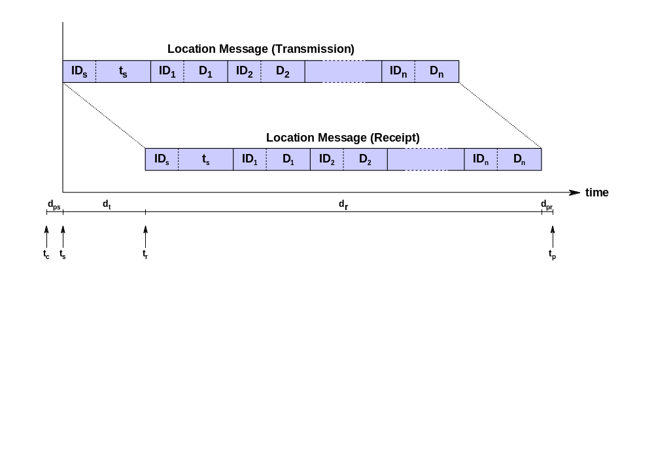
Legend:
 | t_{c} | Start compose time | d_{ps} | Sender processing delay | ID_{s} | Sender's ID
 | t_{s} | Start transmit time | d_{t} | Transit delay | ID_{n} | Sender's one-hop neighbour ID
 | t_{r} | Start receive time | d_{r} | Message receive delay | D_{n} | Distance between sender and its
 | t_{p} | Start processing time | d_{pr} | Receiver processing delay |  | one-hop neighbour

Figure 21: Receipt of a location message.
Note: The processing delay of the sender can be estimated by the sender and used to offset the timestamp before insertion into the message body. The receive delay can be computed by dividing the message length (including preambles, CRC, etc.) by the transmission rate. Finally, the receiver processing delay can be estimated by the receiver itself and considered when deriving the "start receive time" t_{r} and the transit delay.
With this procedure, every node knows its one-hop and some of the two-hop neighbours and some of the distances between them. A number of distances cannot be obtained due to the power range limitations or the obstacles between the nodes. Figure 22 shows node A at the origin and its one-hop neighbours and some of its two-hop neighbours. Continuous lines represent the known distances between the nodes.
Selecting two nodes P and Q that are also one-hop neighbours of each other leads to the determination of the local coordinate system as follows:
- Node A is placed at the origin;
- Node P is on the x-axis; and
- The y-coordinate of node Q is positive.
The coordinates of nodes A, P, and Q are shown in Table 7.
Node | x-coordinate | y-coordinate
A | 0 | 0
P | D_{AP} | 0
Q | D_{AQ} • cos γ | D_{AQ} • sin γ
Note: γ is derived from the distances D_{AP}, D_{AQ}, and D_{PQ} using the cosine rule of triangles.
Table 7: Initial coordinates in the local coordinate system
The coordinates of other one-hop neighbours can be computed if at least three other nodes exist whose coordinates are already known and the distance to the new node is known as well (see clause C.4).
Note: The coordinates of node W in Figure 22 cannot be computed, node W could lie anywhere on the dashed arc.
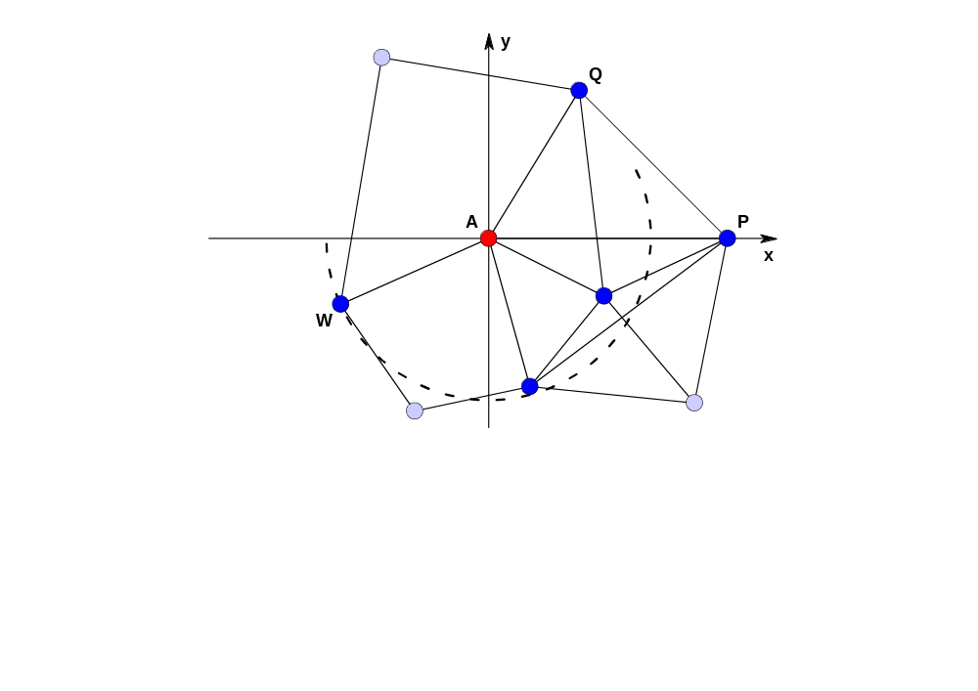
Figure 22: Local coordinate system

C.3 Step 3 – Network coordinate system
The local coordinate systems are – in general – not aligned. In order to achieve a common network coordinate systems, the different local coordinate systems must be rotated and perhaps also mirrored. In Figure 23, the direction of node B in node A's local coordinate systems is at angle α, the opposite direction from node's B view at angle β. Angle α needs to be communicated to node B that the can rotate its coordinate system by β-α+π.
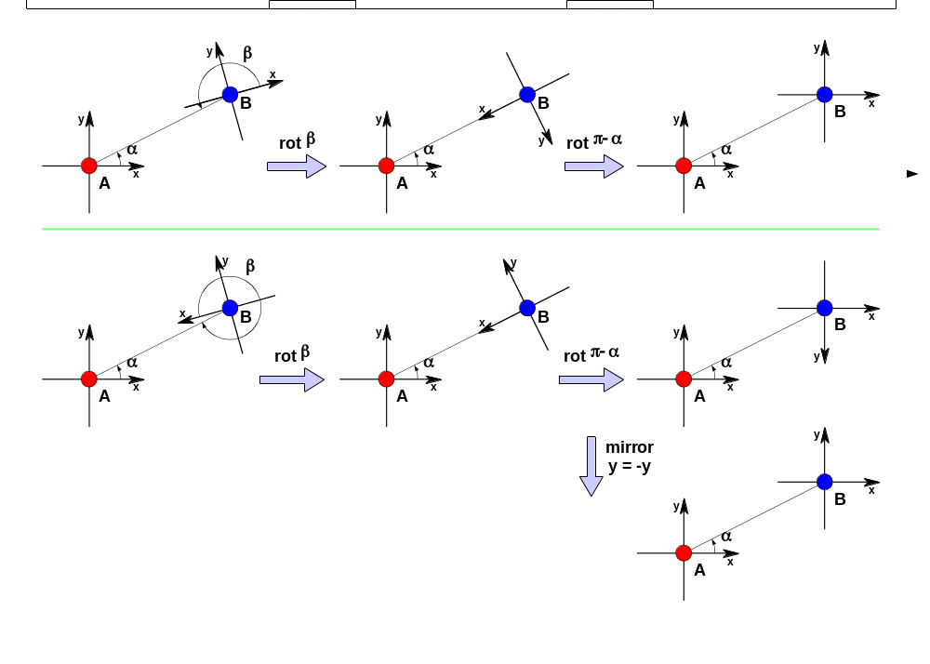
Figure 23: To mirror or not to mirror – two procedures for aligning local coordinate systems
For the determination whether the y-coordinates need to be mirrored, a third node C is required. The mechanism is illustrated in Figure 24 (4a and 4b show the case without mirroring, 4c and 4d with mirroring). The algorithm is as follows:
- if (α_{C}-α_{B} < π and β_{C}-β_{A} > π) or (α_{C}-α_{B} > π and β_{C}-β_{A} < π) then mirroring is not required; and
- if (α_{C}-α_{B} < π and β_{C}-β_{A} < π) or (α_{C}-α_{B} > π and β_{C}-β_{A} > π) then mirroring is required.
Note: The mirroring procedure is required because of the arbitrary decision for the y-coordinate of node Q to be positive (see clause C.2).
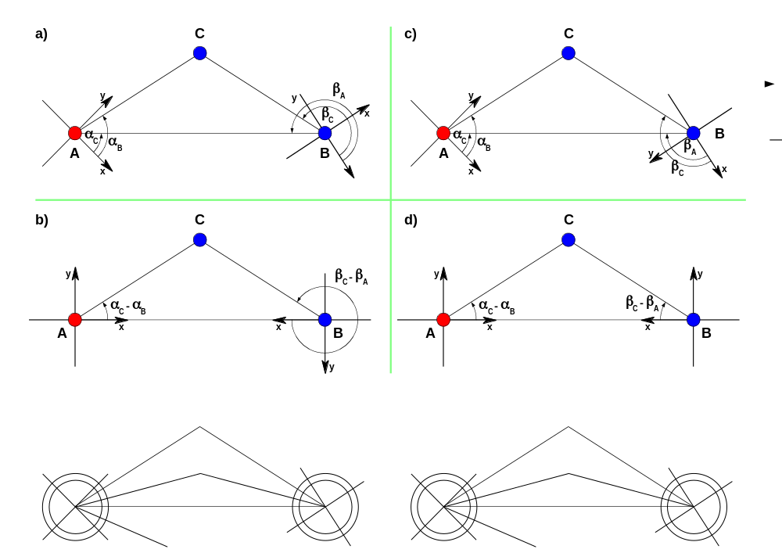
Figure 24: Determination whether mirroring of the y-coordinate is required
The complete procedure is as follows: Node A, B, and C are all one-hop neighbours of each other and know their distances from each other. A instructs B to adjust its coordinate system by giving node B the identity of node C, the angle α_{B}, and the coordinates of node B in node A's coordinate system. Node B knows α_{C}-α_{B} and β_{C}-β_{A} from the triangle A B C. Node B also knows β_{A} through A's coordinates in C's system. Node C has all information to rotate and possibly mirror its coordinate system to align it with node A's. Finally, node B translates its coordinate system by the coordinates supplied by node A, thus, making its coordinate system equal to node A's.

C.4 The anchor and the seed
In self-organising networks, e.g. sensor networks, it is usually sufficient to know the relative location of the individual nodes, no relation to any defined grid, e.g. the World Geodetic System (WGS84), is required. On the other hand, the UE's position is valuable for emergency sessions especially if a wireless path exists between the customer premises network and the UE.
Note: If the UE is connected to a wall socket, the location of this wall socket – maintained by the customer premises network infrastructure – is sufficient for emergency sessions.
Wireless paths are based on equipment that is called "access point", "base station", etc.; this equipment must participate in the Self-Positioning Algorithm. The access point is a natural anchor for the self-organisation of the network by providing its known location.
Note: The algorithm requires a numeric location for the access point, e.g. the World Geodetic System (WGS84) or regional numeric coordinate system.
Unfortunately, having just one anchor point provides not enough information to the Self-Positioning Algorithm to allow the network coordinate system to be congruent with the numeric coordinates of the access point (see Figure 25 where node N could be anywhere on a circle/sphere around the access point). Further equipment is required to provide additional known points (one to three). This equipment does not need the functionality of an access point, it suffices that it is at a known location and that it participates in the Self-Positioning Algorithm to act as a seed for the establishment of a congruent network coordinate system.
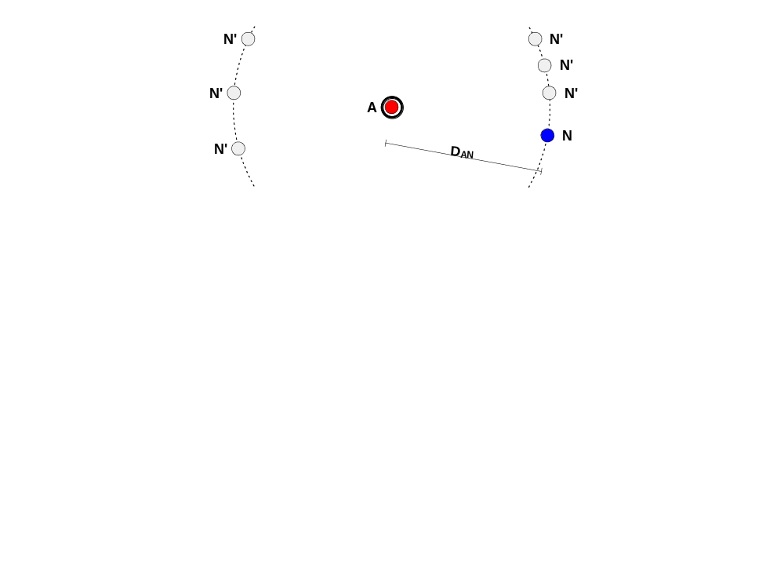
Figure 25: Distance to one node with known coordinates
Note 1: One seed (in addition to the anchor) is sufficient if all UEs are on one side of the "access point – seed" axis and no height component is required (see Figure 26).
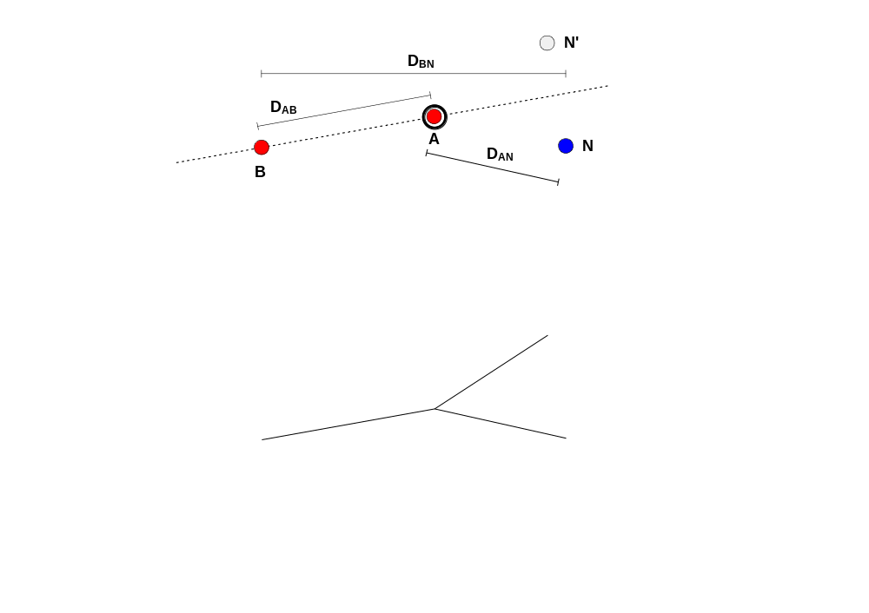
Figure 26: Distance to two nodes with known coordinates
Note 2: Two seeds are sufficient for determination of the location if no height component is required (see Figure 27). The access point and the two seeds must not lie in a line.
Note 3: If height is an essential element for emergency locations, three seeds are required. The access point and the three seeds must not lie in a plane.

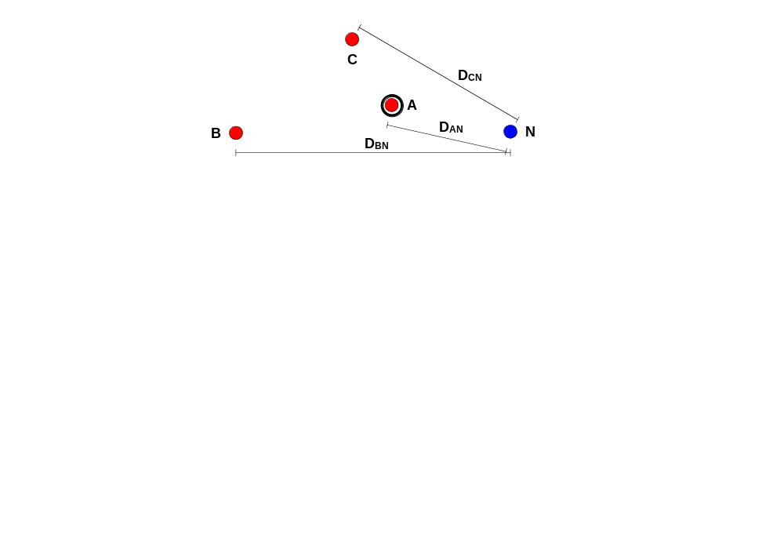
Figure 27: Distance to three nodes with known coordinates
With an anchor and three seeds, a node can receive four different position messages and measure the four distances. This is done by solving (for p and δ) the following system of four equations
for i=(A,B,C,D) ( d_{i} = | L_{i} − p | + c · δ )
where each equation corresponds to one distance d_{i} measured by N to nodes A, B, C, and D. Therefore, the node can determine it’s location p and the synchronization offset δ and therefore synchronize to anchor and seeds. The correct time then trickles from the nodes close to the anchor and the seeds to the outer reaches of the anchor's service area.
Note: The algorithm to solve the four equations above is identical to the algorithm used for determining GPS locations.

C.5 Bibliography

[51] Srdan Čapkun, Maher Hamdi, Jean-Pierre Hubaux, " GPS-free positioning in mobile Ad-Hoc networks", Cluster Computing, 5(2), April 2002.
[52] J.-P. Hubaux, J.-Y. Le Boudec, S. Giordano, M. Hamdi, L j. Blazevic, L . Buttyan and M. Vojnovic, "Towards Mobile Ad-Hoc WANs: Terminodes", IEEE WCNC, September 2000.
[53] Y.B. Ko and N.H. Vaidya, "Location aided routing (LAR) in mobile ad-hoc networks", MOBICOM, 1998.
[54] Lj. Blazevic, S. Giordano and J. Y. Le Boudec, "Self-Organizing Wide-Area routing", SCI 2000/ISAS 2000, Orlando, July 2000.

C.6 Abbreviations
Acronym | Definition
SPA | Self-Positioning Algorithm
TOA | Time of Arrival
GPS | Global Positioning System
GNSS | Global Navigational Satellite System
UTC | Coordinated Universal Time

Annex <N> (informative):
Bibliography
The annex entitled "Bibliography" is optional.
Each annex shall start on a new page.
Use the Heading 8 style for the title and B1+ or Normal for the text.
- <Publication>: "<Title>".
OR
<Publication>: "<Title>".
<PAGE BREAK>

History
Document history
0.0.0 | 2006-12-12 | Document creation
0.1.0 | 2007-03-26 | Scope, ToC, and Introduction
0.2.0 | 2007-06-07 | First draft clauses 4, 5, 7, 9, and 10
0.3.0 | 2007-07-24 | Addition of Annex C

2007-07-24

